Project Overview
This project was developed as part of the Data Engineering Hands-on Training Program (Gear-Up Program) conducted by InOrg Global, under the guidance of Chitresh Rahamatkar
This project implements a modern Medallion Architecture (Bronze → Silver → Gold) on Databricks for a retail store dataset and builds a Star Schema for analytical reporting in Power BI.
The pipeline covers:
- Data ingestion from raw CSV into Delta Lake
- Data cleaning and standardization
- Dimensional modeling (Star Schema)
- Fact and dimension tables
- Data quality handling (null keys, surrogate keys)
- Power BI semantic model and KPI dashboard

Technology Stack
Layer | Tool
Data Storage | Delta Lake (Databricks)
Processing | Databricks SQL
Data Modeling | Star Schema (Kimball)
Orchestration | SQL-based ETL
Visualization | Power BI
Architecture | Medallion (Bronze, Silver, Gold)

Data Architecture
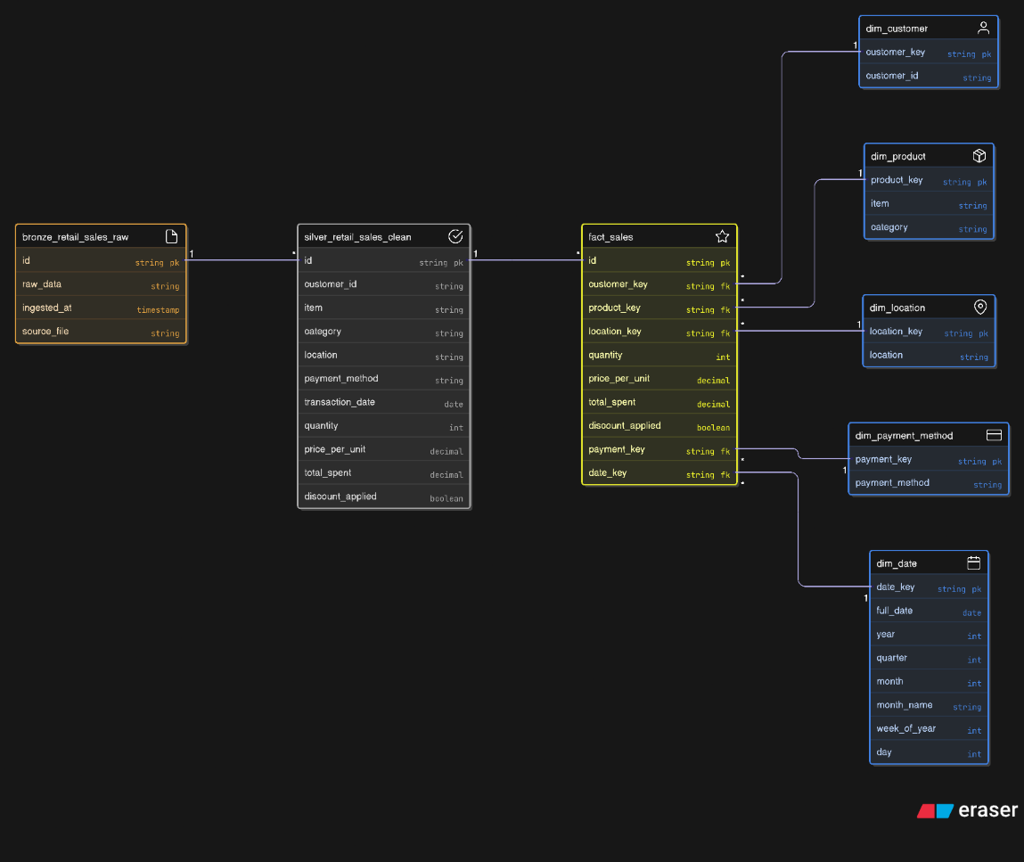
Medallion Architecture
Bronze Layer – Raw Ingestion
- Source: CSV file stored in Unity Catalog Volume
- No transformations
- Schema inferred
- Purpose: auditability & reprocessing
Table:
bronze.retail_sales_raw

Silver Layer – Clean & Standardized
Transformations applied:
- Renamed columns (removed spaces)
- Data type casting
- Null handling
- Uppercasing categorical fields
- Boolean normalization for discount flag
- Date parsing
Table:
silver.retail_sales_clean
This layer provides trusted, query-ready data.
Gold Layer – Business Model (Star Schema)
Designed using Kimball dimensional modeling.
⭐ Fact Table
gold.fact_sales
Contains:
- customer_key
- product_key
- location_key
- payment_key
- date_key
- quantity
- price_per_unit
- total_spent
- discount_applied

Dimension Tables
1. gold.dim_customer
- customer_key (surrogate)
- customer_id (business key)
2. gold.dim_product
- product_key
- item
- category
3. gold.dim_location
- location_key
- location
4. gold.dim_payment_method
- payment_key
- payment_method
5. gold.dim_date
Generated using min/max transaction dates:
- date_key
- full_date
- year
- quarter
- month
- month_name
- week_of_year
- day

Surrogate Key Strategy
- Used DENSE_RANK () to generate surrogate keys
- Implemented Unknown Member (0) to avoid NULL foreign keys in fact table
- Ensured referential integrity for Power BI relationships

Data Quality Handling
Issues handled:
Issue | Solution
Invalid column names | Renamed during Silver load
Null dimension joins | Default key = 0
Duplicate product keys | Rebuilt dim_product with unique grain
Many-to-many in Power BI | Fixed via proper star schema
Date gaps | Generated full calendar table

ETL Flow
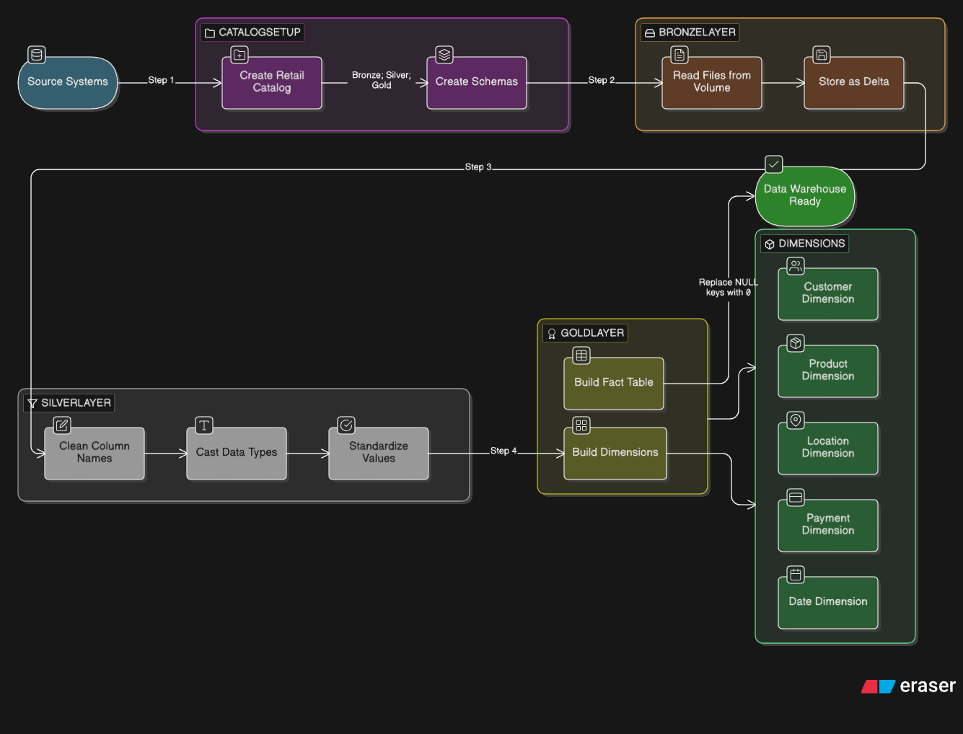
Power BI Semantic Model
Relationships
- All dimensions → fact_sales (1:*)
- No many-to-many
- No bidirectional filters
DAX Measures Implemented
Core KPIs
- Total Revenue
- Total Transactions
- Total Quantity
- Avg Basket Size
- Repeat Purchase Rate
Customer Analytics
- Customer Transactions
- Repeat Customer Flag

Dashboard Design
KPI Cards
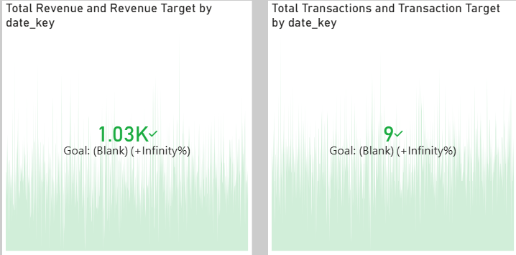

📈 Time Series
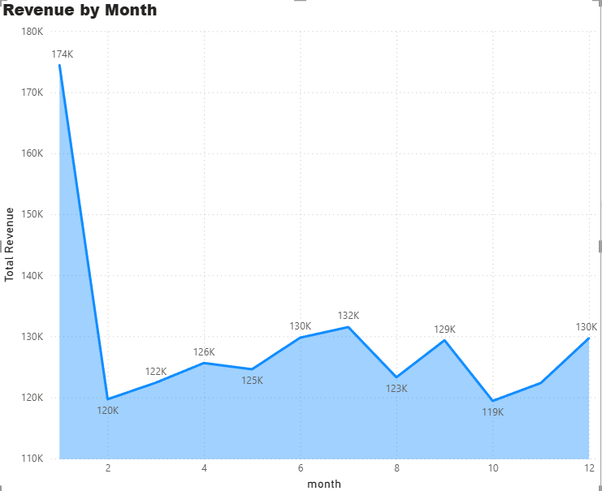

🛍 Product Insights
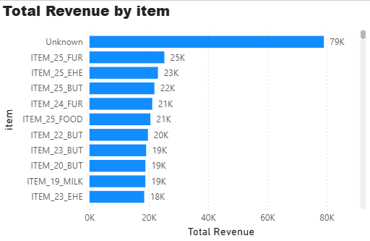
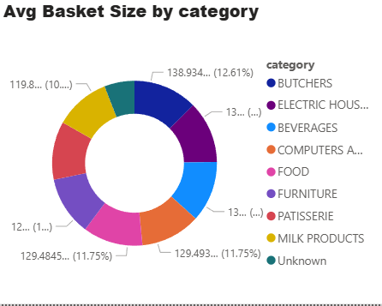

👥 Customer Behavior
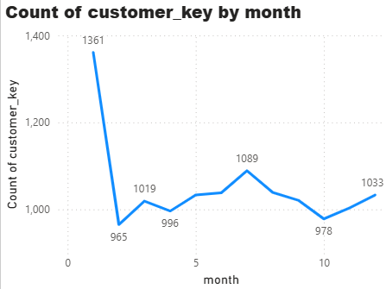
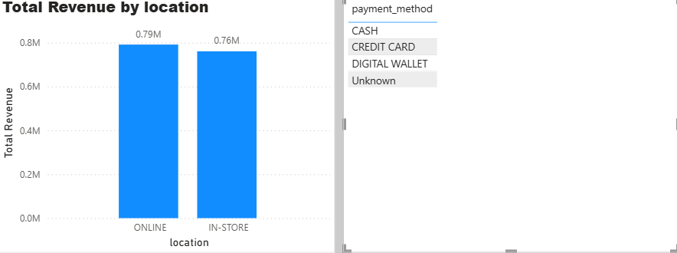
Business Insights Delivered
- Identified high-revenue product categories
- Measured customer retention via repeat purchase rate
- Analyzed basket size trends over time
- Compared payment method performance
- Evaluated online vs offline sales contribution

Challenges Faced & Resolutions
Challenge | Resolution
Invalid Delta column names | Renamed in Silver
Missing tables across schemas | Used fully qualified catalog.schema.table
NULL foreign keys | Introduced Unknown member (0)
Many-to-many in Power BI | Fixed dimension grain
Calendar generation error | Used proper CTE and sequence

Key Learning Outcomes
- Built Medallion architecture end-to-end
- Implemented dimensional modeling in Databricks
- Handled data quality and surrogate key strategy
- Designed BI-optimized star schema
- Created business KPIs in Power BI
- Delivered actionable retail analytics

Conclusion
This project demonstrates a production-style data engineering pipeline from raw ingestion to business dashboards.
It showcases Delta Lake, Medallion architecture, dimensional modeling, and BI semantic design, making it suitable for real-world retail analytics use cases.

