Department of Computer Engineering
Object Oriented Programming 10636212
GUI-HW3

Instructor : Haya Sammaneh

Draw Pad mini-project
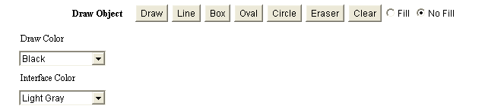

Add extra information such as:
- Dimension of shape.
- Draw string
- Build your own GUI

Dead Line: 18/11/2019

