KARTHIK R
MASTER OF COMPUTER APPLICATIONS
Used Technologies:

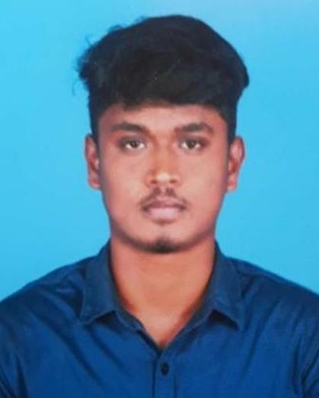
Career Objective:
To grow into a highly effective specialist in the field of information technology by utilizing my technical knowledge and abilities to promote both professional and personal growth as well as success of the firm.

Education:

2020 - 2022 Master of Computer Application
Madurai Kamaraj University-Madurai CGPA -8.1
2017 - 2020 Bachelor of Computer Science
N.M.S.S.Vellaichamy Nadar College –Madurai CGPA -6.1

2015 - 2017 Class 12th ,HSC,(Computer Science)
Personal Info:
Email
karthikofficial1512@gmail.com
Phone
8778748302
Location
133,Ganapathi illam,
Muthaiyakovil street,kochadai
Madurai-625016

LinkedIn
www.linkedin.com/in/karthik-r-
05b785215
Skills:
Time Management Self-Learning Problem Solving Critical Thinking Adaptability
Languages:
Tamil
English
Sethupati Higher Secondary School –Madurai Percentage -79%

2014 – 2015 Class 10th,SSLC
KGV Sala High School- Madurai Percentage -73%

Work Experience:

Business Executive

Sriram Finance Limited( Thirunagar) - 13/06/2024 - Present

Full Stack Developer Internship(Core Php)

Yuzzworks(Chennai) - 01/12/2023 to 08/03/24

Data Entry Operater

Pheenix( Coimbatore) - 28/11/23 to 02/02/2024

Data Entry Operator

Techsix Info solution(Madurai) - 06/06/23 to 14/10/23

Projects:

GiftRecorderApp (Web Application – 2023)

Description:
- This software is designed to helps our home functions and User efficiently manage their budget ,income, expenses and etc.

Used Technologies:
- Front-End: HTML, CSS, JavaScript,bootstrap,Ajax
- Back-End: Core PHP
- Database: MYSQL

Student Result System For Department(Web Application 2022)

Description:

This software is designed to help educators and administrators efficiently manage & organize student marks.

Used Technologies:
- Front-End: HTML, CSS, JavaScript
- Back-End: Core PHP
- Database: MYSQL

Medical Management System(Console Application – 2021) Description:
- This software is designed to help Medical store that manages the day to day operations of goods and billings and other tasks.

Used Technologies:
- Python Tkinter & MYSQL

Library Management System(Web Application – 2020) Description:
- This software is designed to help Students and administrators efficiently manage & organize Library books.

Used Technologies:
- Front-End: HTML, CSS, JavaScript
- Back-End: Core PHP
- Database: MYSQL
Programming Skills:
- Programming Languages: C Programming
- Frond-End: Html5,Css,JavaScript,Bootstrap5
- Back-End: Python, Core Php
- Database: MySql
- IDE’s: PyCharm,Python3 IDE, Sublime Editor, Visual Studio Code
- Operating System : Windows, Linux(Ubuntu)

Skills:

- Presentation
- Microsoft (excel,word)
- Tele-Calling
- Document Files handling and Documentation

Certificate:

Sno | Name | Place |  | Link
1 | SQL | SkillUp By Simplilearn  (Online course) |  | https://1drv.ms/b/s!AjvijTHBBeqIgWjUKXDWrVh8xjyq
2 | Python,Tkinter | Blue Pearl Computer Education |  | https://1drv.ms/u/s!AjvijTHBBeqIgRTp_gLyqYYtJOaW
3 | Certificate in Desk Top Publishing | NMSSVN Arts & Science College |  | https://1drv.ms/i/s!AjvijTHBBeqIgWtRaXmL8ebYLo3r
4 | Soft Skills | Synergy School of Business Skills |  | https://1drv.ms/i/s!AjvijTHBBeqIgWovEMxO_d-jzOsJ
5 | National Level  Conference On  Advanced Computing  Techniques | NMSSVN Arts & Science College |  | https://1drv.ms/i/s!AjvijTHBBeqIgWzJIoRDL9M_3Wxj

Declaration:
I,KARTHIK R hereby declare that all the information furnished above is true to the best of my knowledge .

Place: Madurai Signature
Date: (KARTHIK R)

