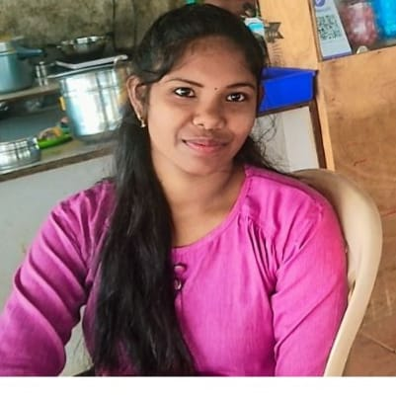

RAJESHWARI R
web developer
📞 6382699384 | 📧 rajeshjashmicka@gmail.com | 📍 channai thambaram camprode insaide pathuvanchary
💼 https://gitlab.com/rajesh9345

Profile Summary
Passionate and motivated Front-End Web Developer with strong skills in
HTML, CSS, JavaScript, and React.js. Dedicated to creating clean,
responsive, and user-friendly websites. Eager to apply my knowledge in real-
world projects, enhance user experience, and continuously learn new
technologies to become a full-stack developer in the future.

EDUCATION
Bachelor of (B.A) English literature
●Nehru memorial college of arts and
science, puthanampatti, India (july
2018 - May 2021)Goverment Girls Hr.
Sec. School, chinnasalem (Jun 2016-
May 2018)
● HSC (12th Grade) – 72%
● SSLC (10th Grade) – 68%
School or University

Work Experience
💻 Project / Learning
Web Developer(Self-Learning & Projects)(2024
Present)Built multiple responsive websites using HTML, CSS, and JavaScript. Created dynamic components and single-page applications with React.js.Focused on improving UI/UX and ensuring responsive design for mobile devices.Practiced version control with Git and GitHub for code management.

Projects
portpolio, to do list
counter ,timer
login page,incres dicress reset numbers
chesbord back ground colour changing
resume tamlate produc cord

Technical skills 💻
HTML5, CSS3, JavaScript
React.js Hooks, Components, Props, State)
Responsive Web Design
Git & GitHub Version Control)
Basic Knowledge of Node.js
🧠 Soft Skills
Problem Solving & Logical Thinking Team Collaboration Adaptability & Quick Learning Time ManagementCreativity & Attention to Detail

