RESUME

Mr. Marudhupandi
1/145, Kalyamman Kovil Street, ChinnaKollapatti,
Sattur, Virudhunagar – 626203

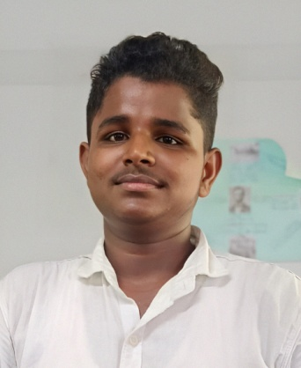
Mob. No: 7539984214
E – Mail :marudhu2004@gmail.com

OBJECTIVE
- Seeking a challenging position position in a reputed organization where I can learn new skill, expand my knowledge and leverage my learning.

EDUCATON QUALAFICATION
- Qualified in HSE(+2) History (2021 – 2022) from Edward Higher Secondary School, Sattur, with 63.3% aggregate.
- SSLC (2020 – 2021) from Edward Higher Secondary School, Sattur, with 51.1% aggregate.

SKILL
- I have many certifications in sporsts.
STRENGTHS
- I believe in smart work.
- I will always behave honestly and punctually.
- I will do any work with passion.

HOBBIES
- I will improve my knowledge everyday.
- Financial books reading & playing.

PERSONAL DETAILS
Name : Mr. G. Marudhupandi
Father’s Name : Ganesan T
Date of Birth : April 26, 2004
Gender : Male
Marital Status : Unmarried
Religion : Hindu
Language Know : Tamil & English (Reading and Writing)

Place : Sattur Signature , Date : G. Marudhupandi

