CURRICULAM VITAE

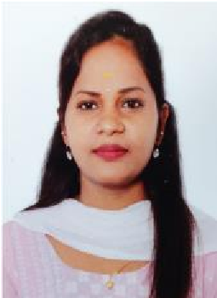
BALA ABIRAMI.S
Contact Number:9345258211
E-Mail:
ID:balaabirami630@gmail.com Chennai –Tamilnadu.

CAREER OBJECTIVE
To develop a strong impact to the company. Where I can put my knowledge and skills with consistency and to continually maintain the good progress of the company.

EDUCATION BACKGROUND
- B.COM(CA) from ST. Antony’s college of arts and science for women ,Dindigul .
MOTHER TERESA WOMEN UNIVERSITY , kodaikanal with 76%(2017th – 2020th batch)
- HSSC from Govt .Girls Higher Secondary School ,Padappai with 87% (2017th batch)
- SSLC from ST. Marys Matriculation Higher secondary school ,Tambram with 84%
(2015th batch) .

TECHNICAL SKILLS
- MS Office tools
- Basic of computer knowledge
- Skill development training has completed “Documentary filmmaking”
- (Innovativz institute of media studies )
- Skill development training has completed “Videography”
(Innovativz institute of media studies.

EXPERIENCE
- I have over five years of experience as a soldering operator in the production field at Vishay Precision Group,Oragadam.

PERSONAL DETAILS

FATHER’S NAME: SHANMUGAM.S
MOTHER’S NAME: NAGALAKSHIMI.S
D.O.B :22.08.1999
NATIONALITY : INDIAN
GENDER : FEMALE
MARITAL STATUS :UNMARRIED

DECLARATION

I here declare all the above furnished details are true and correct to the best of my knowledge.
(BALAABIRAMI.S)

