CURRICULUM VITAE
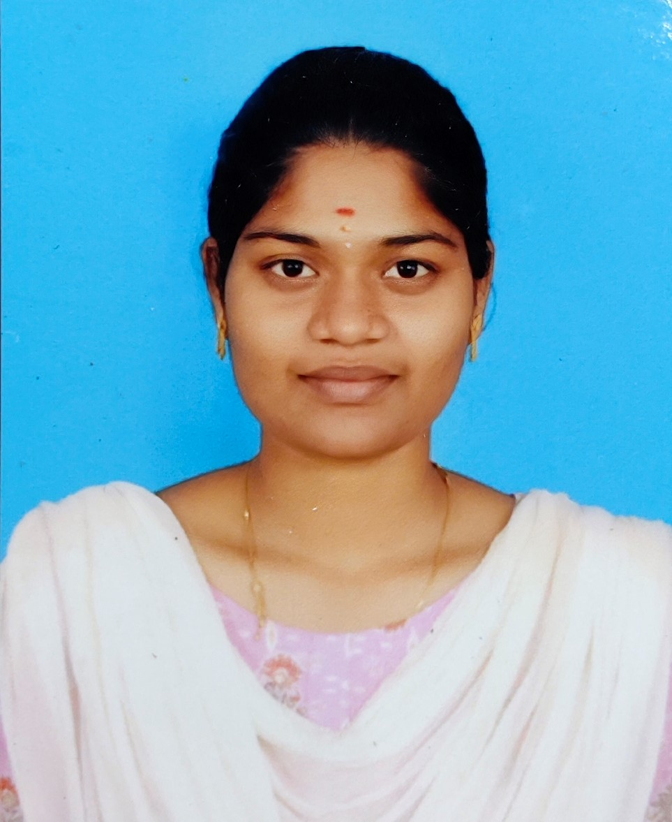

Name: Yogamozhi S
E mail yogamozhis1622004 @gmail.com
Ph No : +918778093016
Permanent Address:
2/171,Allapatti(Vil), (Po)
Krishnagiri-635122.
Languages Known : Tamil, English,

Technical skills :
- MATLAB
- Medical device Installation
- Time management skills
- MS-office (Word, Excel, PowerPoint)
Certification & Participation :
- NPTEL:Biophotonics,Genetic Engineering
- Introduction to 3D printing and CAD modelling .
- Participated in “Machine Techniques For ECG Signal Processing” in 2023
- Certification in National Level Conference & Technical Symposium “BIOCIENCIA 2024” in Simats Engineering College
- Participated In National Level Technical Symposium “TECHTRINITY 2K24” At Vivekanandha College Of Engineering For Women In 2024.
Internship & course:
- Medical coding course - Thoughtflows academy – Coimbatore.
- Internship with Apollo speciality hospital ,Main branch Chennai.
Workshops:
- CIT/ Top Engineering /march21,2021
- Digital ultrasound in pocus/kongunadu college of engineering and technology in 2024
- PLC in industrial automation-Sona college 2024
- Participated in “Biomedical engineers conclave for carrier guidence”in 2023.
- Participated in 3 days workshop Atheenapandiyan private limited.

CAREER OBJECTIVE
To obtain a challenging position as a Biomedical Engineer where I can apply my knowledge of engineering, biology, and medical technologies to develop innovative solutions that improve patient care, enhance diagnostic tools, and contribute to the advancement of healthcare systems.”
PERSONAL PROFILE
- Biomedical engineering graduate with knowledge of medical science and technology.
- Proficient in python ,MATLAB & MS Office with strong attention to detail and problem solving skills .
- Knowledge of ICD-10-CM , CPT & HCPCS coding systems with attention to accuracy

EDUCAUTIONAL QUALIFICATION
- PAAVAI ENGINEERING COLLEGE
Bachelor of biomedical Engineering in 73%
- NALANDHA MATRIC HIGHER SECONDARY SCHOOL
- SSLC at 74 % in 2019.
- HSC at 78 % in 2021.

ADDITIONAL SKILLS
- Basics of ICD-10-CM, CPT & HCPCS coding concepts
- Knowledge of medical terminology, Anatomy & physiology
- Biomedical Instrument Handeling
- Electronic health record handling basics

PROJECT

AI based deep learning for diagnosis of thyroid using image detection.
- Developed python coding to detect thyroid using AI tools.

DECLARATION
I hereby declare that the information furnished above is true and correct to the best of my knowledge and belief.
Thanking You,
Date: Yours faithfully,
Place: S YOGAMOZHI

