RESUME

S. KANAGALAKSHMI,
D/o Sekar,
No-5/274, Muthukrishnapurm,
Pandarapuram,
Sathankulam(tk).
Tuticorin (Dt)-628704.

Mobile No : 9080526053
Mail Id : kanagalakshmi23082003@gmail.com.

Objective

To make use of every small opportunity for the growth of the institution, society and individual.

Academic Qualification

Qualification | Name of the Institution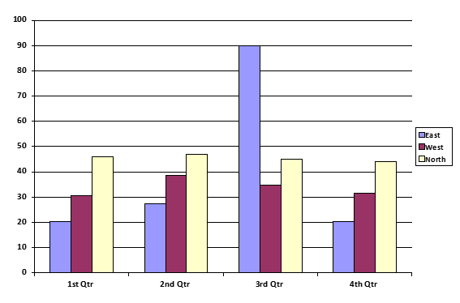 | Year of passing | Scored
B.SC COMPUTER SCIENCE | MANONMANIAM SUNDARANAR UNIVERSITY | 2023 | 80%

EXTRA QUALIFICATIONS

- DCA
- Photoshop
- TYPE WRITING COURCE ON PROCESS

WORK EXPEREINCE

I have worked in these following prestigious Company
- FOXCONN INDIA PVT LTD, (Chennai) 2 Years of apprentice training done at various departments like electronics assembling field & admin & human recourses area.

- STI india ltd, Indore.

EXTRA CURRICULAR ACTIVITIES

- Drawing & painting
- Listening music’s,

LANGUAGES KNOWN

- Tamil (Speak, Read, write)
- English (Speak, Read, Write)

Personal Details

Name : S. Kanagalakshmi,
Father’s Name : Sekar,
Date of Birth : 23/08/2003,
Age : 22,
Gender : Female,
Nationality : Indian,
Marital Status : Single,

DECLARATION

I hereby affirm that all the details furnished above are true and correct to the best of my knowledge and belief.
Place: Tirunelveli.
Date:

Signature
(S. KANAGALAKSHMI)

