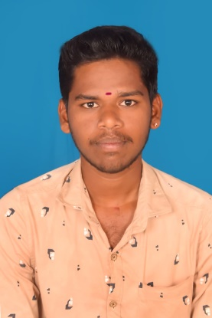
RESUME

SANTHOSH.E
Email Id : santhoshegambaram @gmail.com
Mobile No : 6380577761
===========================================================================

CAREER OBJECTIVE :

To secure a challenging position where I can contribute my skills to learn and grow
along with the growth of the Organnization to prove my self meeting the challenges
around me and shoulder the responsibilities assigned to me.

WORK EXPERIENCE :

- CHOLAA DYNASTY :
A Bergamont Group of Hotel Kumbakonam :
Worked as a ‘’December 25 th 2021 to June 09th 2023’’ to as a Room Attendant in worked in Houseman.

- THE SUN WAY MANOR :
Pondicherry , House keeping department.
Worked for from ‘’September 26th 2023 to August 10th 2024 as
Room Attendant in Houseman.

- HOTEL KINGS BURRYINN:
KUMBAKONAM, House keeping department
Assistant Supervisor October 5th 2025 to Till date.

EDUCATIONAL QUALIFICATION :

COURSE | INSTITUTIONS | UNIVERSITY | YEAR | % of marks
S.S.L.C | Govt.Boys.Hr.Sec. School, Nannilam | State Board | 2019 | 85%
H.Sc | Govt.Boys.Hr.Sec. School, Nannilam | State Board | 2021 | 90%
B.Sc  (Catering and Hotel Administration) | Bharath College of Hotel Management  Thiruvarur | Alagappa University | 2024 | 86%

STRENGHTS :

- Time management
- Work management
- Quick Learner
- Leadership Quality
- Responsible
- Listening
- Personal Management
- Strong work Ethic
- Honesty and Intergrity
- Punctuality, Regularity and responsibility
- Customer analyzing
- Team work skills
- Loyalty

Personal Details :

Father Name : R.EGAMBARAM
D.O.B : 26.09.2004
Gender : Male
Marital Status : Unmarried
Nationality : Indian
Religion : Hindu

Address :
50/2, Kallukudi
Nemmeli (Po)
Nannilam (Tk)
Thiruvarur – (Dist) – 610 105.

Languages : Tamil , English & malayalam

DECLARATION:
I Hereby declare that all the above given information is true to the best of my knowledge and belief.

Date :
Place :
Yours Faithfully

( SANTHOSH.E )

