Name: PRASANNA LAKSHMI. S
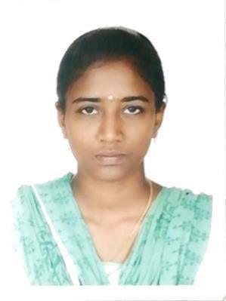
Mail id:prasannalakshmi271029@gmail.com
Phone No: 9790769191
Address: No.68/65,Anna st,Kamaraj nagar, New perungalathur, Chennai600063.
CAREER OBJECTIVE:
To rise in career by serving to the best of my ability with honesty, dedication, and
hard work by striving to achieve excellence in everyday work life.
ACADEMIC QUALIFICATION:
Sl. No | Course | Institution | Year of Passing | Percentage/CGPA
1. | BSc  Biotechnology | Prince Sri venkateswara arts and science college | 2019 | 75.5%
2. | HSC | Shanthosh vidhyalaya Mat. Hr. Sec. School | 2016 | 70%
3. | SSLC | Shanthosh vidhyalaya Mat. Hr. Sec. School | 2014 | 93.8%

SKILLS:
- Computer operating basic knowledge, Excel shortcuts, Vlookup, Pivot, Hlookup
- Typewritting: Lower(Distinction)
- Completed Advanced Certification in Medical Coding at Sri Raetna Solution, Chennai

EXPERIENCE:
- From September 2019 Present - 6 years experience as a "Customer Support Associate" in SUTHERLAND GLOBAL SERVICES.
- Designation: Senior Associate - CS Internet
Job Role: Chat associate, E-mail, DART & Escalation chat
- Process: Amazon NA
- Department: Service delivery operation
- Current role: DART escalation connect
WORKS UNDERTAKEN:
- Handling the customer query's via Chat and Email.
- Troubleshooting and raising tickets with appropriate teams.
- Creating follow up with customer issue to make sure the issue gets resolved quickly
AWARDS AND ACHIEVEMENTS IN SUTHERLAND:
  - Season topper, Monthly performer, Shinning Star in Prime week
  - Handled 100 customer per day when our target is just 52
  - Super star performer for a season in Email
  - Perceived best performer of the month 8 times as agent and 7 months as DART Escalation since I joined and gave more productivity to Amazon as a chat & email associate
FIELD OF INTEREST:
MEDICAL CODING
STRENGTH:
  - Quick learning
  - Dedication to work
  - Co-ordination
PERSONAL DETAILS:

Date of birth: Oct 27 1998
Martial status: Married
Father name: Mr. Sundar
Mother name: Mrs. Malar
Known language:English, Tamil
DECLARATION:
I hereby declare that all the particulars furnished by me in this application are true
correct and complete to the best of my knowledge and belief
PLACE : Chennai
DATE : 15 December 2025 S.PRASANNA LAKSHMI

