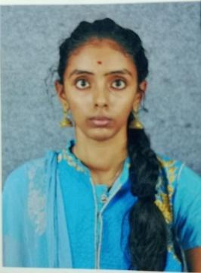
Resume
B.MYTHILI
869, Maruthi Nagar,
Ammapet,
Salem-636003, Tamil Nadu.
Mobile No: 8668131034
E-Mail:mythilibasker143@gmail.com

OBJECTIVE
To work in a challenging atmosphere by exhibit my skills with utmost sincerity and dedicated smart work for the growth of your esteemed organization along with mine.

EDUCATIONAL QUALIFICATIONS
Degree | College / University | Year of Passing | Percentage
BCA | Vysya College /  Periyar University | 2022-25 | 79%
HSC | Government Girls Higher Secondary School, Salem-636001 / State Board | 2021-22 | 59.16%
SSLC | Government Girls Higher Secondary School, Salem-636001 / State Board | 2019-20 | 55%

- AERA OF INTEREST / SKILLS:
- HTML
- Web Technology
- SQL&Relational Database Management System
- Programming in C
- Basic:Microsoft Excel, Microsoft PowerPoint

PROJECT:
Gym management system
- Team member
A “gym management system” is a robust and versatile desktop.
The application developed using pythons tkinter for its graphical user interface and SQLite as the backend database for persistent data storage .
HOBBIES:
- Watching movies
- Cooking

PERSONAL PROFILE:
Date of Birth : 13.12.2004
Regional Languages : English, Tamil& Telugu

DECLARATION
I hereby solemnly declare that the particulars furnished above by me are true and correct to the best of my knowledge and belief.

Place: salem
Date: 12.09.2025
(B.Mythili)

