CURRICULAM VITAE
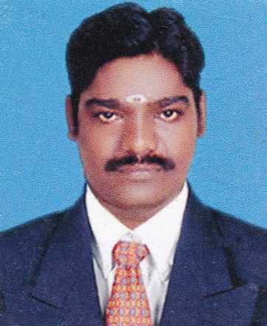  Name: MARIYAPPAN.V  e-Mail :  mrv.mariyappan@gmail.com Mobile : +8220936122, 9600639119  PERSONAL INFORMATION  Father’s Name:  V.VARATHAN  D.OB : 03-06-1982.  Nationality : Indian.  Marital  Status : Single.  Languages Known : English, Tamil,Hindi  Address: 345, Dhanalakshmi Nagar,  SrimieasapuramPost, Reddipalayam Road, Thanjavur – 613009, | OBJECTIVE  To be a part dynamic firm where I can effectively utilize all my skills for our mutual and social welfare.  EDUCATION QUALIFICATION  - B.E (EEE) - 62% (2006)  - H.S.C - 56% (2001)  - S.S.L.C - 72% (1998)  TECHNICAL QUALIFICATION  Bachelor of Engineering in Electrical & Electronics, completed in 2006  CAREER YEARS:6 Years  CAREER PROFILE  6 years Involvement in Testing & Commissioning and Electrical Maintenance.  - Testing & Commissioning of Indoor and Outdoor Substation up to 220KV Voltage Level.  - Testing & Commissioning of Power Transformers, Oil / Vacuum / SF6 Circuit breakers, current Transformers, Voltage Transformers and Distribution Transformers.  - Maintenance Testing and Trouble shooting of substations etc..  WORK EXPERIENCE - 1  1.M/S. STAR INDIA PROMOTERS(2006-2007)  Designation: Gas Light & Interior decoration in Marketing Field (Assistant Manager)  WORK EXPERIENCE - 2  2. M/s.VOLTECH ENGINEERS PVT LTD, CHENNAI.  Designation: Testing and Commissioning Engineer.  Period: Jan 2008 to Sep 2011  Key responsibility:  Responsible for Testing & Commissioning of Protection Relays and associated Switchgears for the following projects mentioned below  MAJORE PROJECTS EXECUTED  1. M/s ESSEL ENGINEERING PROJECTS PVT LTD, RAIPUR.  Job performed: testing & commissioning 220KV Switchyard in Nagpur.  Responsible for Testing and Commissioning of 20MVA, 132/11KV Power Transformer, 11/0.415KV station Auxiliary Transformer, 132KV Switchyard, 11KV Switchyard and 132/11KV Protection relays, LVAC, DC SYSTEM, 11kV/132kV Cable Schedule, earthing system.  2. M/s Sarda Energy & Minerals Pvt. Ltd, Raipur.  Job Performed: Testing’s & Commissioning 25 M.W Thermal Power Plant.  3. M/s Action &Aryan Ispat Power Plant, Jharsuguda (Orissa).  Job Performed: Testing & Commissioning 25 M.W Power Plant.  4. M/s Techno Electrical & Engineers Pvt. Ltd, Kolkatta.  Job Performed: Testing & commissioning 132/11KV Substation in the three different sites.  5. M/s Mukund Engineers Ltd.  Job Performed: Testing &Commissioning 250 MW Thermal Power Plants, Kolkata.  6. M/s HPCL, Mumbai.  Job Performed: Electrical Maintenance of MCC, PMCC board and respective motors in HPCL Refineries, Mumbai.  7. Rail Wheel Factory, Chappra Bihar.  Job Performed: Electrical Maintenance of MCC, PMCC board and respective motors.  8. Jothi Malleables Pvt. Ltd., (JMPL) Thuvagudi.  Job Performed: Production Manager (Assistant) in melting section  WORK EXPERIENCE - 3  3.i-Max IAT ,Trichy.(Nov 2001 –Jul 2015)  Job Performed:  - Prepare conceptual and detailed engineering involving  schedule and functional logic diagrams.  - Product performance monitoring and Action taking  - Program verification  - Electrical circuit Diagram Designing  - Panel Wiring  - Field Wiring  WORK EXPERIENCE  - Worked in Testing of 220/132/11KV Switchgear Substations. Skilled in commissioning of Transformer & Generator protection relays.  - Tested Various Relays During Maintenance and Break Downs.  - Commissioned various switch gear panels.  - Skilled in analyzing single Line Diagram, Control Circuit & Interlocking Scheme etc..

DECLARATION

I hereby declare that the above furnished details & Information’s are true according to best of my knowledge and belief.
Place :
Date :
(V.Mariyappan)

