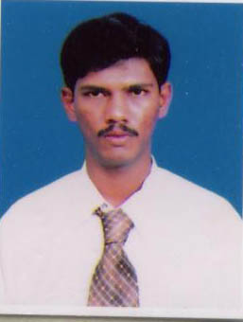

Resume

M.RAJA MOHAMMED e-mail : rajamalick@gmail.com

No.12B, Thenmathathi street, Mob. no: +91-9943977250,9543690695

Tiruvannamalai – 606 601.

OBJECTIVE:

Intend to build a career with leading corporate of hi-tech environment with committed and dedicated people, which will help me to explore myself fully and realize my potential. willing to play a key role in a creative environment.

EDUCATIONAL PROFILE:

Qualification | Name of Board/University | Name of  College/school | Year of  Passing | Percentage  of marks
B.TECH  (IT) | .Anna University (Tamilnadu) | S.K.P.Engineering College - Tiruvannamalai | April2005 | 68%
DEEE | DOTE (Tamilnadu). | Kumaran Polytechnic, Tiruvannamalai | April 2001 | 62%
SSLC | State Board of Tamilnadu | SRGDS Hr. Sec. School, Tiruvannamalai | April 1998 | 55%

EXPERIENCE:
- Teaching experience in Engineering Colleges- 8 years
- Presently working as principal in Tirumala polytechnic Tiruvannamalai Past 2 years
Technical Skill:
- Operating System : Windows 9x, XP & LINUX.
- Languages : C, C++, visual basic,java
- RDBMS : Microsoft Access, SQLplus.
- Multimedia :Photoshop, Imagestyler, Macromedia flash, dream weaver

PERSONAL SKILLS:
- Good Attitude
- Managing Capability
- Optimistic approach
- Ability to move within a team
- Learning new things
- Singing

PROJECT:

- Project Title : TRANSMITTING AND RECEIVING LIVE MEDIA
- Platform : JAVA
- Tools : JMF 2.1.1.

Transmission of media takes place from one computer to another computer. It also wants to multicast video feed to company intranet. The source of video can be file. Live video using a video capture device or any other source.

Project Title : LINUX VIRTUAL SERVER WITH HEART BEAT
The LVS is a group of servers with a director that appear to the outside world (a client on internet) as one server. Each real server thinks that it as connected directly to the client. Neither client nor the real servers have any way of telling that a director has intervened in the connection.

AREA OF INTEREST:

- Computer networks concept.
- Operating system.

PERSONAL PROFILE:

Name : M.RAJA MOHAMMED

Gender : Male

Date of Birth : 24th –Feb-1982

Father’s name : Mr. P.T.Malick basha

Marital Status : Married

Permanent Address : No. 12b,Thenmathathi street,
Tiruvannamalai-606 601.

Languages Known : English, Tamil, Hindhi.

Nationality : India

DECLARATION:
I hereby declare that all the information furnished above is true to the best of my knowledge and belief.

Place: SIGNATURE
Date : (M.RAJAMOHAMMED)

