Product Requirements Document & Implementation Plan - BoosterNRT AI

This document defines the product requirements, user workflows, and implementation strategies for building the BoosterNRT AI multi-tenant platform.

👥 Three Core User Roles

- Super Admin
- Configures new customers/tenants (e.g., creating a profile for a company like 4S Logistics).
- Creates labels, maps document templates, links cross-document verification points, and records web entry automation sequences.
- Tenant Admin
- Created by the Super Admin for a company. Logs in to create Operator accounts.
- Configures user permissions, data formatting rules, and adds descriptive text hints for document fields.
- Operator (Customer / End User)
- Logs in with credentials created by the Tenant Admin.
- Uploads documents, reviews AI-extracted data, validates verification results, and executes automated web entries.

Roles and Workflow Diagram
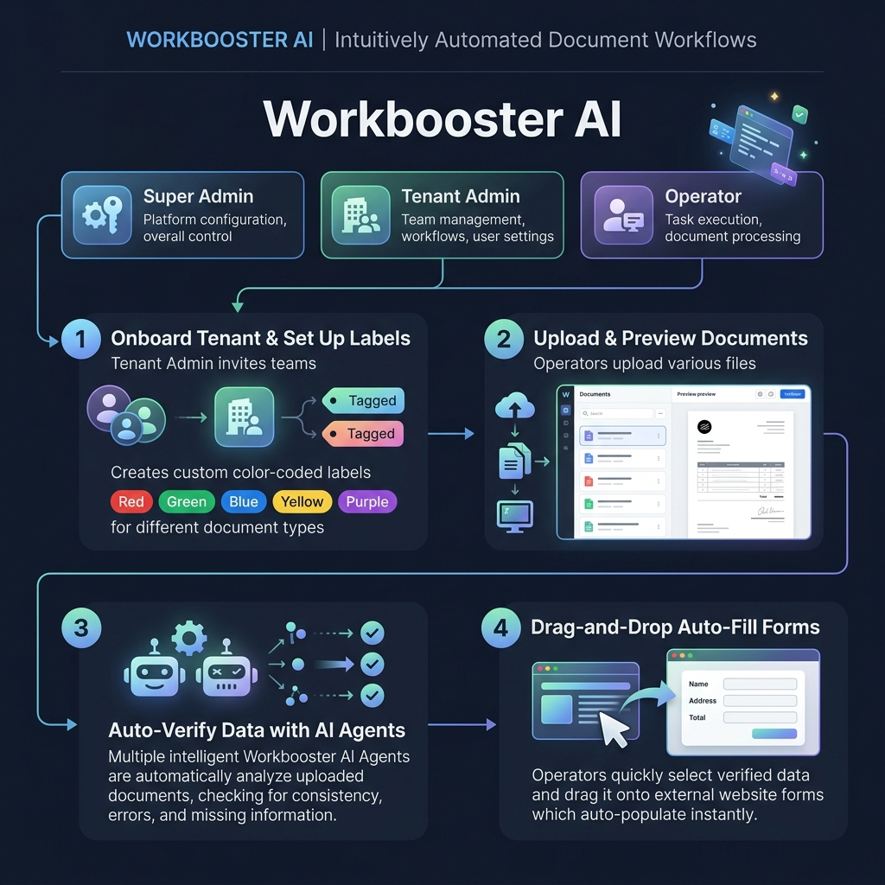
Figure: Workbooster AI Product Workflow & Roles

🛠️ Super Admin: Step-by-Step Customer Onboarding Workflow

The Super Admin configures a new customer (Tenant) by following this sequence:

Step 1: Customer Creation
- The Super Admin inputs the new customer's name (e.g., 4S Logistics) and clicks Next Step.
- This dynamically registers the tenant record in the database.

Step 2: Custom Label Configuration
- The system asks the Super Admin to create document labels.
- The Super Admin can create unlimited custom labels (e.g. seaway_bill_no, gross_weight, container_number, invoice_no, total_amount).
- Each label is configured as a key-value concept.
- During creation of each label, the system displays a checkbox: "Verify with other document" (Yes/No).
- If checked, this label is flagged to run cross-document AI verification.

Step 3: Reference Document Uploads
- The Super Admin uploads one sample reference document file for each type (e.g. uploading a sample Bill of Lading PDF for bl, a sample Commercial Invoice PDF for invoice).
- Once uploaded, the Super Admin clicks Go.

Step 4: Preview and Key-Value Tagging
- The system loads the uploaded documents and shows a preview of the files one by one.
- The Super Admin views a document and draws bounding boxes (crops) over the target values to create custom tags.
- When a value is cropped (e.g., cropping a seaway bill number value like HLCU2602810):
- The backend crops that specific coordinate area from the document image.
- The system performs OCR on the cropped area and its surrounding text.
- The surrounding words are stored as anchor terms (e.g., the word "Seaway Bill No:").
- This anchor term and coordinate metadata are combined to automatically generate a tailored system prompt for that field.

Step 5: Verification Mapping (Previous Labels Sidebar)
- If the Super Admin marked a label as Verify with other document = Yes in Step 2:
- For the first document (Document 1), the Super Admin draws the crop box over the source value.
- When moving to the next documents (Document 2, Document 3, etc.), the system displays a left-hand sidebar listing all the verification labels created in previous documents.
- The Super Admin selects a label from the left sidebar and crops the corresponding value on the current document page.
- This links the source and target values together in the database for consistency checks.
- The verification system does not blindly match strings. Instead, it uses an AI agent to understand the context and meaning of the words (handling varying formats, date layouts, and unit conversions like MT to KGS).

Step 6: Testing & Prompts Training Loop
- The system shows a verification preview containing the extracted and cross-checked values.
- If the values are correct, the Super Admin clicks Next.
- If a value is incorrect, the Super Admin selects the incorrect field and clicks Train Data:
- The Super Admin enters the correct value on-screen.
- The system appends this manual correction as a few-shot instruction to the AI's prompt, refining the system prompt overrides for future runs.
- Once satisfied, the Super Admin clicks Next to preview the final extracted JSON data.

Step 7: Data Export or Web Entry (RPA) Setup
The system prompts the Super Admin: "How do you want the data or entry?"
- Option A: Data
- Downloads the extracted data directly as a structured JSON file.
- Option B: Entry (RPA Browser Automation)
- The system asks for the target web URL.
- It asks: "Does this ERP have login? (Yes/No)".
- If Yes, it prompts the Super Admin to provide the Username and Password.
- The system opens a visual browser window directly inside the software interface.
- A left-side panel displays all the extracted document labels as draggable buttons.
- Interactive Recording:
- The Super Admin logs in by dragging the username and password buttons and dropping them onto the corresponding web form inputs, then clicking submit.
- The Super Admin configures page navigation by dragging and dropping extracted labels into the respective web fields.
- While recording, the backend automatically logs all user actions (clicks, keypresses, selections), generates DOM selectors (CSS, XPath, JS Path), and monitors telemetry data (page loading latency, page idle status, and user pause times).
- End Block & Condition Settings:
- When finished, the Super Admin clicks End Block to save the sequence.
- They can configure conditional handlers:
- Success Event: (e.g. If the final URL contains /success or page HTML contains Cleared, show a success message in the UI).
- Error Event: (e.g. If the page displays error text, capture a screenshot, show the alert in the UI, and pause the automation).

🏢 Tenant Admin & Operator Workflows

Tenant Admin Setup
- Once the Super Admin publishes the customer tenant profile:
- The Tenant Admin logs in to create Daily Operator accounts.
- They can configure data conversion preferences (e.g., date formats) and add slight prompt descriptions or input hints to guide operators.

Daily Operator Process
- The Operator logs in using their credentials.
- They upload transaction files (Bill of Lading, Invoice, Packing List).
- The AI engine matches the files to the templates, parses the fields, and alerts them to any cross-document validation issues (e.g., weight differences).
- The Operator reviews the results, corrects any anomalies, and triggers the saved RPA script. The automation runs entirely in the background (headless backend execution) rather than showing a browser window on the screen. Once completed, the interface displays whether the submission succeeded or failed, along with any confirmation logs.

