Systems Integration & Technical Overview Guide - BoosterNRT AI

This guide explains the technical design and operational workflows of BoosterNRT AI in a way that is easy to understand for both technical teams and business leaders (such as HR and Management). It outlines the core technologies we use to automate manual document reading and data entry tasks, and how the entire system works under the hood.

🗺️ System Architecture Diagram

Tech Components & Data Flow
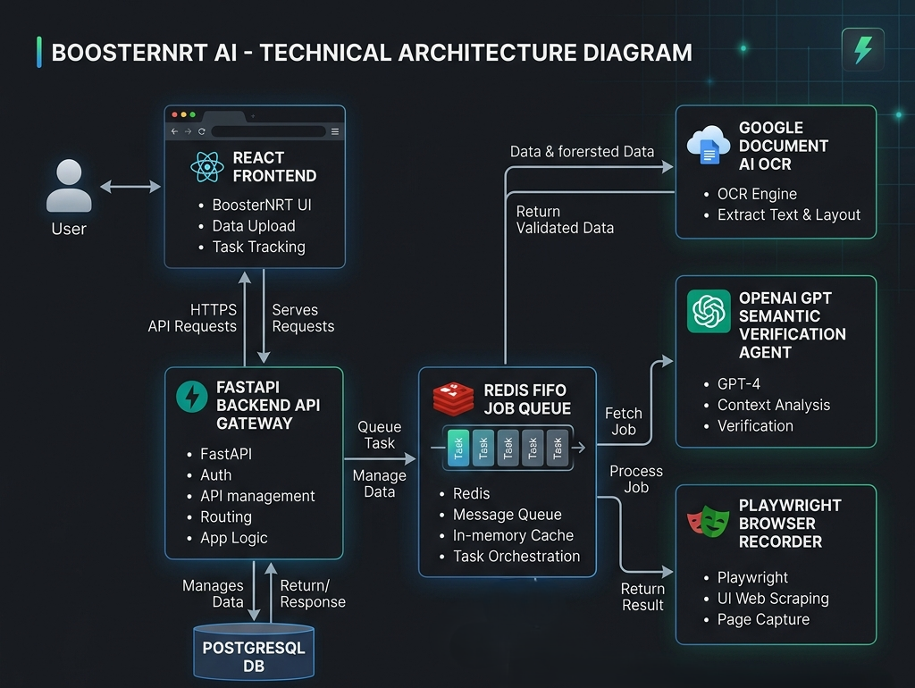
Figure: BoosterNRT AI Technical Architecture

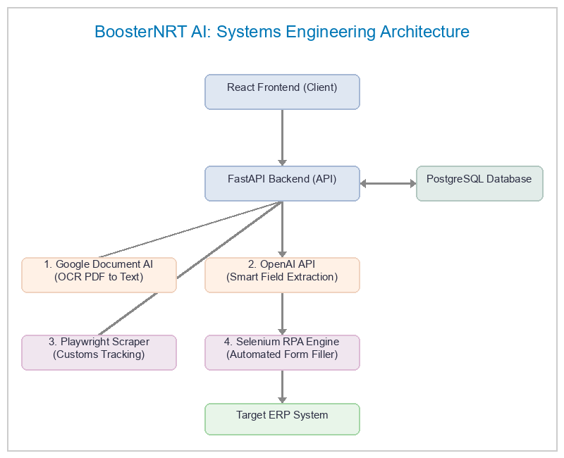
Figure: BoosterNRT AI Systems Engineering Architecture

🛠️ The Core Technology Stack (What We Use)

We have built BoosterNRT AI using modern, industry-standard tools to ensure it is secure, fast, and intelligent. Here is a breakdown of our tools:

1. React (The User Interface)
This is the frontend dashboard that operators interact with. It is designed to be highly visual, showing side-by-side document previews, mismatch alerts, and live-streaming browser windows for recording web steps.

2. FastAPI (The System Orchestrator)
This is the backend server that manages traffic, processes file uploads, runs authentication, and coordinates all background tasks.

3. PostgreSQL (The Secure Database)
Our database securely stores template mappings, user roles, and clearance files. It is configured with multi-tenancy, meaning each customer's data is isolated so no company can ever see another company's records.

4. Google Cloud Document AI (The OCR Scanner)
When an operator uploads a PDF or scanned image, Google Cloud Document AI reads the document and transcribes the raw image into clear, editable digital text.

5. OpenAI API (The Smart AI Assistant)
Once the text is extracted, the OpenAI API acts as the "brain." It reads through the unstructured document text, isolates the exact logistics details (such as container numbers, gross weights, and consignee names), normalizes date formats, and runs checks to flag discrepancies (such as mismatching weights between the Bill of Lading and Invoice).

Additionally, it handles AI Prompt-Based Data Transformation. If a customer needs their data restructured in a specific format (for example, extracting a combined description block and formatting it to put the part number first and description second), they write a natural language instruction. The OpenAI API executes this transformation dynamically during extraction.

6. Playwright & Selenium (The Automated Browsers)
These tools act like digital hands:
- Playwright: Runs headless browser queries to search government customs sites (like ICEGATE) for live container tracking records.
- Selenium: Powers our visual web recording screen, allowing operators to record actions (like clicking buttons and typing values) and play them back to automatically enter verified data directly into their target ERP systems.

🔄 Core Workflows (How It Works)

1. Simple Visual Template Builder
Instead of hiring engineers to write custom code for every customer, operators can onboard new layouts in minutes:
- They upload a sample document.
- They highlight target fields visually (e.g. drawing boxes over the Invoice Number or Address).
- BoosterNRT AI saves these coordinate positions in the database. Future documents of the same type will automatically look at those coordinate areas to find the data.

2. Smart AI Ingestion & Cross-Verification
- Uploading Files: Operators upload the cargo documents (e.g., Bill of Lading, Invoice, Packing List).
- AI Extraction & Transformation: Google Document AI scans the files, and the OpenAI API extracts and restructures the key fields based on the custom transformation prompts.
- Discrepancy Checking: The system compares fields across all documents. If the weight or container number doesn't match, the system alerts the user.
- Delivery Term Detection: The AI automatically identifies the Incoterm (e.g., FOB or CIF) and notifies the operator if they are missing required documents.

3. Automated Customs Tracking
The backend uses Playwright to automatically log onto customs portals, submit tracking numbers, and pull back container records (like IGM details) directly into the operator's workspace without manual web searching.

4. Direct ERP Web Entry (RPA)
Once data is verified and approved:
- The system launches an automated browser in the background.
- It replays the recorded clicks, logins, and dropdown selections to input the verified details directly into the company's ERP portal.
- Since this process runs entirely on the backend server, the operator is free to work on other tasks, receiving a notification once the entry is successfully completed.

