BoosterNRT AI - Product Overview & Strategic Vision

This document provides a comprehensive, non-technical overview of the BoosterNRT AI platform. It describes the business challenges, the product vision, the three core user roles, step-by-step onboarding workflows, and the main system modules.

📈 The Business Challenge

Historically, delivering automated document extraction and data entry solutions to clients required building custom software branches for each customer. For example:
- Client A (e.g. Customs Broker): Had a custom code repository.
- Client B (e.g. Freight Forwarder): Had another custom code repository.
- Client C (e.g. Warehouse Operator): Had a third custom code repository.

This approach created significant challenges:
- Implementation Delays: Onboarding a single client took 1 to 2 months of writing custom code, configuring rules, and setting up direct integrations.
- High Maintenance: Maintaining separate codebases meant bug fixes and updates had to be manually repeated for each client.
- Poor Scalability: Scaling the business to dozens of clients was impossible without exponentially increasing the engineering team size.

🎯 The BoosterNRT AI Product Vision

BoosterNRT AI replaces client-specific codebases with a single, unified, multi-tenant SaaS platform.

Instead of writing custom code, the platform uses a no-code configuration engine. Onboarding a new customer is done by simply configuring rules and templates through a visual interface. This reduces implementation time from 1–2 months down to a few days.

[Separate Client Codebases] ──► [ Unified BoosterNRT AI Product ]
(Custom Code & Integrations) (Configuration-Driven Multi-Tenancy)

👥 Three Core User Roles

The platform is designed around three distinct user profiles, each playing a specific role in the workflow:

┌────────────────────────────────────────────────────────┐
│ SUPER ADMIN │
│ - Configures customers/tenants (e.g., 4S Logistics) │
│ - Creates custom document labels & templates │
│ - Sets up cross-document AI verification links │
│ - Records visual web entry automation (RPA) tasks │
└───────────────────────────┬────────────────────────────┘
│ (creates tenant accounts)
▼
┌────────────────────────────────────────────────────────┐
│ TENANT ADMIN │
│ - Creates Daily Operator credentials │
│ - Configures date and currency formatting preferences │
│ - Configures AI prompt-based data transformations │
│ - Adds field labels and descriptive helpful hints │
└───────────────────────────┬────────────────────────────┘
│ (creates operator users)
▼
┌────────────────────────────────────────────────────────┐
│ DAILY OPERATOR │
│ - Uploads clearance documents (BL, Invoices, etc.) │
│ - Reviews side-by-side extracted data and alerts │
│ - Corrects anomalies (trains server-side AI Agent) │
│ - Triggers the visual web entry automation (RPA) │
└────────────────────────────────────────────────────────┘

🗺️ Product Workflow & Roles Diagram

Below is the visual workflow map showing how the Super Admin, Tenant Admin, and Operator interact with the platform:

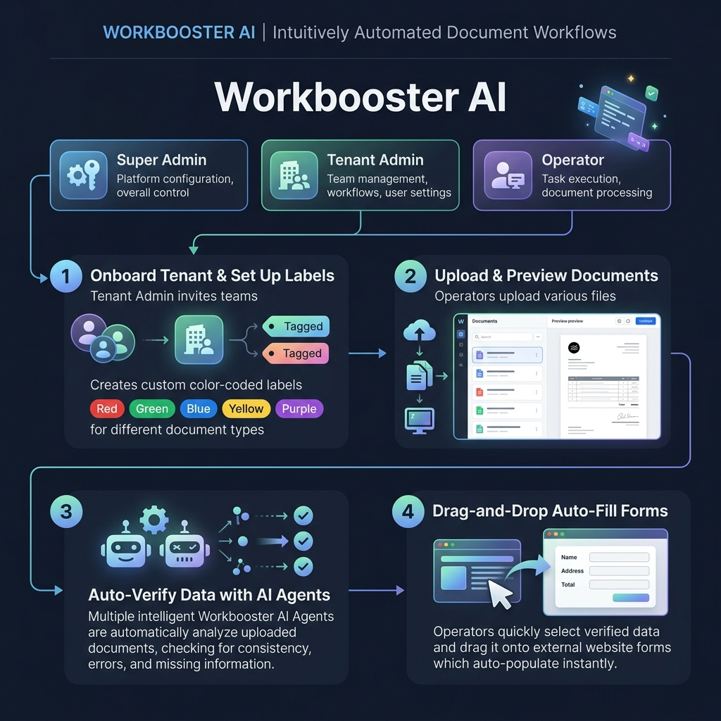
Figure: BoosterNRT AI Product Workflow & Roles

🛠️ Super Admin Onboarding & Setup Workflow

Super Admins use a step-by-step onboarding wizard to bring new clients onto the platform without writing code:

1. Customer Tenant Setup
- The Super Admin inputs the company name (e.g., 4S Logistics), uploads branding logos, and selects regional settings like currency and timezone.

2. Custom Label Builder
- The Super Admin creates the data keys (labels) they want to extract from the documents (e.g. invoice_no, gross_weight, container_number).
- During creation, they can check a box: "Verify with other document". If enabled, the system will ensure this value matches across all uploaded documents for a transaction.

3. Template Reference Upload
- The Super Admin uploads a typical sample file for each document type (e.g., one typical Bill of Lading, one typical Invoice) to teach the system the layout.

4. Interactive Page Cropping
- The wizard shows a preview of the sample documents page-by-page.
- The Super Admin draws bounding boxes around the target values using a mouse.
- The system automatically scans the text inside the box and matches it with surrounding terms (like the word "Invoice No:") to establish reliable anchor words.

5. Verification Connections
- For fields marked to verify across multiple documents:
- When moving to the next document preview, a sidebar on the left displays all the verification labels created in previous steps.
- The Super Admin selects a label (e.g. invoice_no) and draws a box over where that value appears in the second document.
- Intelligent AI Checking: Rather than matching text exactly, the system uses a server-side AI Agent to verify information semantically. For example, it understands that 12-May-2026 is the same date as 2026/05/12, and that 1.5 MT is equivalent to 1500 KGS.

6. AI Prompt-Based Data Transformation
- The Tenant Admin or Super Admin can provide a natural language prompt to instruct the server-side AI on how to format or restructure extracted data.
- Example: If a description contains a part number and item name (like *"Part #9923 - Engine Belt"*), the admin can type: *"Extracted description should put the part number first and item name second, separated by a colon."* The server-side AI agent will automatically format the output as *"9923: Engine Belt"*.

7. AI Prompt Training Loop
- The Super Admin reviews the extraction results on a test preview page.
- If the AI makes a mistake, they highlight it, type the correct text, and click Train Data.
- The system appends this manual correction as a few-shot learning rule in the database, automatically adjusting its prompt instructions to prevent the mistake from happening again.

8. Visual Web Entry (RPA) Recorder
After document verification is configured, the system asks: *"How do you want the data or entry?"*
- Option A: Data: Downloads the verified document information directly as a structured JSON file.
- Option B: Entry: Opens a visual browser window directly inside the software.
- The Super Admin inputs the target website URL.
- If the website requires log in, the Super Admin enters the Username and Password variables.
- The left panel displays all the extracted document labels as draggable buttons.
- The Super Admin drags the labels (like invoice_no) and drops them onto the matching text fields on the website.
- The system automatically records every click, typing event, and button press, including network page loading times and user pause delays.
- End Block Rules: Once the recording is saved, the Super Admin defines success conditions (e.g., if page contains "Completed") or error alerts (e.g., if page displays "Invalid Code") to show custom messages to the Operator.

🏢 Daily Operator Operations

Once the tenant is configured, daily operational users execute transactions in four steps:

- Upload: Drag-and-drop a transaction package (e.g. BL and Commercial Invoice) into the system.
- AI Read: The system matches the files to the templates, extracts the data, and runs cross-document verification.
- Review: Discrepancies (like mismatched weights or invoice numbers) are flagged. The Operator manually reviews the alerts and edits any errors directly on the screen, which trains the server-side AI Agent.
- Headless Auto-Submit: The Operator clicks "Submit". The automation runs entirely in the background on the server (headless backend execution) rather than launching a visible browser on the operator's screen. Once completed, the interface updates to clearly display whether the submission succeeded or failed, along with any confirmation logs.

