BoosterNRT AI: Simple User Guidebook

Learn How to Automate Your Document and Web Tasks Easily

Welcome to BoosterNRT AI! This guidebook is written for you, the everyday user. We have left out all the confusing technical jargon and programming code. Instead, we explain exactly what BoosterNRT AI does, how it helps you, and how to use it step-by-step.

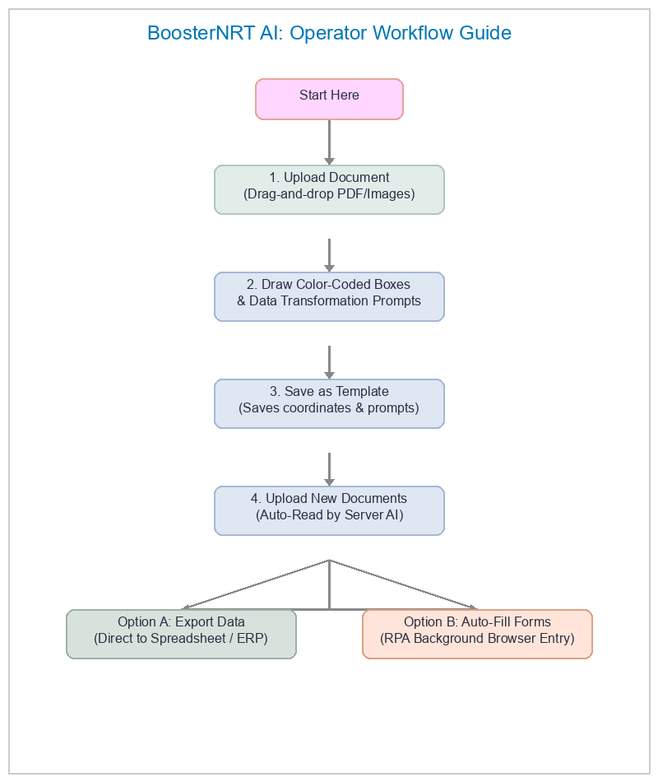
Figure: BoosterNRT AI Operator Workflow Flowchart

Roles and Workflow Diagram
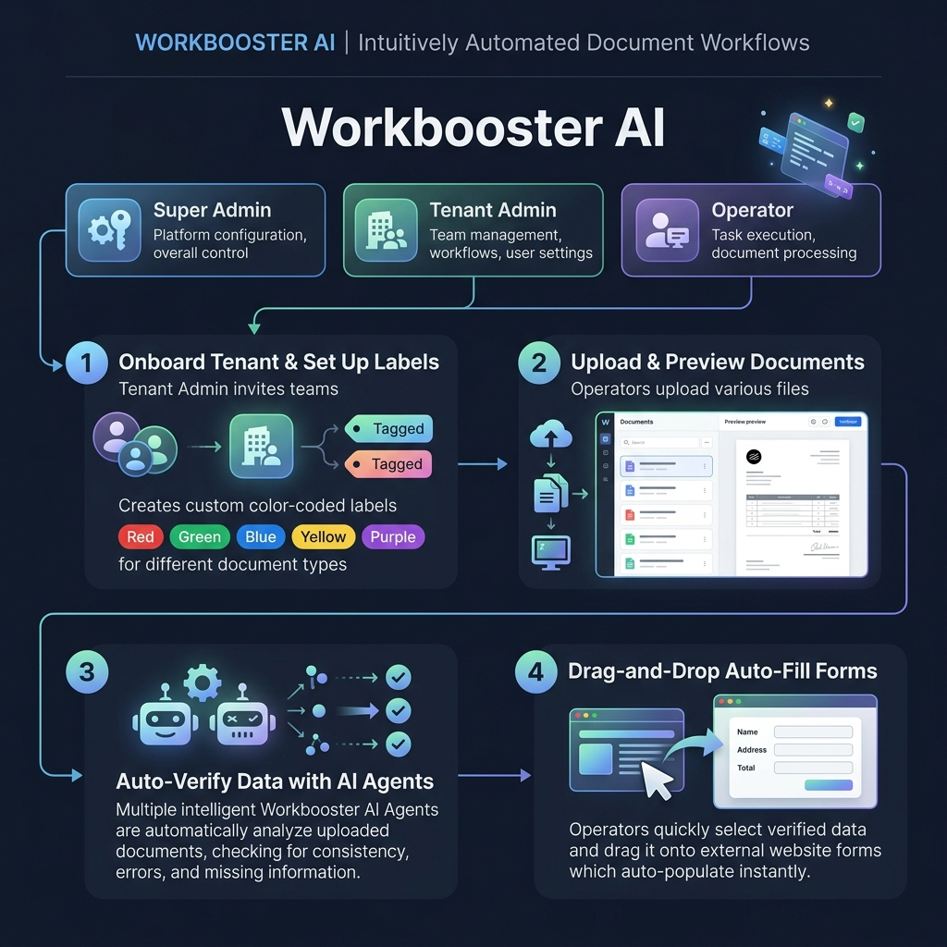
Figure: BoosterNRT AI Product Workflow & Roles

🌟 What is BoosterNRT AI?

Think of BoosterNRT AI as your personal digital assistant. If you handle invoices, receipts, forms, or ID cards, you know how tiring it is to type that information into spreadsheets or websites.

BoosterNRT AI solves this by:
- Reading Documents: It looks at your uploaded files (PDFs or photos) and automatically reads the information.
- Learning Layouts: Once you show it where a field is on a document once, it remembers that layout and reads similar documents automatically.
- Filling Web Forms: It can open web pages and automatically type the read information into form boxes for you, saving you from manual entry.

🎨 The 5-Color System Explained

When you show BoosterNRT AI where information is on a document, you will draw colored boxes around the text. The colors help you stay organized at a glance:

- 🔴 Red Boxes: Use these for unique identification tags (such as Invoice Numbers, ID Numbers, or Receipt IDs).
- 🟢 Green Boxes: Use these for money, totals, and numbers (such as Total Amount, Subtotals, or Quantities).
- 🔵 Blue Boxes: Use these for general text details (such as Customer Names, Vendor Names, or Company Names).
- 🟡 Yellow Boxes: Use these for dates and timestamps (such as Due Dates or Billing Dates).
- 🟣 Purple Boxes: Use these for special long-text descriptions (such as Delivery Addresses or Payment Terms).

Don't worry if you mix up the colors. The system will still read the text inside the box correctly regardless of the color you choose.

🚀 How to Use BoosterNRT AI (Step-by-Step)

Using BoosterNRT AI is as simple as following four steps: Upload ──► Draw ──► Save ──► Auto-Read.

Step 1: Upload a Document
- Go to the Upload page.
- Drag your document file (PDF, PNG, JPG, or JPEG) and drop it into the dashed box, or click the box to browse your computer.
- The system will load the document and display it on the screen.

Step 2: Draw Your Fields & Set Transformations (Create a Template)
- Turn on the drawing mode by clicking the "Click to Draw" button.
- Choose a color from the palette at the top.
- Click and hold on the top-left corner of the value you want to extract (for example, the actual invoice number INV-9092), then drag the box to the bottom-right corner and release.
- Type a name for this box (e.g., invoice_number).
- AI Data Transformation Prompt (Optional): If you want to change how the data looks (for example, you want the part number first and description second), you can set a prompt rule like: *"Put the part number first, then the item description, separated by a colon."* The server-side AI will handle this format shift automatically.
- Repeat this for all other values you need from the document.

Step 3: Save Your Template
- Once all boxes are drawn, click the "Save Annotations" button.
- Give your layout a friendly template name (for example, "Supplier ABC Invoice") so you can find it later.
- Click "Save Template".

Step 4: Let the AI Read Automatically
Now that the template is saved, you don't need to draw boxes ever again for this document type:
- Go to the Extract page.
- Upload a new document from the same company.
- BoosterNRT AI will automatically match the document to your saved template, read the text inside the boxes, and show you the values on the screen in seconds.
- Click "Export" to download all the read data directly into an Excel-friendly spreadsheet (CSV) or push it to your ERP.

🌐 The "Entry" Feature: Automated Form Filling

The Entry page is where BoosterNRT AI goes a step further. Instead of just reading document data, it opens a website and automatically types that data into web forms for you.

Here is how you set it up:
- Enter the Website URL: Type in the website where you want to enter the data (for example, your company's internal portal or an accounting website) and click Continue.
- Select Your Template: Choose the template containing the document fields you want to use.
- Login (Optional): If the website requires a username and password, enter them. BoosterNRT AI will log in for you and open the main page.
- Link Fields to Web Boxes:
- You will see a live view of the website on your screen.
- On the left sidebar, you will see the list of fields from your template (like invoice_number or total_amount).
- Simply drag a field from the sidebar and drop it directly onto the text box on the website where it belongs.
- BoosterNRT AI will immediately type the information into that box and remember the connection.
- Record Actions: If you need to click buttons (like "Submit" or "Next Page"), click them directly on the live website view. BoosterNRT AI will record these steps.
- Save: Click "Save Template". You have now created an automated robot sequence that can read a document and type it into a website automatically. When you trigger it as an operator, it runs entirely in the background (headless server-side execution) without opening a browser on your screen, and updates your dashboard with the final success or error status when completed.

💡 Top Tips for Best Results

- Leave a Little Breathing Room: When drawing boxes, make the box slightly wider than the text. If the text grows longer on future documents, the box will still capture it.
- Avoid Labels: Do not include headings (like the word "Date:") inside your boxes. Only draw the box around the actual value (like 02/07/2026).
- Clear Documents: Make sure your document photos are taken straight-on under good lighting. Blurry, dark, or heavily tilted images can make it harder for the AI assistant to read accurately.
- Keep Template Names Clear: Give your templates names that make sense to you (like "Amazon Receipts" or "Vendor XYZ Invoices") to make batch processing easier.

🛠️ Simple Troubleshooting

The system did not match my document automatically.
- Why: The document layout might look too different from the one you used to create the template, or the page is tilted.
- Solution: You can manually select the correct template from the dropdown menu on the Extract page, or create a new template for this layout if it is a new design.

The website in the "Entry" view is loading slowly or won't open.
- Why: The target website might be offline, or its security settings are blocking automated tools.
- Solution: Click the "Refresh View" button (the circular arrow) to reload the web page. If the page continues to fail, verify that the website opens correctly in your normal web browser.

The read values contain typos or extra characters.
- Why: The scanned text might be hard to read, or there are handwriting marks on top of the text.
- Solution: You can edit the values manually before exporting, or recreate the template using a clean scan to help the AI read the text more clearly.

