Joint UAT Timeline — BRD Module Coverage
Project: Zetapharma Sales Cloud for Pharmaceuticals
Document type: UAT / Validation Schedule (aligned to BRD Modules summary §4 & Module requirements §5)
Period: Sunday 25 October 2026 – Tuesday 3 November 2026 | Working week: Sun–Thu
Parties: Cloudastick (first-pass) × Zeta Pharma (retest / acceptance)
Reference: Zeta Business Requirements Document (Discovery Draft)
1. Graphical timeline (BRD functionalities in each box)
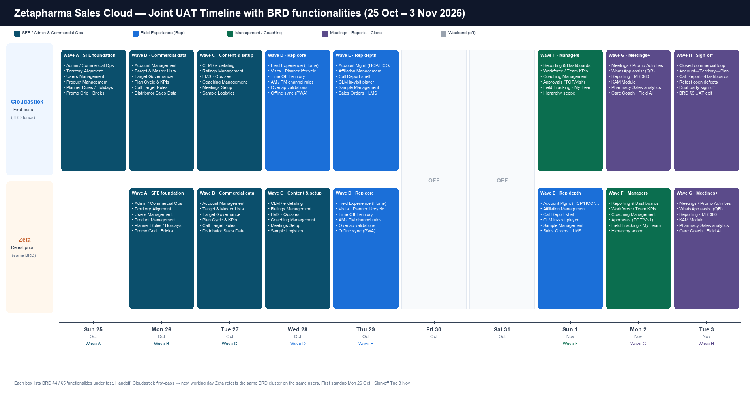
Figure 1 — Every box lists the BRD functionalities under test that day. Top = Cloudastick first-pass; bottom = Zeta retest of the prior working day’s BRD cluster.
2. Handoff model
Cloudastick first-passes a BRD module cluster each working day. Next working day Zeta retests that same cluster on the same named users, while Cloudastick opens the next cluster. First standup: Mon 26 Oct. Coverage close: Tue 3 Nov.
3. BRD functionalities by wave
Wave A · SFE foundation | Sun 25 Oct CS → Mon 26 Oct Zeta
BRD refs: Admin / Commercial Ops (#23), Territory Alignment & Targeting (#17), Users Management (#14), Product Management (#13)
MoSCoW: M
Functionalities shown in the timeline box:
• Admin / Commercial Ops
• Territory Alignment
• Users Management
• Product Management
• Planner Rules / Holidays
• Promo Grid · Bricks
Wave B · Commercial data | Mon 26 Oct CS → Tue 27 Oct Zeta
BRD refs: Account Management (#1), Target Governance, Plan Cycle & Rep 360 / KPIs (#21), Distributor Sales Data (#15)
MoSCoW: M
Functionalities shown in the timeline box:
• Account Management
• Target & Master Lists
• Target Governance
• Plan Cycle & KPIs
• Call Target Rules
• Distributor Sales Data
Wave C · Content & setup | Tue 27 Oct CS → Wed 28 Oct Zeta
BRD refs: CLM / e-detailing (#18), Ratings Management (#3), LMS (#12), Coaching Management (#11), Meetings Setup (#10), Sample Management (#19)
MoSCoW: M
Functionalities shown in the timeline box:
• CLM / e-detailing
• Ratings Management
• LMS · Quizzes
• Coaching Management
• Meetings Setup
• Sample Logistics
Wave D · Rep core | Wed 28 Oct CS → Thu 29 Oct Zeta
BRD refs: Field Experience Home+Planner (#20), Visits / Planner lifecycle (#5), Time Off Territory (#8)
MoSCoW: M
Functionalities shown in the timeline box:
• Field Experience (Home)
• Visits · Planner lifecycle
• Time Off Territory
• AM / PM channel rules
• Overlap validations
• Offline sync (PWA)
Wave E · Rep depth | Thu 29 Oct CS → Sun 1 Nov Zeta
BRD refs: Account (#1), Affiliation (#2), Ratings (#3), Call Report, CLM (#18), Samples (#19), Sales Orders (#25), LMS (#12)
MoSCoW: M
Functionalities shown in the timeline box:
• Account Mgmt (HCP/HCO/Rx)
• Affiliation Management
• Call Report shell
• CLM in-visit player
• Sample Management
• Sales Orders · LMS
Wave F · Managers | Sun 1 Nov CS → Mon 2 Nov Zeta
BRD refs: Reporting & Dashboards (#22), Coaching (#11), Approvals, Users Management hierarchy scope
MoSCoW: M
Functionalities shown in the timeline box:
• Reporting & Dashboards
• Workforce / Team KPIs
• Coaching Management
• Approvals (TOT/Visit)
• Field Tracking · My Team
• Hierarchy scope
Wave G · Meetings+ | Mon 2 Nov CS → Tue 3 Nov Zeta
BRD refs: Meetings/Promotional Activities (#10), WhatsApp assist (#9 C), Reporting/MR 360 (#21–22), KAM (5.4.6), Care Coach, Field AI
MoSCoW: M / S / C
Functionalities shown in the timeline box:
• Meetings / Promo Activities
• WhatsApp assist (QR)
• Reporting · MR 360
• KAM Module
• Pharmacy Sales analytics
• Care Coach · Field AI
Wave H · Sign-off | Tue 3 Nov both
BRD refs: Closed commercial loop; BRD §9 UAT exit
MoSCoW: M
Functionalities shown in the timeline box:
• Closed commercial loop
• Account→Territory→Plan
• Call Report→Dashboards
• Retest open defects
• Dual-party sign-off
• BRD §9 UAT exit
4. Day-at-a-glance
Date | Cloudastick (BRD functionalities) | Zeta retest | Lane
Sun 25 Oct | Admin Ops · Territory · Users · Products · Planner Rules · Promo/Bricks | — | SFE
Mon 26 Oct | Accounts · Targets · Governance · Plan Cycle · Call Target Rules · Dist. Sales | Wave A | SFE
Tue 27 Oct | CLM · Ratings · LMS · Coaching · Meetings Setup · Sample Logistics | Wave B | SFE
Wed 28 Oct | Field Home · Visits/Planner · TOT · AM/PM · Overlaps · Offline PWA | Wave C | Rep
Thu 29 Oct | Accounts · Affiliations · Call Report · CLM · Samples · Orders/LMS | Wave D | Rep
Fri–Sat | Off | Off | —
Sun 1 Nov | Dashboards · Workforce KPIs · Coaching · Approvals · Field Tracking | Wave E | Mgr
Mon 2 Nov | Meetings · WhatsApp QR · MR 360 · KAM · Pharmacy Sales · Care Coach/AI | Wave F | Close
Tue 3 Nov | Closed loop · defect retest · dual-party sign-off (BRD §9) | Wave G → sign | Close
5. Suggested named seats
Medical Rep: Abadir Esmat (GIT-I ASSUIT-A). District Manager: Ahmed Magdy (GIT-I DM CAIRO B). SFE: Pharma_Admin + Pharma_SFE_App.
6. Sign-off
Party | Name | Date | Coverage overall
Cloudastick |  | 3 Nov 2026 | Pass / Fail / Blocked
Zeta Pharma |  | 3 Nov 2026 | Pass / Fail / Blocked

