# Experiment No. 05

* 1. **Experiment Name:**

Experimental study on PABX (Private Automatic Branch Exchange) system

# Objectives:

* + - To become accustomed with the working procedure of PABX
    - To get acquainted with the basic parts of PABX
    - To learn about distribution system and digital exchange

# Theory:

PABX enables a complex web of multiple network connections, allowing corporate interactions as they increase and change. As a result, the system can handle a large number of incoming and outgoing calls, which can be increased by installing additional hardware.

PABX is an abbreviation for Private Automatic Branch Exchange. A PABX system is made up of two primary components. One is an exchange, and the other is a distributor.

# Exchange:

The 'Panasonic D500 Digital Super Hybrid System' was utilized as the digital exchange at RUET PABX. This exchange activity was kept running by utilizing three different types of cards and software. They are as follows: ESLC, PLC, and HLC.

* + - ESLC is 'Enlarged Single Line Telephone Circuit.' It is worth 16 points. In the RUET PABX exchange, there were 19 ESLC cards. It is intended for all general users.
    - HLC is for 'Hybrid Line Telephone Circuit.' It is worth 8 points. It shows the user the caller's information. As a result, it is reserved for VIP users such as the Vice Chancellor, Registrar, Deans, and Heads.
    - PLC is a VIP card that displays caller information and functions similarly to HLC.

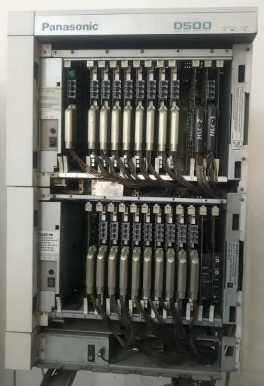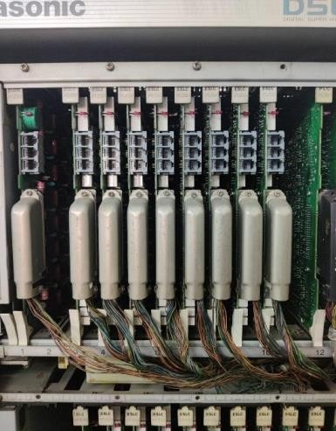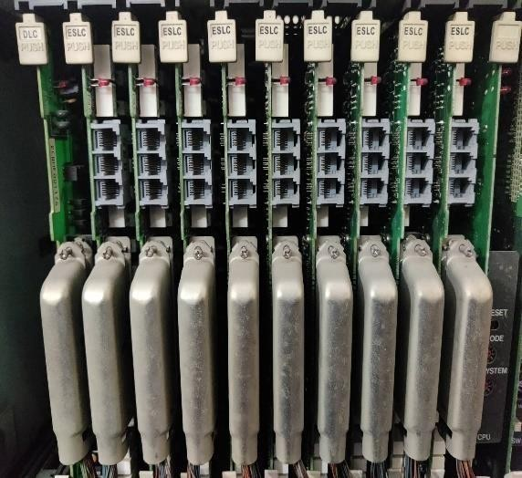

**(1) (2) (3)**

**Fig.1**: (1) Panasonic Digital Exchange; (2) ESLC (Upper Raw); (3) ESLC (Lower Raw)

# Distributor:

The distributor stocks MDF, IDF, and Fuse. MDF is for Main Distribution Feeder, and IDF stands for Internal Distribution Frame. The fuse protects the exchange against thunder or any other electrical disbalance.

The T&T line is connected to a contact outside of RUET that requires -50VDC. There are four ways to get in touch with people outside of the institution. Internal connectivity requires - 30VDC. The distribution cable or drop wire consists of some small wires.

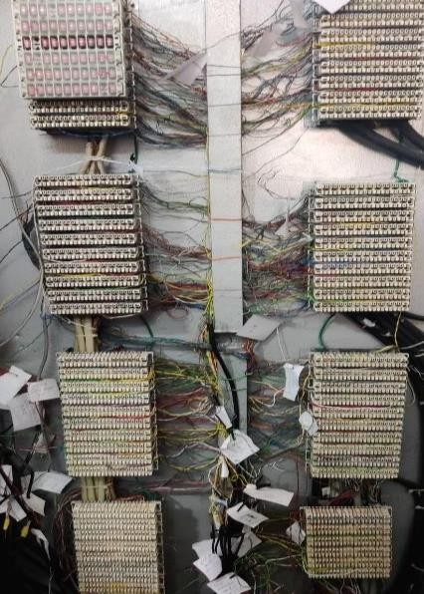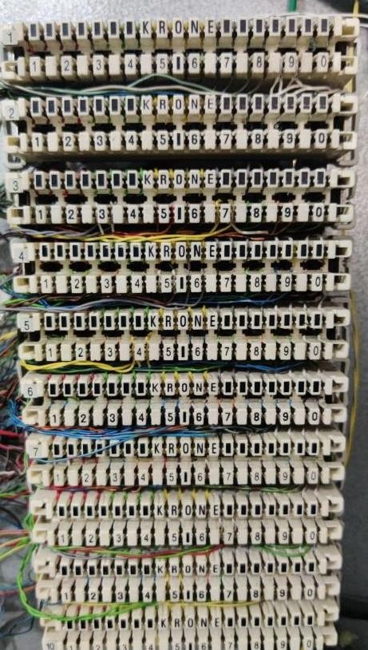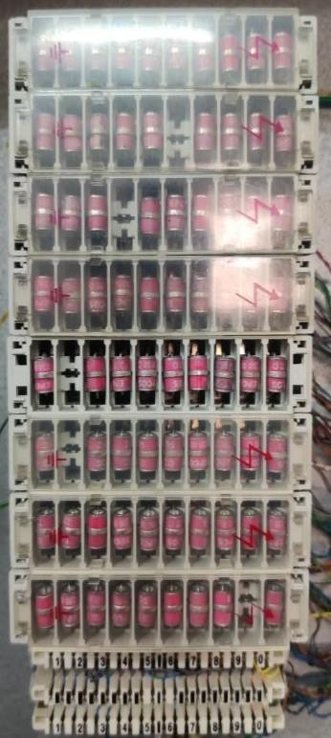

**Fig.4**: Distributor **Fig.5**: Internal Distribution Frame **Fig.6**: Distribution Fuse

# Discussion & Conclusion:

RUET PABX connects all of the officials via a local area network. Officials can speak confidentially and without incurring any costs. It can allow paid communication with RUET's external audience by using four lines at a low cost.

The PABX has a disaster recovery and reliability capability with some extensive features which are easy to maintenance. It ensures mobility and flexibility. A hosted PABX system has several advantages over a traditional phone system. It will assist you in saving money while enhancing efficiency and production inside a business.