**Experiment No. 01**

* 1. **Experiment Name**

To get familiar with Simulink.

* 1. **Objectives**
* To become accustomed with the simulation of power electronic circuits in the MATLAB/Simulink environment.
* Learn how to use Simulink to create and simulate a simple system model.
* Learn how to use Simulink's test and measurement tools for future projects and sessions.
  1. **Theory**
     1. **Simulink**

Simulink is an application that allows you to simulate signals and dynamic systems. Simulink explores two stages: model definition and model analysis. It includes an interactive graphical environment and a collection of customizable block libraries that allow you to design, simulate, implement, and test a wide range of time-varying systems such as communications, controls, signal processing, video processing, and image processing.

Simulink contains toolboxes for developing, simulating, and analyzing communication systems. In addition, source coding, channel coding, interleaving, analog and digital modulation, equalization, synchronization, and channel modeling are all possible with Simulink.

* + 1. **Simulink Library**

The Simulink Library Browser is the library where you can locate all the Simulink blocks. Simulink software contains a large library of functions that are often used in system modeling. These are some examples:

* Commonly Used Blocks
* Continuous
* Discontinuous
* Discrete
* Logic and Bit Operation
* Lookup Tables
* Math Operation
* Model Verification
* Mode-Wide Utilities
* Port & Subsystem
* Signal Attributes
* Signal Routing
* Sinks
* Sources
* User defined Functions
* Additional Math & Discrete
  + 1. **Common Block Library**
* Math Operation
* Continuous
* Port & Subsystem
* Signal Routing
* Sink
* Sources
  1. **Apparatus**
* MATLAB Simulink
  1. **Simulink Diagram**

Some major & basic mathematical operations of a few functions are operated via Simulink & are shown below,

* + 1. **Addition**

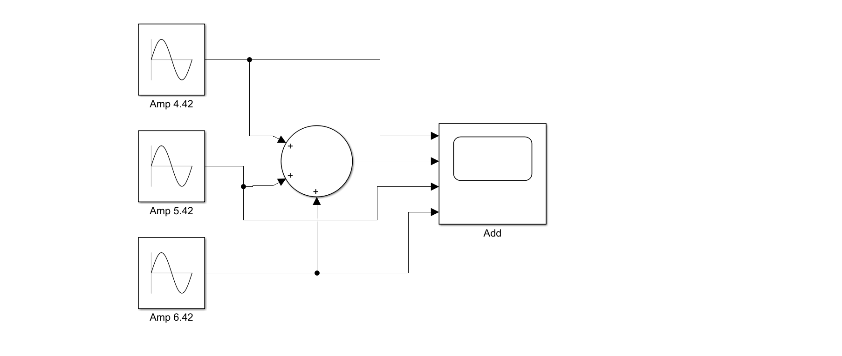

**Fig 1.1:** Block Diagram of adding three Sinusoidal inputs in Simulink.

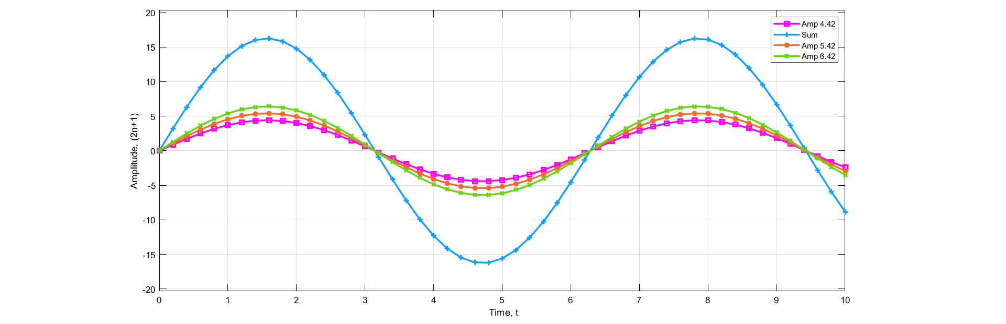

**Fig 1.2:** Input & Output plot of adding three sinusoidal inputs in Simulink.

* + 1. **Subtraction**

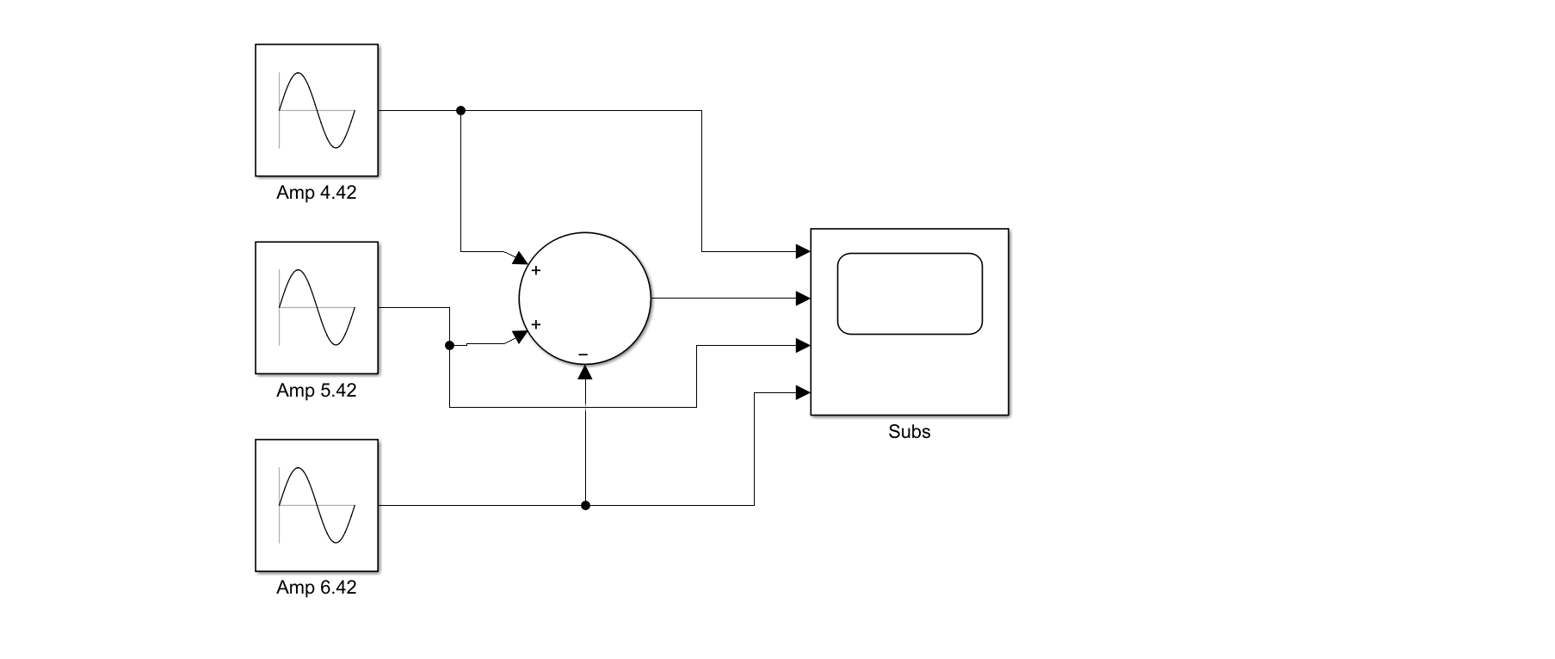

**Fig 1.3:** Block Diagram of subtracting three Sinusoidal inputs in Simulink.

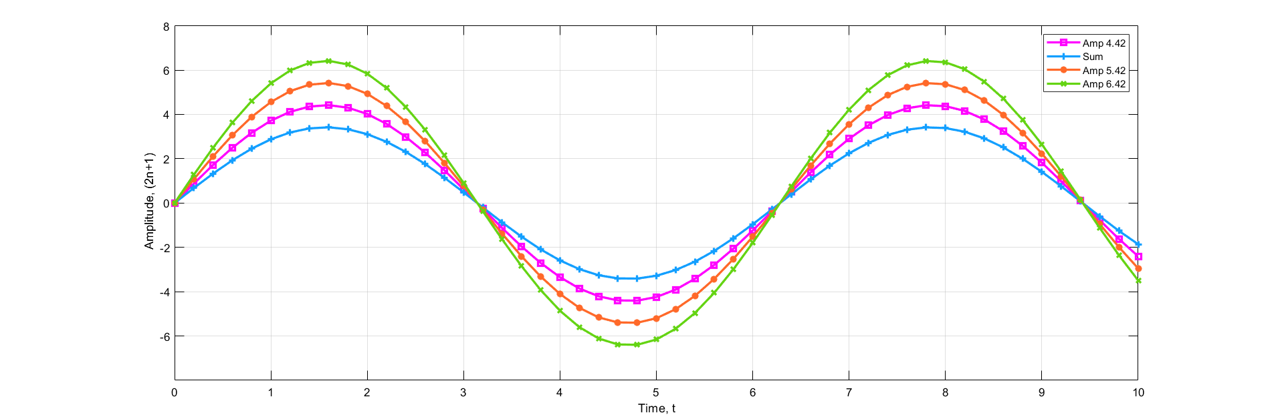

**Fig 1.4:** Input & Output plot of subtracting three sinusoidal inputs in Simulink.

* + 1. **Multiplication**

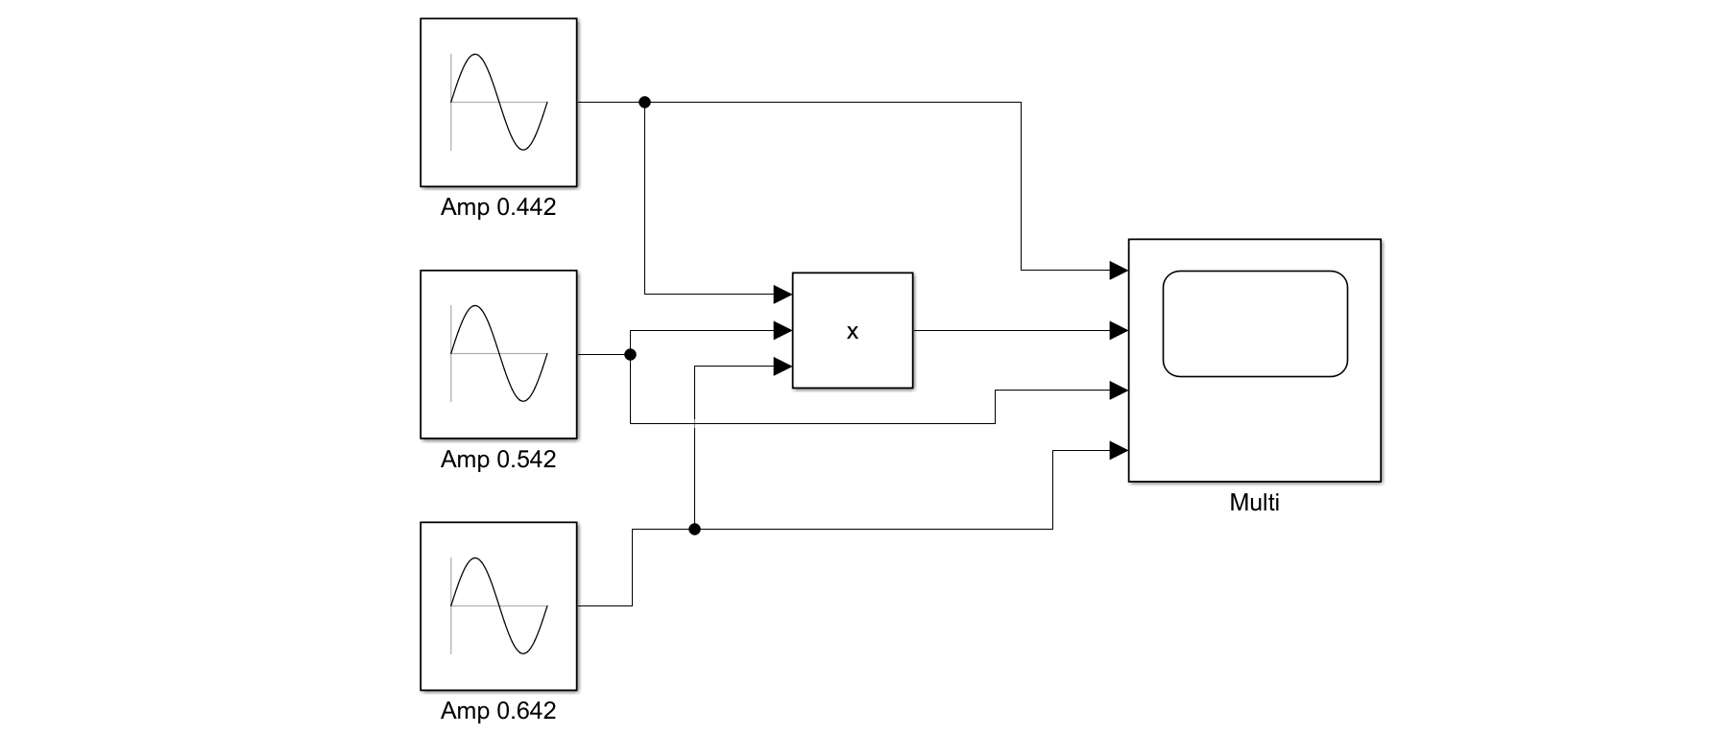

**Fig 1.5:** Block Diagram of multiplying three Sinusoidal inputs in Simulink.

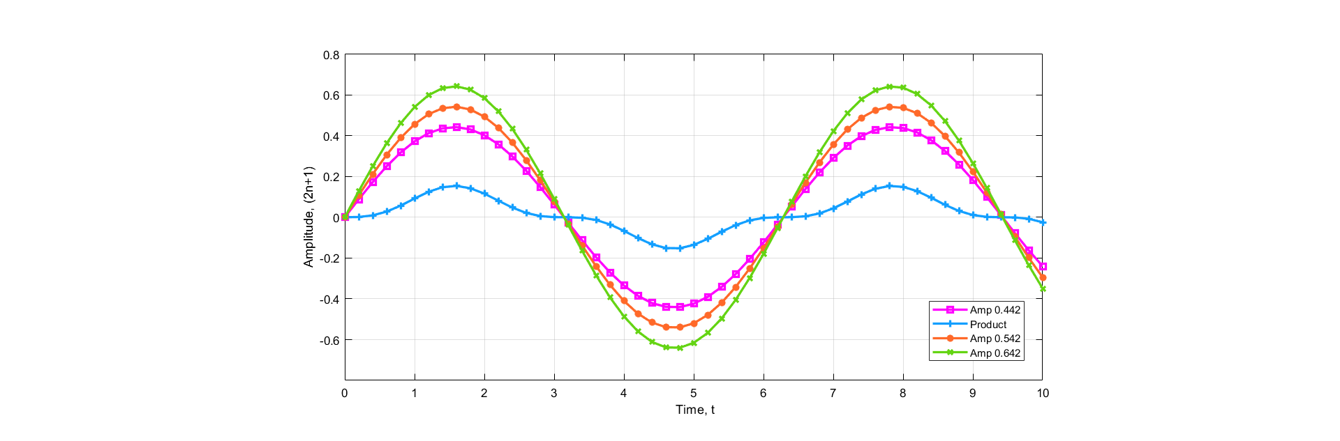

**Fig 1.6:** Input & Output plot of multiplying three sinusoidal inputs in Simulink.

* + 1. **Multiplication & Division**

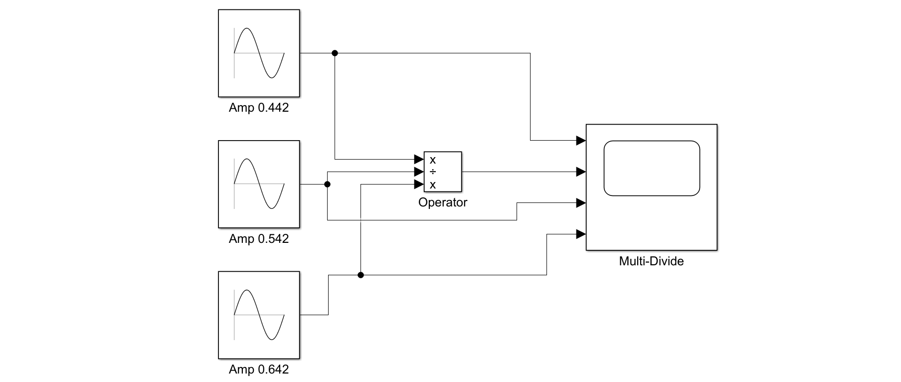

**Fig 1.7:** Block Diagram of multiplying-dividing three Sinusoidal inputs back and forth in Simulink.

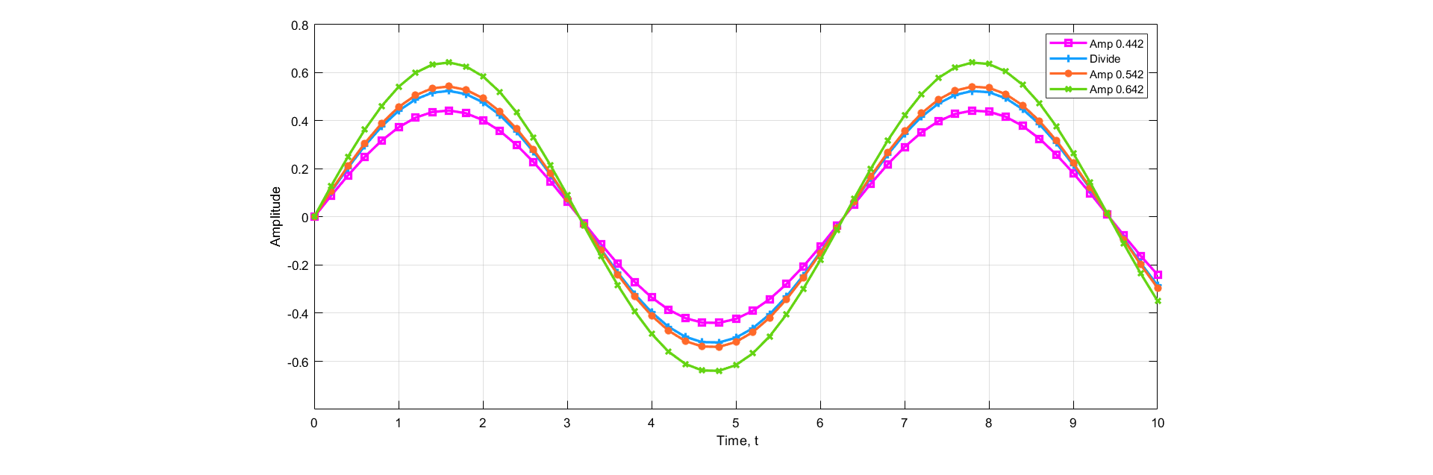

**Fig 1.6:** Input & Output plot of multiplying-dividing three Sinusoidal inputs back and forth in Simulink.

* 1. **Discussion & Conclusion**

In this experiment, amplitude was given in the form of (2n+1), where n was 1.71 for addition and subtraction operation and 0.171 for multiplication and division operation. When these amplitudes were given in the Simulink appropriate sinusoidal output was observed.

The primary goal of executing this experiment was to get familiar with Simulink. While doing so, necessary working procedure was also performed for various operations which gave a clearer idea about the software. Thus, the experiment was a success.