**Experiment No. 02**

* 1. **Experiment Name**

Analyzing the dynamics of a Physical System (Mechanical system)

* 1. **Objectives**
* To become accustomed with the simulation of physical system in the MATLAB/Simulink environment.
* Learn how to use Simulink to create and simulate a physical (mechanical) system model.
* Learn how to use Simulink's test and measurement tools for plotting transfer functions and input, output graph for a physical system.
  1. **Theory**

To analyze the dynamics of a Mechanical system, we considered a Mass spring damper system.

The mass-spring-damper model consists of discrete mass nodes distributed throughout an object and interconnected via a network of springs and dampers. This model is well-suited for modelling object with complex material properties such as nonlinearity and viscoelasticity.

In this system, a mess of ‘M’ is hanging along a spring of spring constant ‘K’. There

is a damper to limit the oscillation and the damping constant of ‘B’. So, here Y(t) is the displacement of the system which is the required output.

Here,

f(t)= Force;

u(t)= Input;

Y(t)= Displacement;

M= Mass;

K= Spring constant;

B= Damping constant.

From analyzing the circuit,

M ($\frac{d^{2}y(t)}{{dt}^{2}}$) + B ($\frac{dy(t)}{dt}$) + K (*y(t)*) = *u(t)……….* (1)

This can be rewritten as,

$\frac{d^{2}y(t)}{{dt}^{2}}$ = *u(t)( $\frac{1}{M}$) - $\frac{B}{M}$ ( $\frac{dy(t)}{dt}$) - $\frac{K}{M}$* (*y(t)*)

Taking Laplace Transform of equation (1)

Ms2Y*(s) +* BsY*(s) +* KY*(s) =* U*(s)……….* (2)

Thus, transfer function of the system,

$\frac{Y(s)}{U(s)}$ = *G(s)* = $\frac{1}{Ms^{2}+Bs+K}$

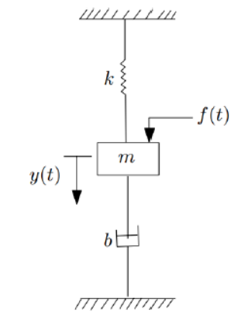

Fig 2.1: Mass spring damper system.

* 1. **Apparatus**
* Simulink
  1. **Simulink** 
     1. **Block Diagram**

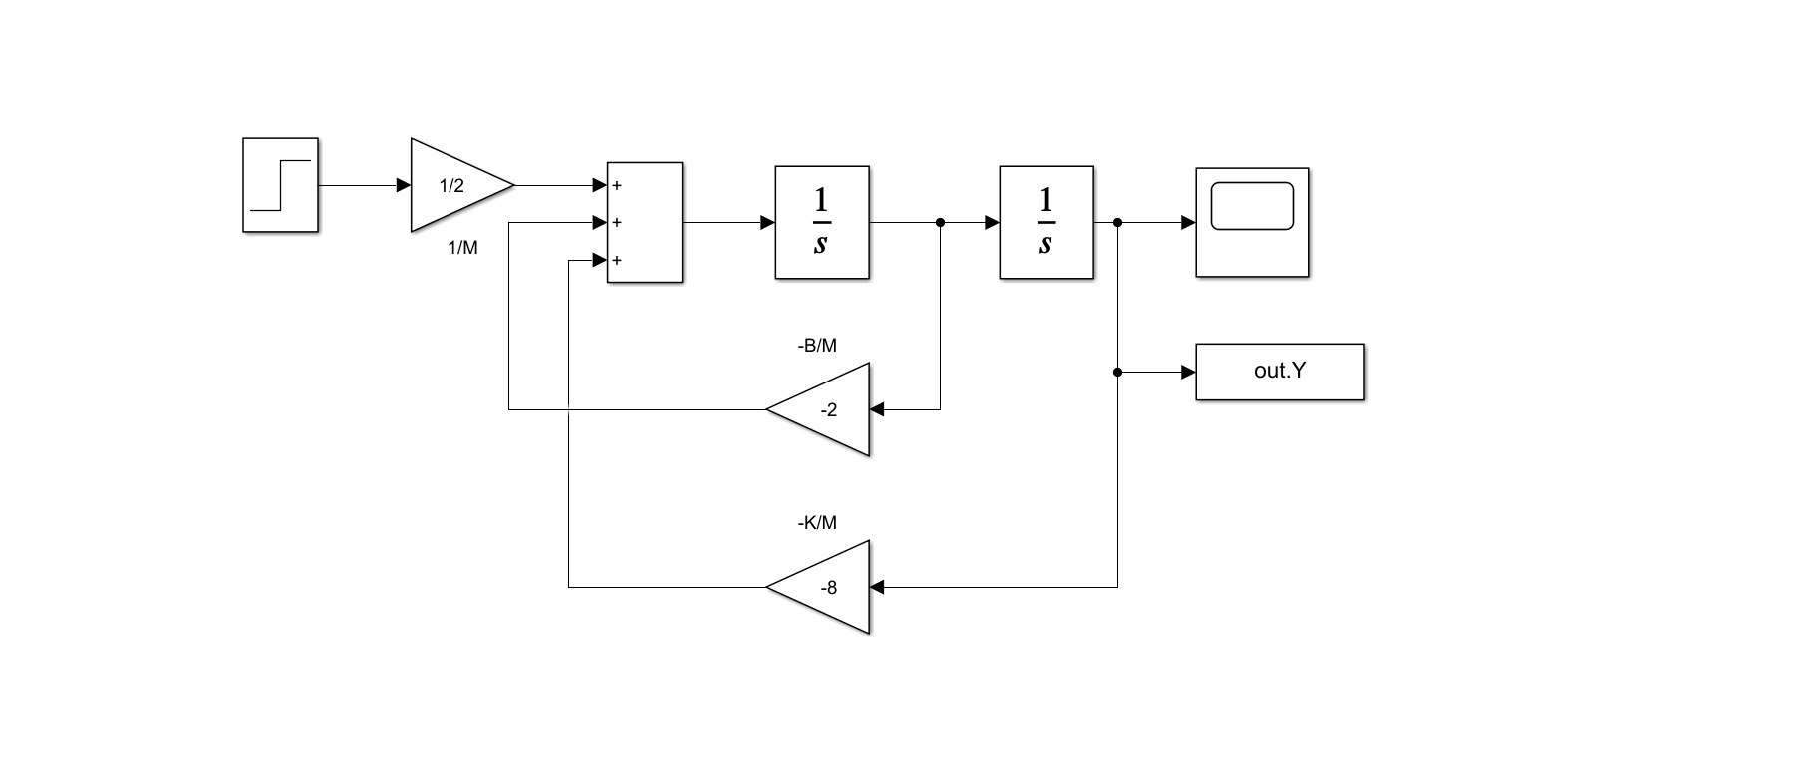

**Fig 2.2:** Block Diagram of a mass-spring-damper system in Simulink.

* + 1. **MATLAB Code**

clc

x = plot(out.Y);

disp(out.Y)

* + 1. **Displacement response**

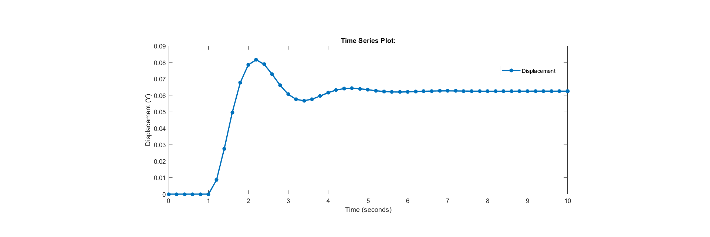

**Fig 2.3:** Input & Output plot of a mass-spring-damper system in Simulink.

* 1. **Discussion & Conclusion**

In this experiment we investigated the dynamics of a physical system, also known as mechanical system. For this experiment, we adapted to mass spring damper system, represented the dynamics using a block diagram, and generated an output for various constants or gains by using a unit step function as triggering.

We gave M=2kg, B=4Ns/m, and k=16Nm-1 as input for a sample simulation on Simulink. For a unit step function as input, the output was transient for 6 seconds before reaching steady state. This output was also plotted using MATLAB code. For this, we used ‘to work space’, defined it as ‘out.Y’ and later defined it as a variable in code and plotted out the graph.

As a result, the dynamics of a mass spring damper system were investigated by creating a block diagram in Simulink and commanding it with a MATLAB.m file.