**Experiment No. 03**

* 1. **Name of the Experiment**

Analyzing the dynamics of a first order system using RC circuit & RL circuit in MATLAB Simulink.

* 1. **Objectives**
* To gather knowledge about the characteristics of a first order system using RL & RC circuit.
* To know how to obtain the characteristics of RC & RL circuit using Simulink platform.
* To observe the characteristics curve through Simulink.
* To command the gains in MATLAB file and run them in designed block diagram in Simulink.
  1. **Theory**
     1. **RL Circuit**

Here, KVL is used in the RL circuit for current I and voltage V, and VL is seen across the inductor. While the circuit is closed, VR was dropped across the resistance.

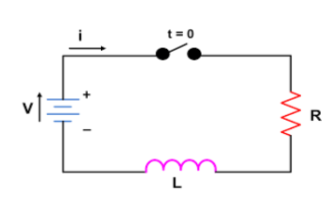

Fig.3.1. RL circuit

Here,

Voltage across resistance = VR

Voltage across inductor = VL

Inductance = L

Resistance = R

Current = i

So, Voltage across Resistance,

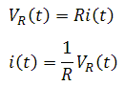

Voltage across inductor,

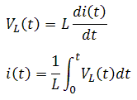

Applying KVL in the RL circuit,

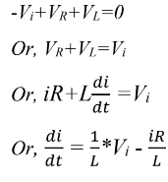

This equation defines the dynamics of the RL circuit.

* + 1. **RC Circuit**

KCL is used in the RC circuit for current I and voltage V, and VC is measured across the capacitor. While the circuit is closed, VR was dropped across the resistance.

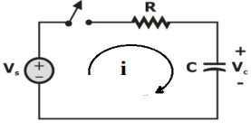

Fig.3.2. RC circuit

Here,

Voltage across resistance = VR

Voltage across capacitor = Vc

Inductance = L

Resistance = R

Current across capacitor = ic

So, Voltage across Resistance,



Voltage across capacitor,

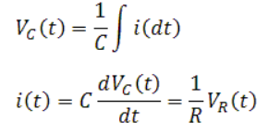

Applying KCL in the RC circuit,

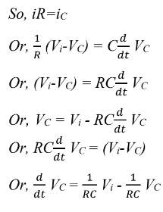

This equation defines the dynamics of a RC circuit.

* 1. **Apparatus**
* Simulink
* MATLAB

**3.5 Block Diagrams**

* **RL Circuit**

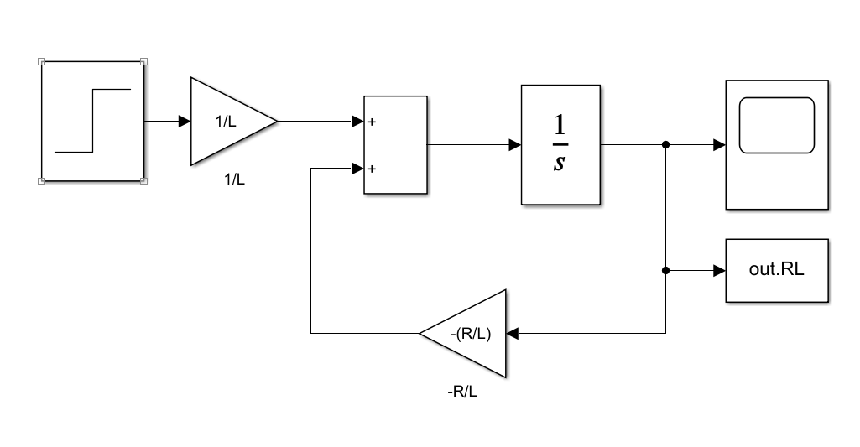

Fig 3.3: Block diagram for the RL circuit

* **RC Circuit**

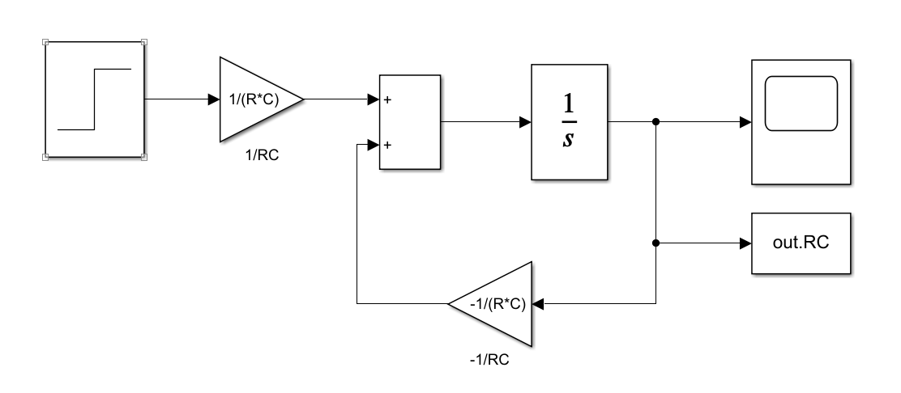

Fig 3.4: Block diagram for the RC circuit

* 1. **MATLAB**
* **RL Circuit Code**

clc;

R=input('R=');

L=input('L=');

disp(plot(out.RL));

ylabel('Inductor Current');

xlabel('Time');

title('RL Circuit');

**Command window**

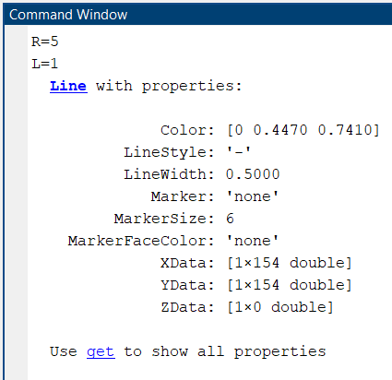

* **RC Circuit Code**

clc;

R=input('R=');

C=input('C=');

x=plot(out.RC);

disp(plot(out.RC));

ylabel('Capacitor Voltage');

xlabel('Time');

title('RC Circuit');

**Command Window**

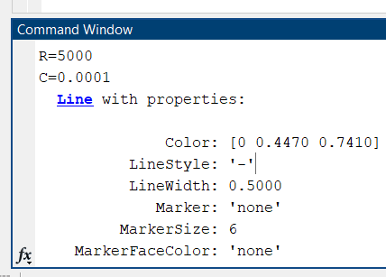

* 1. **Characteristics Curves**
* **RL Circuit**

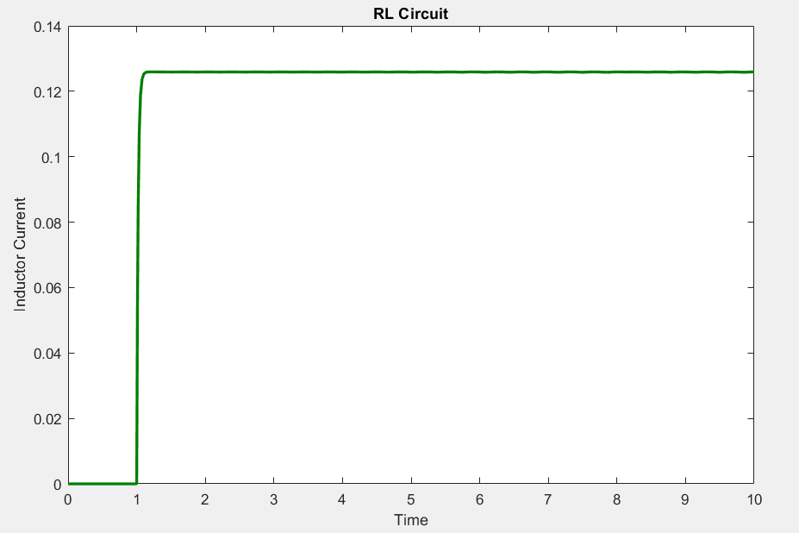

Fig 3.5: Inductor current vs time curve for the analysis of RL circuit

* **RC Circuit**

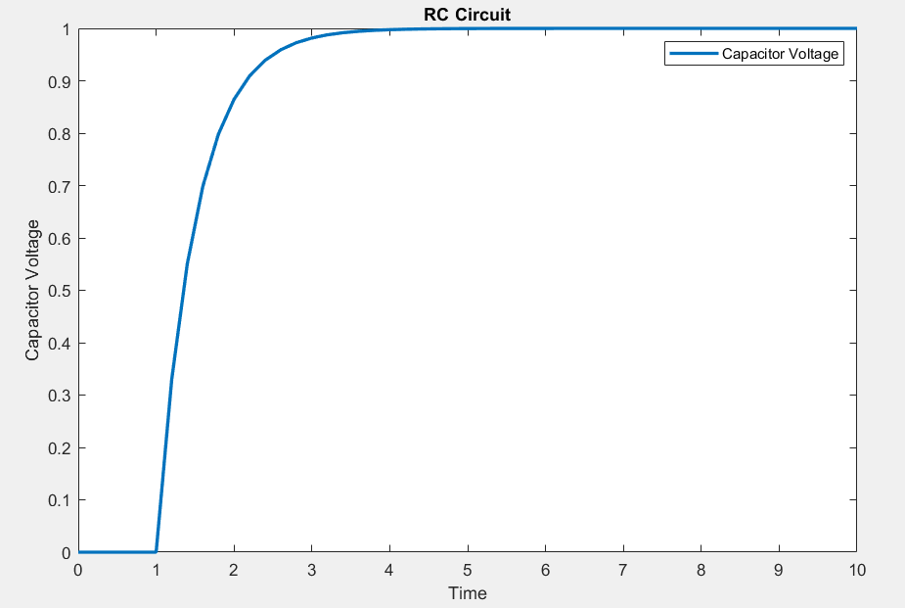

Fig 3.6: Capacitor voltage vs time curve for the analysis of RC circuit

* 1. **Discussion & Conclusion**

Here, we investigated the dynamics of a first order system in this experiment. As first order systems, the RL and RC circuits had one differential equations. It’s because they had only one energy storage device.

Again, the obtained equations are acting as dynamics of the system. The equation was then depicted in a block diagram and then the appropriate values were provided via MATLAB (.m file). A graphical depiction of the dynamics was plotted and used to test the dynamics using unity step input.

The main goal of this experiment was to learn about the properties of a RL & RC circuit and how to use MATLAB Simulink to identify such qualities. Various blocks from the Simulink library were utilized in the experiment, and their functionalities were observed by taking certain inputs and graphing the outputs. As a result, the experiment was a success