**Experiment No. 04**

**4**.**1** **Name of the Experiment**

Analyzing the dynamics of a second order system using DC motor in MATLAB Simulink.

* 1. **Objectives**
* To gather knowledge about the characteristics of a second order system using DC motor.
* To know how to obtain the characteristics of DC motor using Simulink platform.
* To observe the characteristics curve through Simulink.
* To command the gains in MATLAB file and run them in designed block diagram in Simulink.
  1. **Theory**

A motor is an electromechanical component that yields a displacement output for a voltage input, that is, a mechanical output generated by an electrical input. The transfer function of a separately excited DC motor can be obtained as follows:

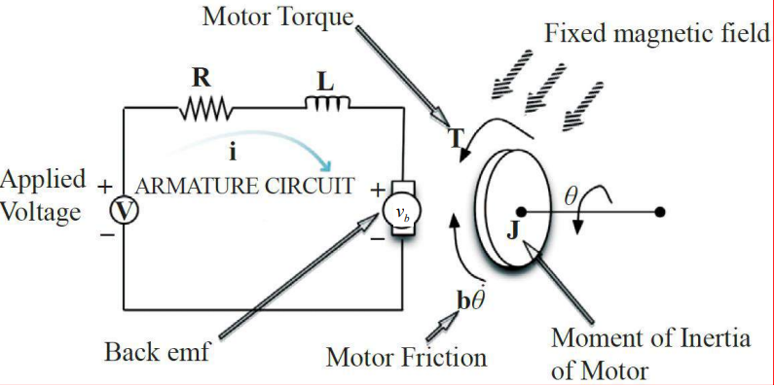

Fig 4.1: Simplified model of a separately excited DC motor

Here,

R = Armature resistance B = Viscous friction

L = Armature inductance τ(t) = Motor torque

ia = Armature current

Vi = Input voltage

Vb = Back emf

θ = Angular position

ω = Angular velocity

J = Rotor inertia

Back emf is proportional to angular velocity and motor torque is proportional to armature current.

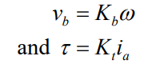

Now, from the armature circuit:

Since,



So,

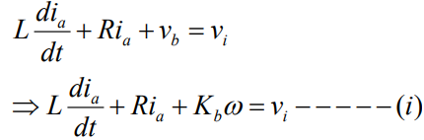

An equation describing the rotational motion of the inertial load:

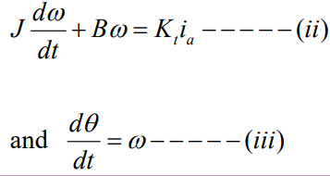

Now from equation (i) and (iii)

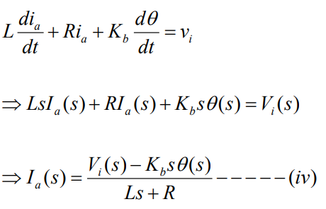

Now from equation (ii) and (iii)

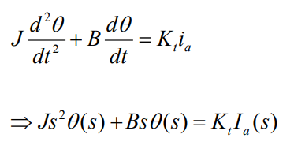

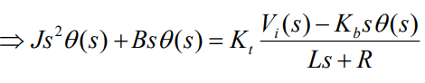

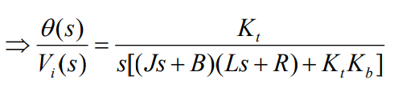

And,

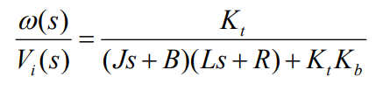

The linearized state-space equation for a system is as follows:

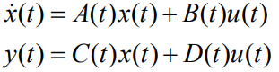

Here

A(t) = State matrix / system matrix / characteristics matrix

B(t) = Input matrix

C(t) = Output matrix

D(t) = Feedthrough matrix / direct transmission matrix

The dynamic equations of a DC motor are:

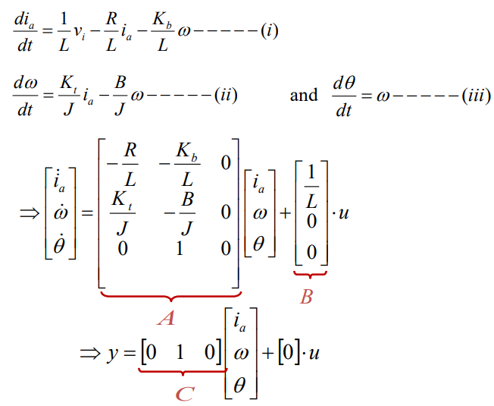

* 1. **Apparatus**
* Simulink

**4.5 Block Diagrams**

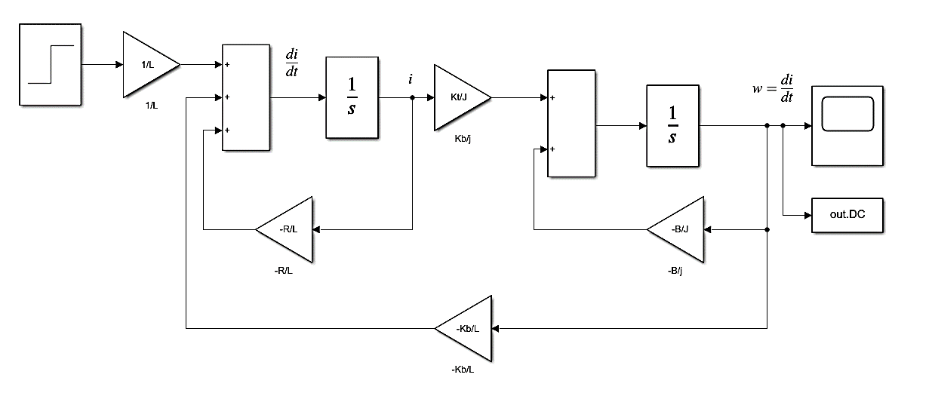

Fig 4.2: Block diagram for the analysis of characteristics of a DC motor

* 1. **MATLAB Code**

clc;

L=input('Enter value of L=');

Kt=input('Enter value of Kt=');

Kb=input('Enter value of Kb=');

J=input('Enter value of J=');

B=input('Enter value of B=');

R=input('Enter value of R=');

plot(out.DC);

ylabel('Angular Velocity');

xlabel('Time');

title('DC Motor');

* 1. **MATLAB Command window**

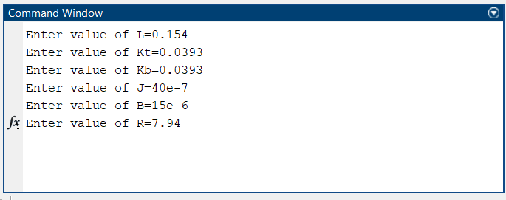

* 1. **Characteristics Curves**

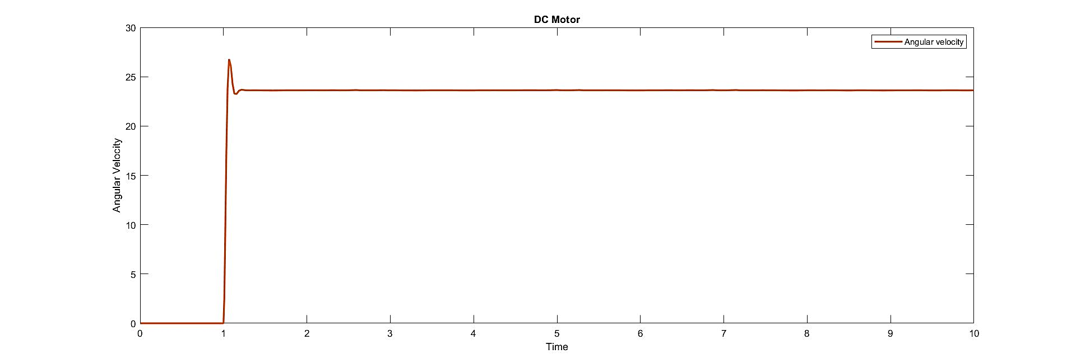

Fig 4.3: Angular velocity vs Time graph of the analysis of characteristics of a DC motor

* 1. **Discussion & Conclusion**

The properties of a second order system were examined using MATLAB Simulink in this experiment. As a second order system, the DC motor has two differential equations. Here, these two equations represent the DC motor's electrical circuit and mechanical portion.

These equations were then depicted using a block diagram and then the appropriate values were provided via MATLAB (.m file). A graphical depiction of the dynamics was plotted and used to test the dynamics using unity step input.

The main goal of this experiment was to learn about the properties of a DC motor and how to use MATLAB Simulink to identify such qualities. Various blocks from the Simulink library were utilized in the experiment, and their functionalities were observed by taking certain inputs and graphing the outputs. As a result, the experiment was a success.