**Experiment No. 05**

5.**1** **Name of the Experiment**

Formation of State-space, Transfer function and domain conversion using MATLAB

* 1. **Objectives**
* To gather knowledge about the formation of state-space using MATLAB
* To gather knowledge about the formation of transfer function using MATLAB
* To gather knowledge about the domain conversion using MATLAB
* To observe the command window for desired output
  1. **Theory**

**Transfer Function**

Under the assumption that all initial conditions are zero, the transfer function of a linear, time-invariant differential equation system is defined as the ratio of the Laplace transform of the output (response function) to the Laplace transform of the input (driving function).

The transfer function of a system is the ratio of the Laplace transformed output to the Laplace transformed input when all initial conditions are zero, or

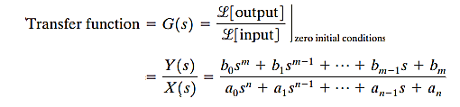

System dynamics can be represented by algebraic equations in ***S*** utilizing the concept of transfer function. If the highest power of ***S*** in the transfer function's denominator equals ***n***, the system is called an nth-order system.

The concept of the transfer function is only applicable to linear, time-invariant differential equation systems.

**State-space**

A dynamic system consisting of a finite number of lumped elements may be described by ordinary differential equations in which time is the independent variable.

An nth-order differential equation can be represented as a first-order vector-matrix differential equation using vector-matrix notation. The vector-matrix differential equation is a state equation if n elements of the vector constitute a collection of state variables.

The linearized state-space equation for a system is as follows:

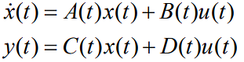

Where,

|  |  |
| --- | --- |
| A(t) = State matrix/ characteristics matrix; | B(t) = Input matrix; |
| C(t) = Output matrix; | D(t) = Feedthrough matrix |

* 1. **Apparatus**
* MATLAB
  1. **MATLAB Code**

clc

clear all

num = [1 1];

den = [1 2 5];

G = tf(num,den)

[A,B,C,D] = tf2ss(num,den);

sys = ss(A,B,C,D)

A = [1 -2;3 -1];

B = [0;1];

C = [1 0];

D = [0];

sys = ss(A,B,C,D)

[num,den] = ss2tf(A,B,C,D);

sys = tf(num2,den2)

* 1. **MATLAB Command window**



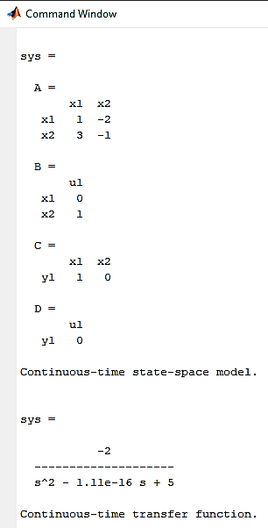

* 1. **Discussion & Conclusion**

MATLAB was used to create the state-space, transfer function, and domain conversion in this experiment. In this experiment, the transfer function and state-space were implemented on MATLAB using a ‘.m’ file, and the output was displayed in the command window.

The major goal of this experiment was to learn about the state-space transfer function and domain conversion, which is necessary in the development of a control system since the transfer function and state-space provide information about a system's reaction to any type of input.

We also learnt how to use MATLAB and determine the appropriate representation for this experiment. Thus, the experiment was completed effectively.