**Experiment No. 06**

**6**.**1** **Name of the Experiment**

Control the dynamics of a physical system (DC motor) using PID controller

* 1. **Objectives**
* To gather knowledge about the dynamics of a physical system
* To understand operation of a PID controller.
* To observe the command window for desired output.
  1. **Theory**

A PID controller is an instrument used in industrial control applications to regulate temperature, flow, pressure, speed and other process variables. PID (proportional integral derivative) controllers use a control loop feedback mechanism to control process variables and are the most accurate and stable controller.

Here, 'P' stands for proportional; 'I' stand for integral, and 'D' stand for derivative. It is the use of proportional, integral, and derivative expressions to regulate a system. It is a highly powerful controlling device since we can control a system even if we do not fully understand the system.

However, the downside of this system is that it is not optimal in the sense that a controller must be optimal, and it is not accurate. This sort of controller is used by more than half of all industries because it is simple to develop, regulate, and is inexpensive.

Now,

P = kP e(t) ; where kP is the proportional gain

I = kI ∫e(t)dt ; where kI is the integral gain

D = KD (𝑑/𝑑𝑡)(e(t)) ; where KD is the derivative gain

So, CPID (t) = kP e(t) + kI ∫e(t)dt + KD (𝑑/𝑑𝑡)(e(t))

* 1. **Apparatus**
* MATLAB
* Simulink
  1. **Block diagram**

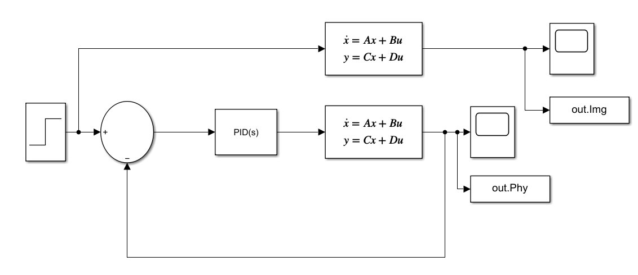

Fig 6.1: Block diagram of DC motor circuit with PID controller

* 1. **MATLAB Code**

clc;

L=input('Enter value of L=');

Kt=input('Enter value of Kt=');

Kb=input('Enter value of Kb=');

J=input('Enter value of J=');

B=input('Enter value of B=');

R=input('Enter value of R=');

A=[-R/L -Kb/L 0;Kt/J -B/J 0;0 1 0]

B=[1/L;0;0]

C=[0 1 0]

D=[0]

plot(out.Img);

ylabel('Angular Velocity(ras/sec)');

xlabel('Time(s)');

title('Dynamics of DC Motor')

plot(out.Phy);

ylabel('Angular Velocity(rad/sec)');

xlabel('Time(s)');

title('Dynamics of DC Motor');

* 1. **MATLAB Command window**

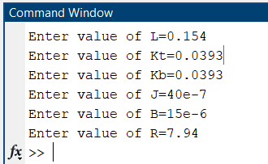

* 1. **Characteristics Curves**

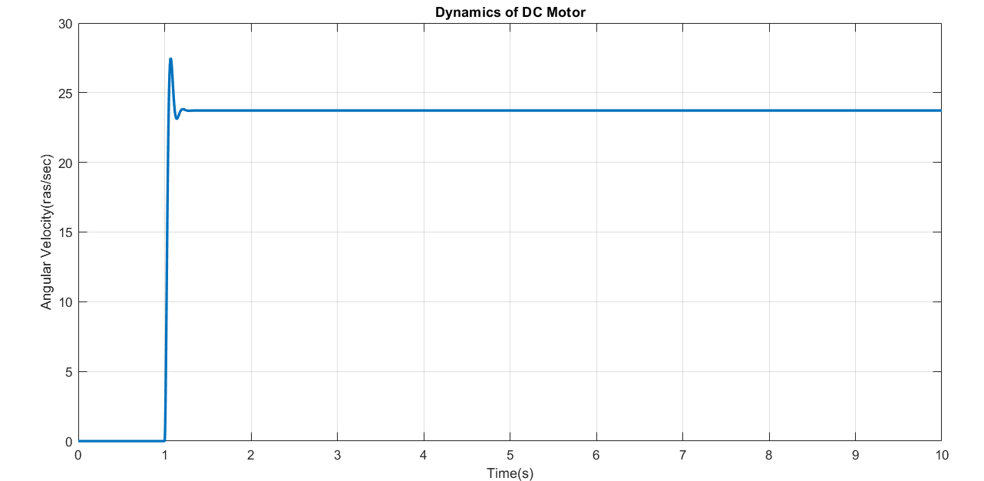

Fig 6.2. Angular velocity vs time graphical representation of DC motor circuit (Uncontrolled)

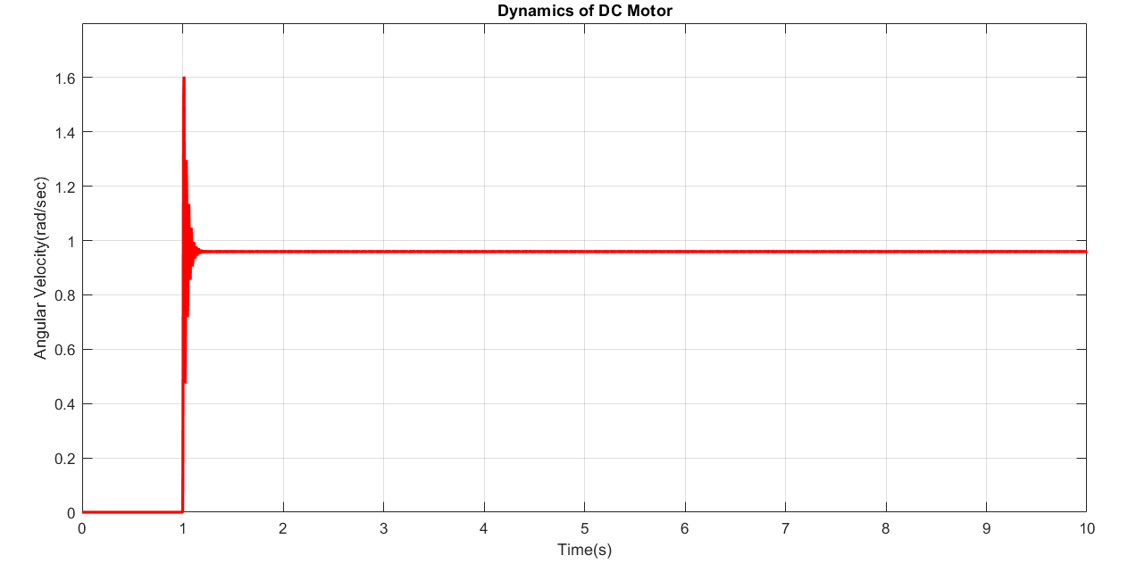

Fig 6.3. Angular velocity vs time graphical representation of DC motor circuit (P=1)

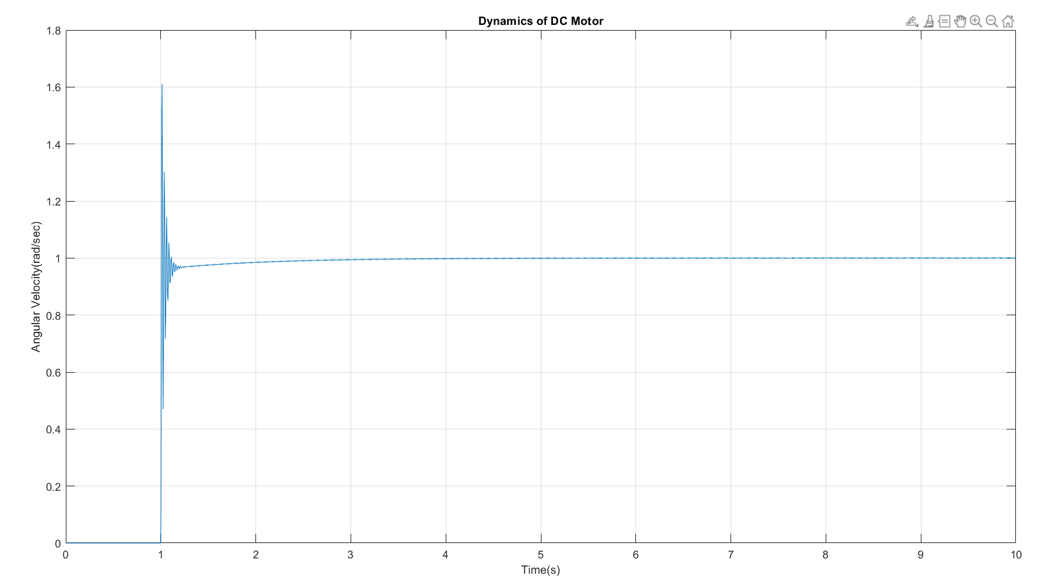

Fig 6.3. Angular velocity vs time graphical representation of DC motor circuit (P=1)

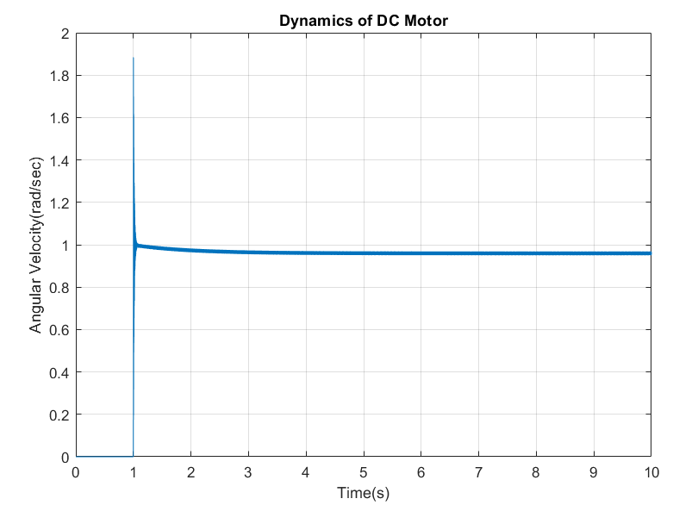

Fig 6.5. Angular velocity vs time graphical representation of DC motor circuit (P=1, D=1)

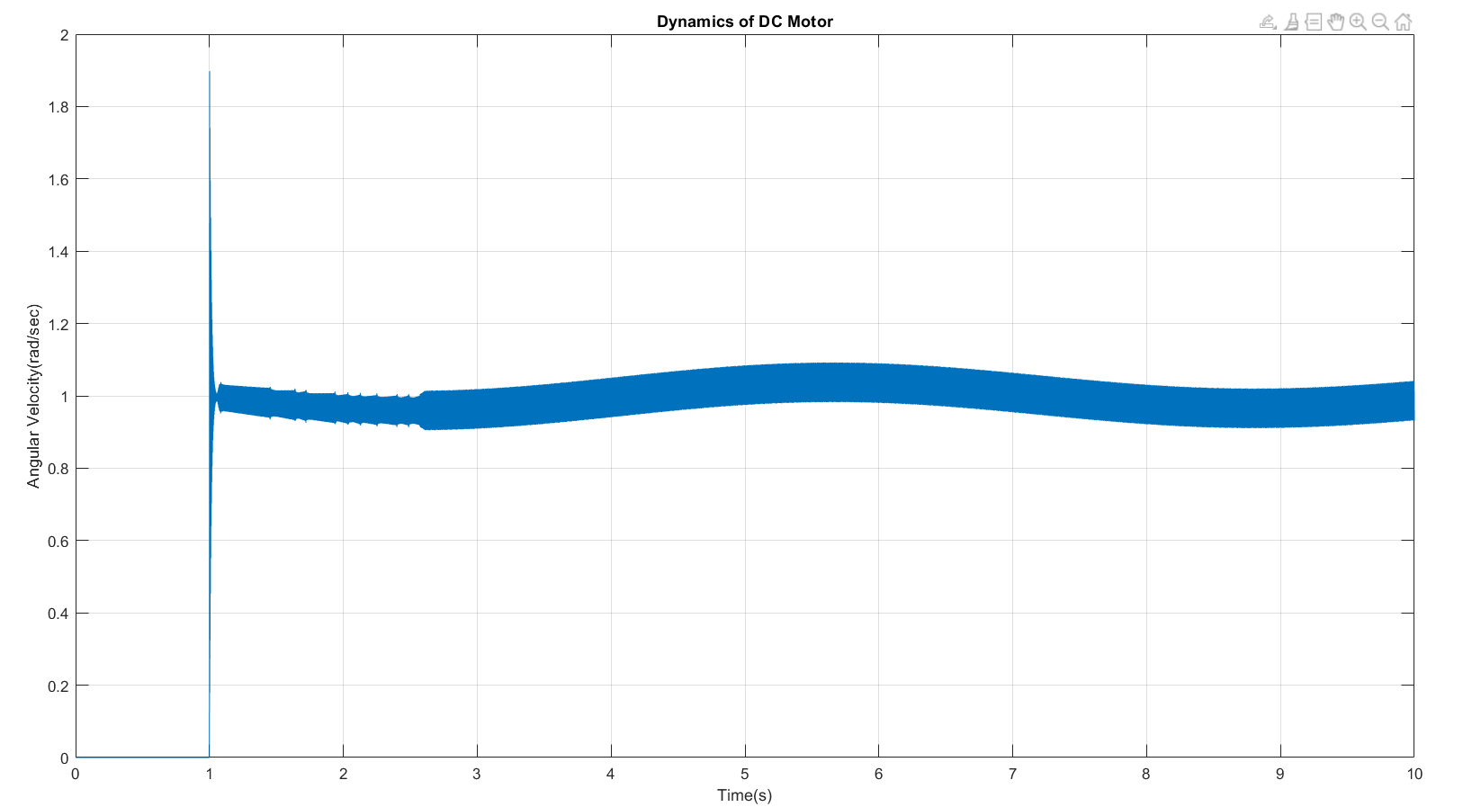

Fig 6.6. Angular velocity vs time graphical representation of DC motor circuit (I=1, D=1)

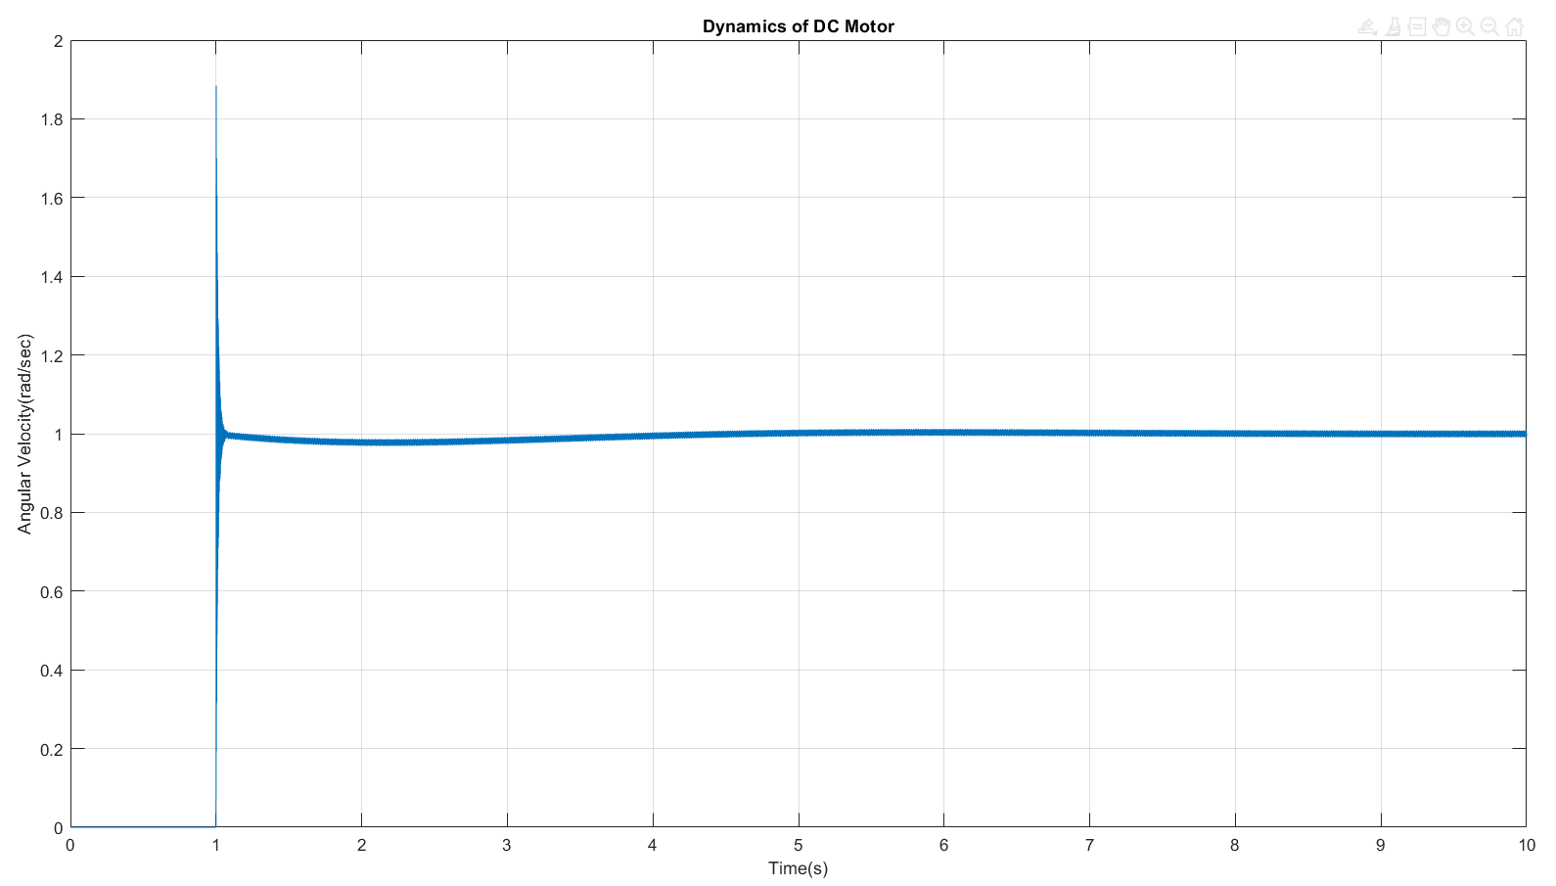

Fig 6.7. Angular velocity vs time graphical representation of DC motor circuit (P=1, I=1, D=1)

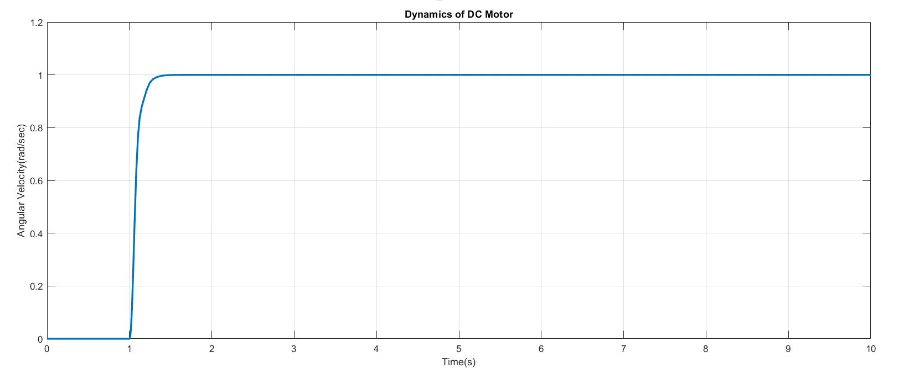

Fig 6.7. Angular velocity vs time graphical representation of DC motor circuit for tuned values of P=0.0009, I=0.5, D=0.000015

* 1. **Discussion & Conclusion**

In this experiment, a PID controller was used to regulate a DC motor using MATLAB Simulink. To regulate the DC motor, a step signal was used as input, and PID controllers such as proportional controller, proportional integral controller, proportional derivative controller, and proportional integral derivative controller were used.

When a proportional derivative controller was utilized, the variation between the characteristics without and with the controller was the greatest.

The main goal of this experiment was to use MATLAB Simulink to control a DC motor using a PID controller. A DC motor was controlled in this experiment by adjusting the values of P, I, and D of a PID controller, and the corresponding characteristics were seen by graphing the outputs in the figure window. As a result, the experiment was a success.