**Experiment No. 07**

7.**1** **Name of the Experiment**

Analysis the dynamics of a system using root locus

* 1. **Objectives**
* To gather knowledge about the dynamics of a system using root locus
* To understand the stability of a system using root locus
* To observe the command window for desired output
  1. **Theory**

Root locus is defined as the graphical method through which roots of a characteristic’s equation are plotted in s domain plane for different values of parameter. The root locus is a plot of the roots of the characteristic equation of the closed-loop system as a function of gain. The effect of adjusting the closed-loop gain of the system on its stability can be studied by root locus method of stability analysis.

Let’s consider, a negative feedback system with a closed loop transfer function of,

$$\frac{C(s)}{R(s)}=\frac{KG(s)}{1+G\left(s\right)H(s)}$$

Characteristic equation is $1+G\left(s\right)H\left(s\right)=0$

Or, $G\left(s\right)H\left(s\right)=-1$

The phase angle of $G\left(s\right)H\left(s\right)$ is

$∠G\left(s\right)H\left(s\right)= \tan^{-1}\left(\frac{0}{1}\right)=(2n+1)π$

The magnitude condition of $G\left(s\right)H\left(s\right)$ is

$$\left|G\left(s\right)H\left(s\right)\right|=1$$

From above equation, it can be concluded that,

* The angle condition is at point at which the angle of the open loop transfer function is odd multiple of 1800
* The magnitude condition is at that point at which the magnitude of open loop transfer function is one.

Advantages of root locus technique

* Root locus technique in control system is easy to implement as compared to other methods.
* With the help of root locus, we can easily predict the performance of the whole system.
* Root locus provides the better way to indicate the parameters.

For this experiment we take,

* 1. **Apparatus**
* MATLAB
  1. **MATLAB Code**

clc;

clear all;

num = [1];

den = [1 3 2 0];

G = tf(num,den)

rlocus(G)

* 1. **MATLAB Command window**

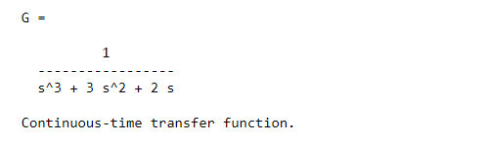

* 1. **Characteristics Curves**

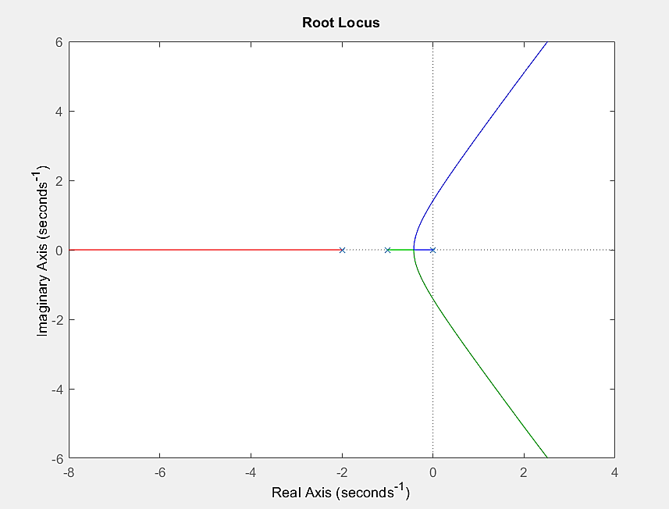

* 1. **Discussion & Conclusion**

In this experiment, frequency response analysis was performed in MATLAB using the root locus. Initially, some understanding of the root locus was acquired and then plotted using the systems' transfer function. As a result, it was relatively simple to predict the performance of the whole system and thus a better way to indicate the parameters was obtained. Here, all the functions worked correctly and the output shown was perfect. Hence, it can be said that the experiment was performed properly