**Experiment No. 08**

**8**.**1** **Name of the Experiment**

Analysis the dynamics of a system using bode plot

* 1. **Objectives**
* To gather knowledge about the dynamics of a system using bode plot
* To understand the stability of a system using bode plot
* To observe the command window for desired output
  1. **Theory**

Bode plot can be defined as the form of diagram that allows us to determine the absolute and relative stability of a system. A Bode diagram is made up of two graphs:

The first is a plot of the logarithm of a sinusoidal transfer function's magnitude, while the second is a plot of the phase angle. In the same graphic, both are plotted versus frequency on a logarithmic scale.

The magnitude of the open loop transfer function in dB is -

*M =* 20*log|G(jω)H(jω)|*

The phase angle of the open loop transfer function in degrees is -

Φ *= ∠G(jω)H(jω)*

In order to determine the stability of a system using Bode plot, following terms are

significant:

**Phase Margin (PM)**

The phase margin refers to the amount of phase, which can be increased or decreased without making the system unstable. It is usually expressed as a phase in degrees. Similarly, the greater the Phase Margin (PM), the greater will be the stability of the system.

**Gain Margin (CM)**

The greater the Gain Margin (GM), the greater the stability of the system. The gain margin refers to the amount of gain, which can be increased or decreased without making the system unstable.

**Phase crossover frequency (ω𝑐𝑝)**

The phase crossover frequency is the frequency at which the phase angle first reaches −180°

**Gain crossover frequency (ω𝑐𝑔)**

It refers to the frequency at which the magnitude curve cuts the zero dB axis in the bode plot.

**Conditions for stability:**

**1**. Stable system: PM → (+ve), GM → (+ve), ω𝑐𝑝 > ω𝑐𝑔

**2**. Marginally stable system: PM =0, GM =0, ω𝑐𝑝 = ω𝑐𝑔

**3**. Unstable system: PM → (-ve), GM → (-ve), ω𝑐𝑝 < ω𝑐𝑔

By analyzing the above terms and conditions, the absolute and relative stability of a system

can be determined.

For this experiment we take,

* 1. **Apparatus**
* MATLAB
  1. **MATLAB Code**

clc;

clear all;

num = [1];

den = [1 3 2 0];

G = tf(num,den)

bode(G),grid

* 1. **MATLAB Command window**

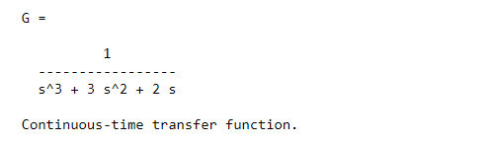

* 1. **Characteristics Curve**

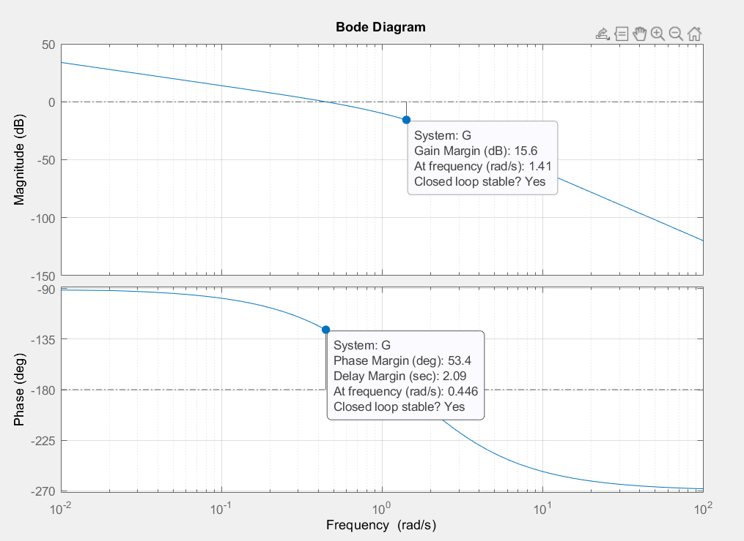

* 1. **Discussion & Conclusion**

In this experiment, frequency response analysis was performed in MATLAB using the Bode plot. Initially, some understanding of the Bode plot was acquired was then plotted using the systems' transfer function. By right-clicking on the figure and selecting the 'All stability margin' in ‘characteristics’ option, the necessary information for assessing stability was also retrieved directly. For the given the system, it was shown stable. As a result, it was relatively simple to plot the Bode diagram and calculate the system's stability from the diagram using MATLAB.