*Heaven’s light is our guide.*

*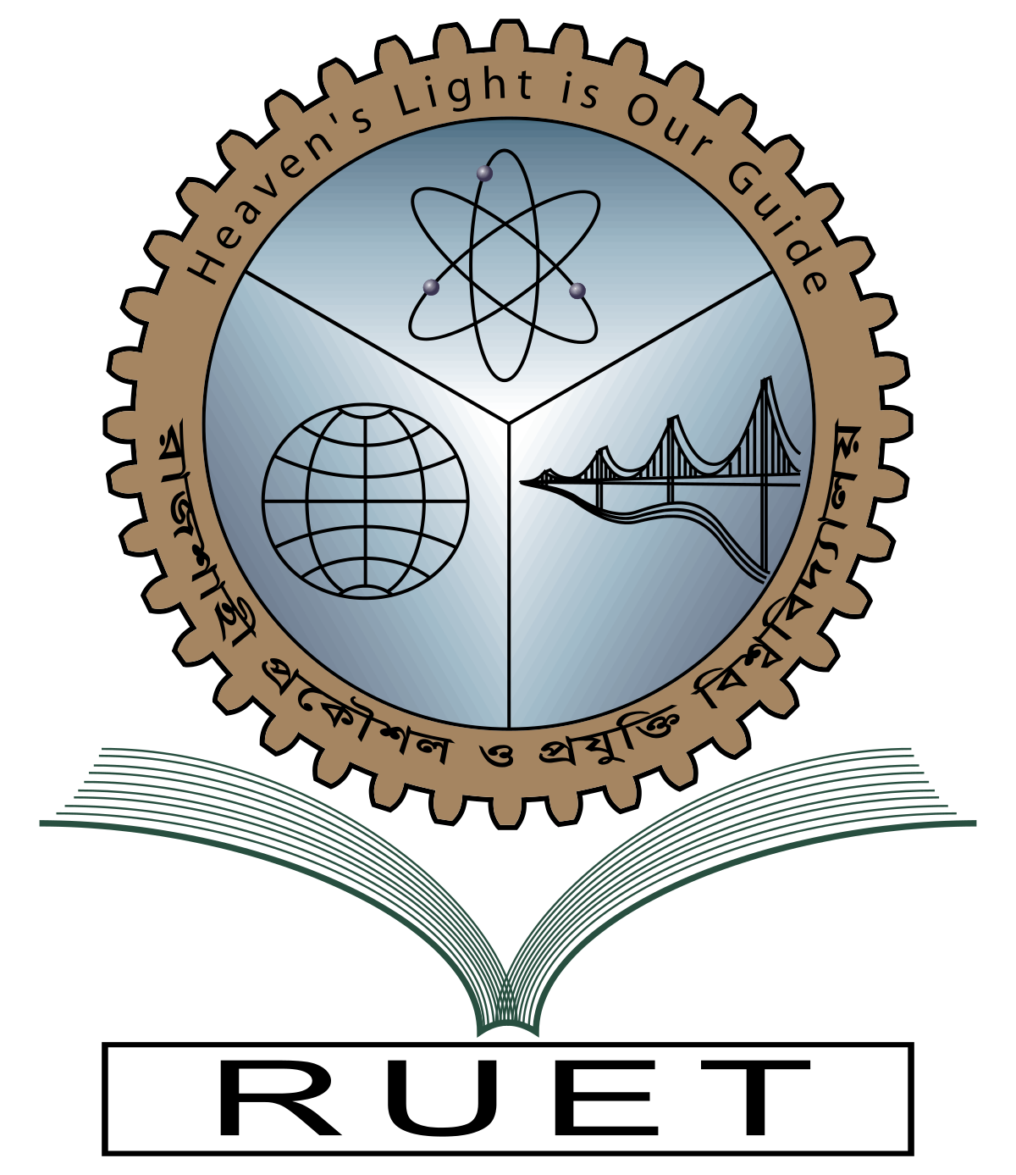***Rajshahi University of Engineering and Technology**

**

**Department of Electrical & Electronic Engineering**

**Course no.** EEE3106

**Course title:** Control System Sessional

**Experiment no.** 08

**Experiment name:** Analysis the dynamics of a system using bode plot

**Date of experiment:** July 17, 2022

**Date of submission:** July 31,2022

|  |  |
| --- | --- |
| **Submitted to:** | **Submitted by:** |
| **Dr. Md. Sohel Rana**  **Professor**  Dept. of Electrical & Electronic Engineering,  Rajshahi University of Engineering and Technology. | **Ashraf Al- Khalique**  **Roll:** 1801171  **Session:** 2018-2019  Dept. of Electrical & Electronic Engineering,  Rajshahi University of Engineering and Technology. |