**LAB EXPERIMENT # 6:** Solution of a linear system using ‘Gauss Seidel Method’.

**Name & Roll No.:** Ashraf Al- Khalique, 1801171 **Grade (20)**

**Registration Number:** 351

**Lab Section:** C-2

**6.1 Objectives**

* To determine Solution of a linear system using ‘Gauss Seidel Method’
* To understand the MATLAB implementation of the ‘Gauss Seidel Method’
* To analyze of results using different initial values and different ranges of error.
  1. **Theory**

The Gauss-Seidel method is an improvisation of the Jacobi method. In Jacobi method the value of the variables is not modified until next iteration, whereas in Gauss-Seidel method the value of the variables is modified as soon as new value is evaluated. For instance, in Jacobi method the value of xi(k) is not modified until the (k + 1)th iteration but in Gauss-Seidel method the value of xi(k) changes in in kth iteration only.\

Set of equations:

10x1+2x2-x3=27

-3x1-6x2+2x3= - 61.5

x1+x2+5x3= - 21.5

solving by Gauss Seidel Method,

x1(k+1) = (1/10) (27 – 2x2(k) + x3(k))

x2(k+1) = (1/−6) (-61.5 + 3x1(k) - 2x3(k))

x3(k+1) = (1/5) (-21.5 – x1(k-1) – x2(k+1))

By putting k=1,2, 3…. we can get the 1st ,2nd,3rd……. iterations. We put the roots from iteration 1 in 2nd iteration and get the root of 2nd iteration and so on until we can the same root from consecutive two iterations.

* 1. **Apparatus**
* MATLAB
  1. **Algorithm**

**Step: 1** Start

**Step: 2** Arrange the given linear equation system in diagonally dominating form.

**Step: 3** Read tolerable error (e)

**Step: 4** Convert the first equation to the first variable, the second equation to the second variable, and so on.

**Step: 5** Set initial guesses for x0, y0, z0 and so on

**Step: 6** Substitute value of x0, y0, z0 ... from step 5 in equation obtained in step 4 to calculate new values x1, y1, z1 and so on. Use x1, z0, u0 .... in second equation obtained from step 4 to calculate new value of y1. Similarly, use x1, y1, u0... to find new z1 and so on.

**Step: 7** If| x0 - x1| > e and | y0 - y1| > e and | z0 - z1| > e and so on then go to step 9

**Step: 8** Set x0=x1, y0=y1, z0=z1 and so on and go to step 6

**Step: 9** Print value of x1, y1, z1 and so on

**Step: 10** Stop.

* 1. **Pseudocode**

**Choose an initial guess to the solution x.**

**for k = 1,2**

**for i = 1,2…n**

**α=0**

**for j=1,2,….,i-1**

**α = α+βi,j xj(k)**

**end**

**for j=i+1,,n**

**α = α+βi,j xj(k-1)**

**end**

**xi(k) = (bi - α) / βi,i**

**end**

**Check convergence;**

**continue if necessary**

**end**

**6.6 MATLAB Code**

clc;

close all;

A= [10 2 -1;-3 -6 2;1 1 5]; %Coefficient matrix

B= [27;-61.5;-21.5]; %Source vector

I= [0;0;0]; %Initial guess

itr= input('No of Iteration: '); %no of iteration

e= input('No of tolerance: '); %tolerance

L=length(B);

z=zeros(L,1);

y=zeros(L,1); %for stopping criteria

for j=1:itr

for i=1:L

z(i)=(B(i)/A(i,i))-(A(i,[1:i-1,i+1:L])*I([1:i-1,i+1:L]))/A(i,i);

I(i)=z(i);

end

fprintf('\nIteration no %d',j)

z

if abs(y-z)<e

break

end

y = z

end

* 1. **MATLAB Output**

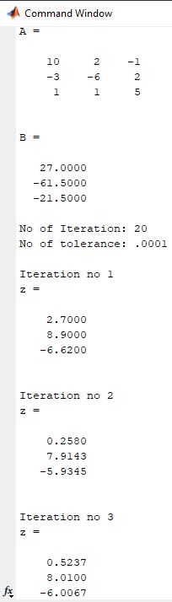

* 1. **Discussion & Analysis**

Numerical methods are strategies for formulating mathematical problems so that they can be solved using arithmetic operations. They invariably require a huge number of time-consuming arithmetic calculations. There are numerous ways for solving a linear system with multiple linear equations. One of them is the Gauss-Seidel method, which is an iterative procedure. In this case, each root's initial value is considered to be zero, and they are solved for zero. The root is then substituted in the next equation to solve the other roots, followed by another iteration, and so on.

* **How does the choice of the initial guess affect the solution?**

For the first iteration of the Gauss seidel method, the initial guess is all the root zero. It facilitates the next stage of iteration.

* **Discuss the convergence of the Gauss seidel method**

The Gauss seidel method convergence is substantially faster than the Jacobi methods. Because the discovered root in one equation is substituted in the following equation in the same iteration. As a result, the technique took only seven iterations to discover the root in the necessary tolerance, as opposed to Jacobi's ten iterations.