**LAB EXPERIMENT # 9:** **Find the value of a function at a given point from given data set using** **Newton’s forward interpolation method.**

**Name & Roll No.:** Ashraf Al- Khalique, 1801171 **Grade (20)**

**Registration Number:** 351

**Lab Section:** C-2

**9.1 Objectives**

* To find the value of a function at a given point from given data set using interpolation.
* To understand the excel implementation of the interpolation method
* To analyze of results using different values
  1. **Theory**

Interpolation is a method of fitting data points to represent a function's value. It has a variety of uses in engineering and research, such as constructing new data points within the range of a discrete data set of existing data points or determining a formula of the function that will pass from the given set of points (x,y).

Newton's forward interpolation is a polynomial interpolation which depends on the initial value and degrees of Newton's forward operator. The degree of polynomial fitted is one less than the number of data points. This type of interpolation is only used for equally spaced data points.

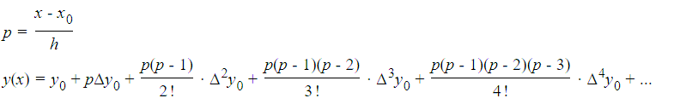

* 1. **Apparatus**
* MATLAB
  1. **Algorithm**

**Step: 1** Start

**Step: 2** Make a table for x and y to find *y = f(x)*

**Step: 3** Determine *Δy, Δ2y, Δ3y, Δ4y, Δ5y, Δ6y from* the table

**Step: 4** Determine ‘h’ using equation, *h = (x0 – x1)*

**Step: 5** Determine ‘p’ using equation, *h = {(x – x0)/h}*

**Step: 6** Calculate *y = f(x) = y0 + pΔy0 +p(P−1)2!Δ2y0 +p(p−1)(P−2)3!Δ3y0 + ⋯*

**Step: 7** Display the value of y

**Step: 8** Stop

* 1. **Excel Output**

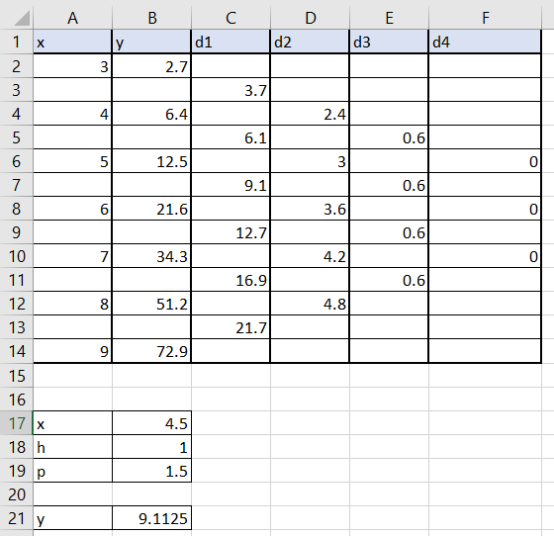

* 1. **Function & result**

*x =***B18**

*h =* **A4-A2**

*p =***(B18-A2)/B19**

*y =* **B2+(B20*C3)+(((B20*(B20-1))/2)*D4)+(((B20*(B20-1)*(B20-**

**2))/6)*E5)+(((B20*(B20-1)*(B20-2)*(B20-3))/24)*F6)+(((B20*(B20-1)*(B20-2)*(B20-**

**3)*(B20-4))/120)*G7)+(((B20*(B20-1)*(B20-2)*(B20-3)*(B20-4)*(B20-5))/720)*H8)**

At, ***x*** = 2.2,

***y*** = 5.222387

* 1. **Discussion & Analysis**

Using the formula of newton’s forward interpolation method, we take the initial values of each difference and get the approximated value at a data point. In this experiment, we used Microsoft Excel to implement the Newton forward interpolation method and examined the results.

We started by determining the differences between the data sets and then the differences between the differences. Then, using the Newton forward difference interpolation procedure, we calculated the value of 'y' at the position 'x = 2.2'.