**LAB EXPERIMENT # 11:** **Study of numerical differentiation (Euler’s Differential**

**Equation)**

**Name & Roll No.:** Ashraf Al- Khalique, 1801171 **Grade (20)**

**Registration Number:** 351

**Lab Section:** C-2

**11.1 Objectives**

* To understand the numerical differentiation method and its MATLAB implementation
* To understand Euler’s method of differentiation method and its MATLAB implementation
* To analyze of results using different values
  1. **Theory**

Conventional differentiation is difficult to solve, especially for large amounts of data such as data engineering. As a result, numerical differentiation is applied. The derivative is found using a simple algebraic formula in this numerical differentiation method. Numerical differentiation is the process of finding the numerical value of a derivative of a given function at a given point.

The Euler technique (also known as the forward Euler method) is a first-order numerical procedure for solving ordinary differential equations (ODEs) with a given initial value in mathematics and computing science. It is the simplest Runge-Kutta method and the most fundamental explicit method for numerical integration of ordinary differential equations.

For this experiment, given equation is,

$$\frac{dy}{dx}= -xy$$

And, *y*(0) = 1; *x* = 0:0.25; *h* = 0.05

* 1. **Apparatus**
* MATLAB
  1. **Algorithm**

**Step: 1** Start

**Step: 2** Define function

**Step: 3** Calculate the values of *x0*, *y0*, *h*, *s* = 0, and *xn*

The initial conditions are *x0* and *y0* in this case, *h* denotes the interval, while *xn* is the needed value.

**Step: 4** Determine ‘*n*’ using equation, *n = x/h*

**Step: 5** Calculate the value of *x(i)*

**Step: 6** Calculate the value of *y(i)* and *y(i +* 1*),* where *y(i) = y(i) + h*f(x,y)*

**Step: 7** Display the value of *x(i), y(i+*1*)*

**Step: 8** Stop

* 1. **Pseudocode**

Define function

input x0, h, y0

n = x/h

for i=1:n+1

x(i)=0;

x(i)=x(i)+h;

end

for i=1:n

y(i);

y(i+1)= y(i)+h*(f(i,i));

end

D=[x' y']

* 1. **MATLAB Code**

clc;

clear all;

f=@(x,y) (-x)*y

x=0.25;

h=0.05;

n=x/h;

x=zeros(1,n+1);

x(1)=0;

for i=1:n+1

x(i)=0

x(i)=x(i)+h;

end

y=zeros(1,n);

y(1)=1;

for i=1:n

y(i);

y(i+1)=y(i)+(h*f(i,i));

end

D = [x' y']

* 1. **MATLAB Output**

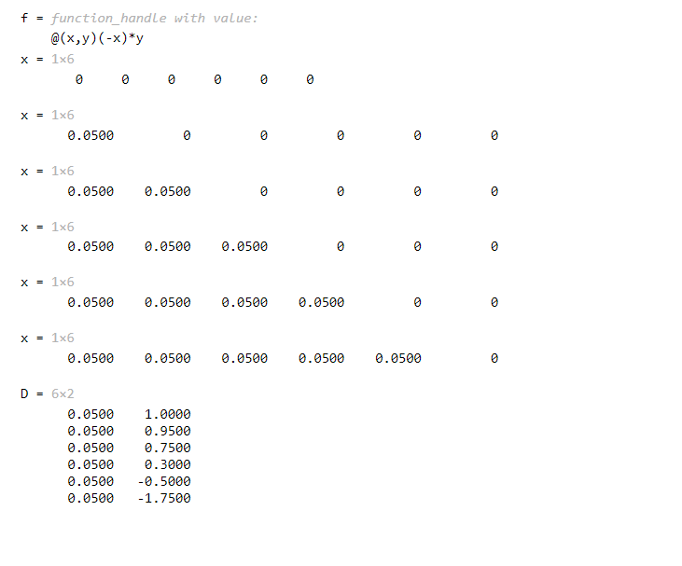

* 1. **Discussion & Analysis**

In this experiment, Euler's approach to solve the value of *'y'* from a given differential equation for a particular function and conditions. Here, the initial value of *‘y’* and *‘x’* is given. Thus, we solved *'y'* for the corresponding value of *'x'* and created a table for the value of *'y'* for the corresponding '*x'*.

Thus, the experiment was done was successfully and MATLAB implementation of the method was carried out accordingly.