*Heaven’s light is our guide.*

*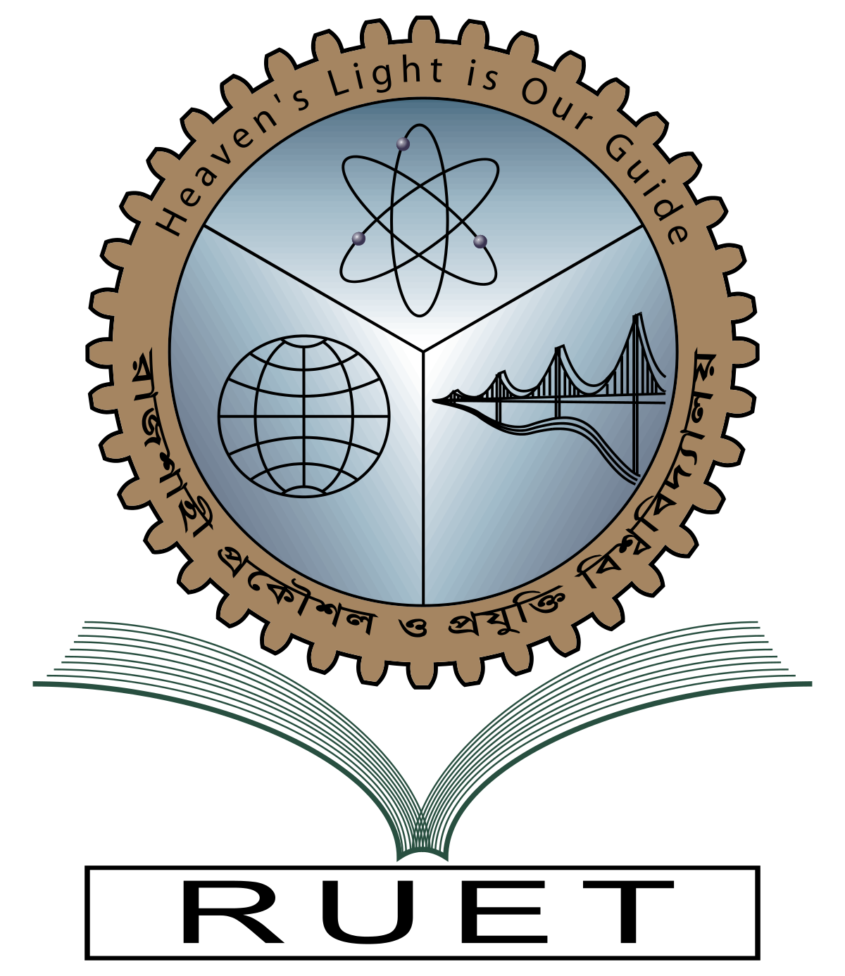***Rajshahi University of Engineering and Technology**

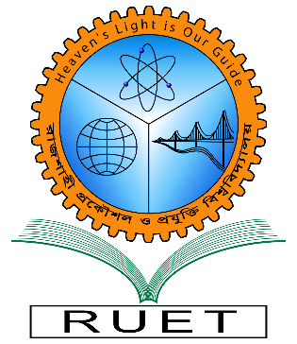

**Department of Electrical & Electronic Engineering**

**Course no.** EEE3110

**Course title:** Computational Methods in Electrical Engineering Sessional

**Experiment no.** 10

**Experiment name:** Study of numerical integration,

(i) Trapezoidal rule (ii) Simpson’s rule

**Date of experiment:** July 25, 2022

**Date of submission:** August 07,2022

|  |  |
| --- | --- |
| **Submitted to:** | **Submitted by:** |
| **Dr. Md. Masud Rana**  **Professor**  Dept. of Electrical & Electronic Engineering,  Rajshahi University of Engineering and Technology. | **Ashraf Al- Khalique**  **Roll:** 1801171  **Session:** 2018-2019  Dept. of Electrical & Electronic Engineering,  Rajshahi University of Engineering and Technology. |