*Heaven’s light is our guide.*

*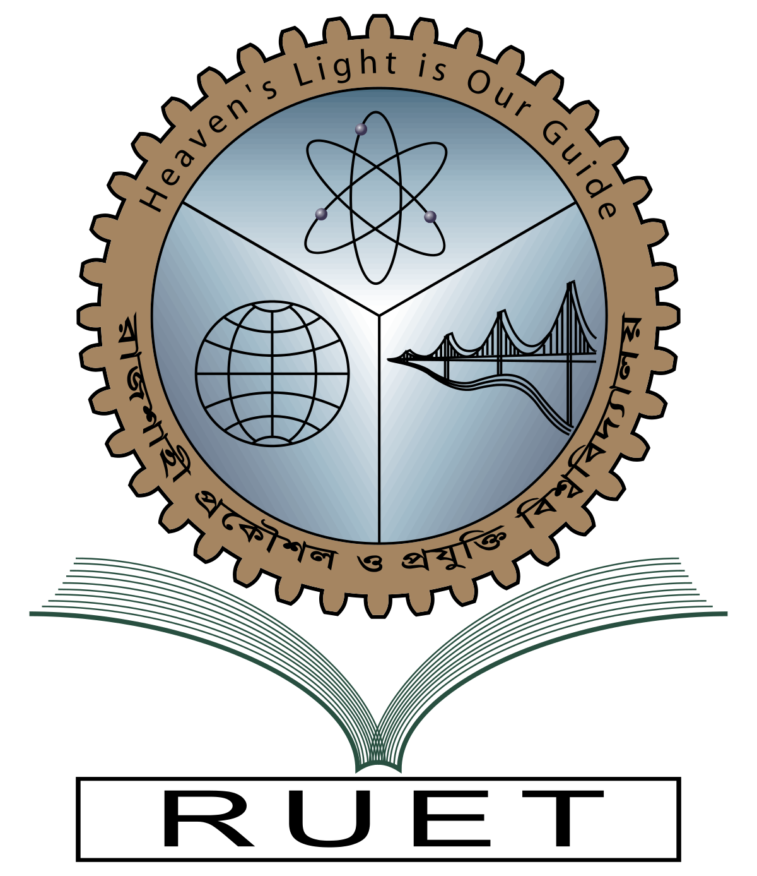***Rajshahi University of Engineering and Technology**

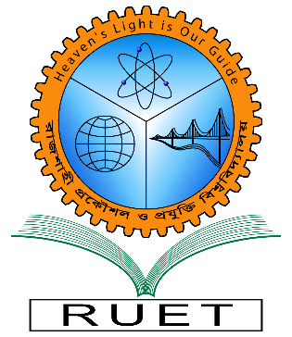

**Department of Electrical & Electronic Engineering**

**Course no.** EEE3100

**Course title:** Electronic Shop Practice

**Experiment no.** 03

**Experiment name:** Fault finding and Troubleshooting of a project board

**Date of experiment:**  , 2022.

**Date of submission:**  , 2022.

|  |  |
| --- | --- |
| **Submitted to:** | **Submitted by:** |
| **Sunjidah Hossain**  **Lecturer**  Dept. of Electrical & Electronic Engineering,  Rajshahi University of Engineering and Technology. | **Md. Mushfiqur Rahman Sagor**  **Roll:** 1801172  **Session:** 2018-2019  Dept. of Electrical & Electronic Engineering,  Rajshahi University of Engineering and Technology. |