*Heaven’s light is our guide.*

*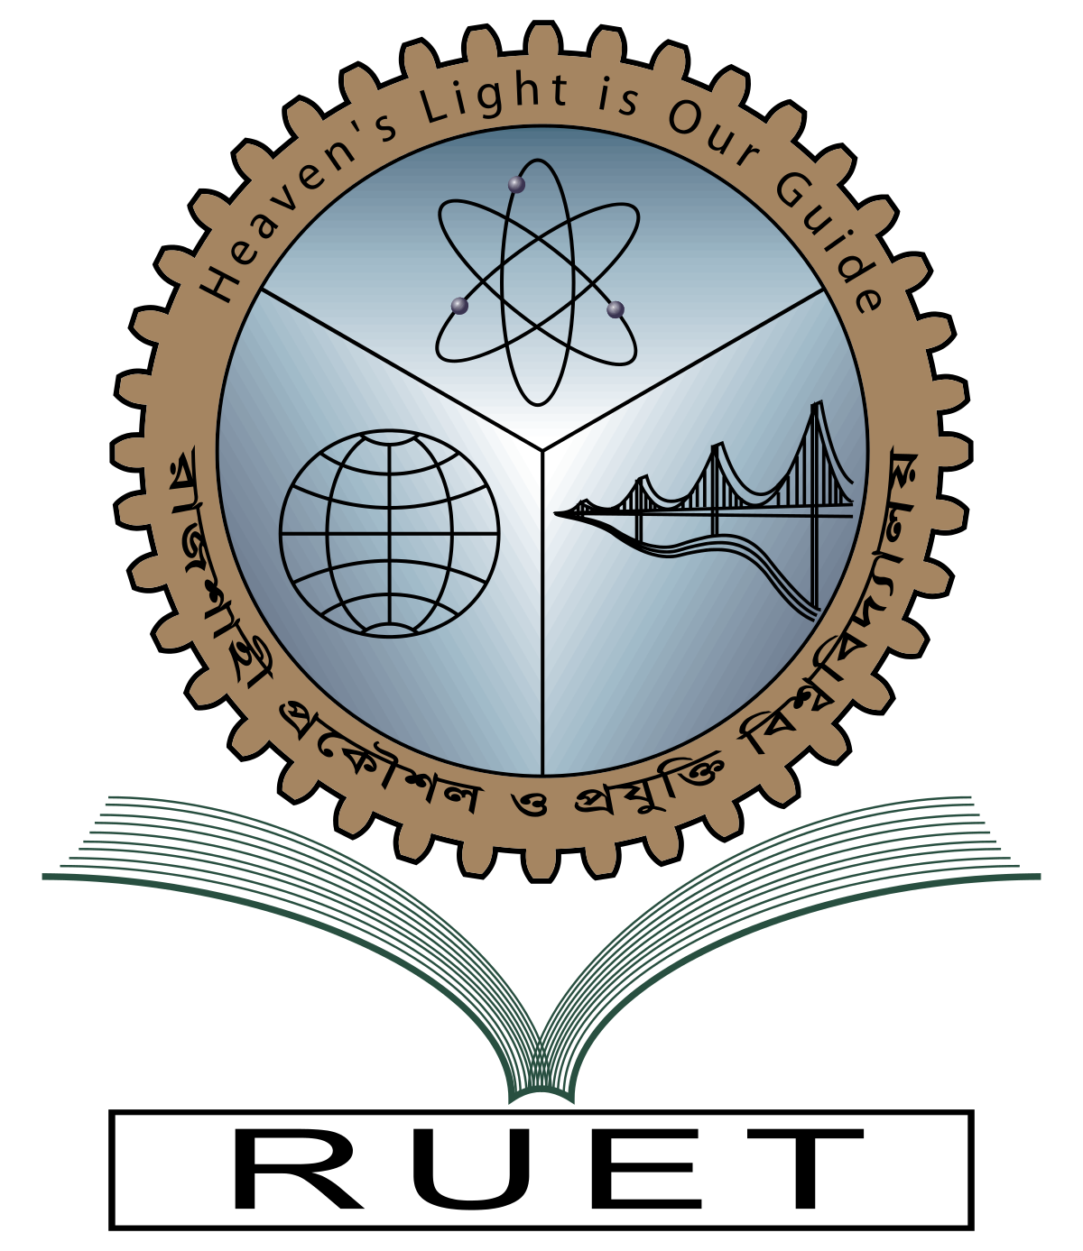***Rajshahi University of Engineering and Technology**

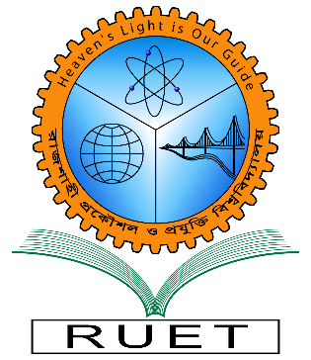

**Department of Electrical & Electronic Engineering**

**Course no.** EEE3218

**Course title:** Communication Engineering II Sessional

**Experiment no.** 03

**Experiment name:** Experimental study of frequency modulation and demodulation

**Date of experiment:** December 13,2022

**Date of submission:** January 23, 2023

|  |  |
| --- | --- |
| **Submitted by:** | **Submitted to:** |
| **Ashraf Al- Khalique**  **Roll:** 1801171  **Session:** 2018-2019  Dept. of Electrical & Electronic Engineering,  Rajshahi University of Engineering and Technology. | **Md. Sarwar Hosen**  **Lecturer**  Dept. of Electrical & Electronic Engineering,  Rajshahi University of Engineering and Technology. |