**Experiment No. 10**

* 1. **Experiment Name**

LED ON/OFF using 8253, 8255 & 8259

* 1. **Objectives**
* To get acquainted with the "MDA 8086" Trainer Board and its operation
* To understand working procedure of LED ON/OFF using 8253, 8255, and 8259
* To learn how to implement program in “MDA 8086” Trainer Board and interconnect it with “Emu 8086”
  1. **Theory**

The **8255** is a **Programmable Peripheral Interface**, is a general purpose programmable I/O device designed to interface the CPU with its outside world such as ADC, DAC, keyboard etc.

On the contrary, the **8253** is a **Programmable Timer Interval IC** which are designed for microprocessors to perform timing and counting functions using three 16-bit registers.

The **8259** is a **Priority/Programmable Interrupt Control IC** which combines the multi-interrupt input sources into a single interrupt output.

For this experiment, in order to turn on or off the LEDs concurrently with the specified time delay, the 8086 will control the 8255 PPI. The 8255 PPI IC's Port B is linked to the LEDs in the following way:

|  |  |
| --- | --- |
| **Port name** | **LED no.** |
| PB0 | 11 |
| PB1 | 12 |
| PB2 | 13 |
| PB3 | 14 |

The LEDs will be on and off in the following sequence by turning on each separately,

**LED-11(PB0) -- LED-12(PB1) -- LED-13(PB2) -- LED-14(PB3)**

The MDA 8086 kit contains I/O mapped memory. So, to communicate with the peripherals, the commands "in" and "out" are needed. The 8255 PPI-CS-2 is used to connect the LEDs. So, port addresses for 8255, 8253 PTIC, and 8259 PICIC respectively are,

|  |  |  |  |  |  |
| --- | --- | --- | --- | --- | --- |
| **8255** | | **8253** | | **8259** | |
| **Port name** | **Port address** | **Port name** | **Port address** | **Port name** | **Port address** |
| Port A | 18H | Counter - 0 | 09H | INTA (Command Register) | 10H |
| Port B | 1AH | Counter - 1 | 0BH |
| Port C | 1CH | Counter - 2 | 0DH | INTA2 (Data Register) | 12H |
| Control register | 1EH | Control register | 0FH |

* 1. **Apparatus**
* MDA 8086 - Trainer Board
  1. **Code and Output as Z pattern**

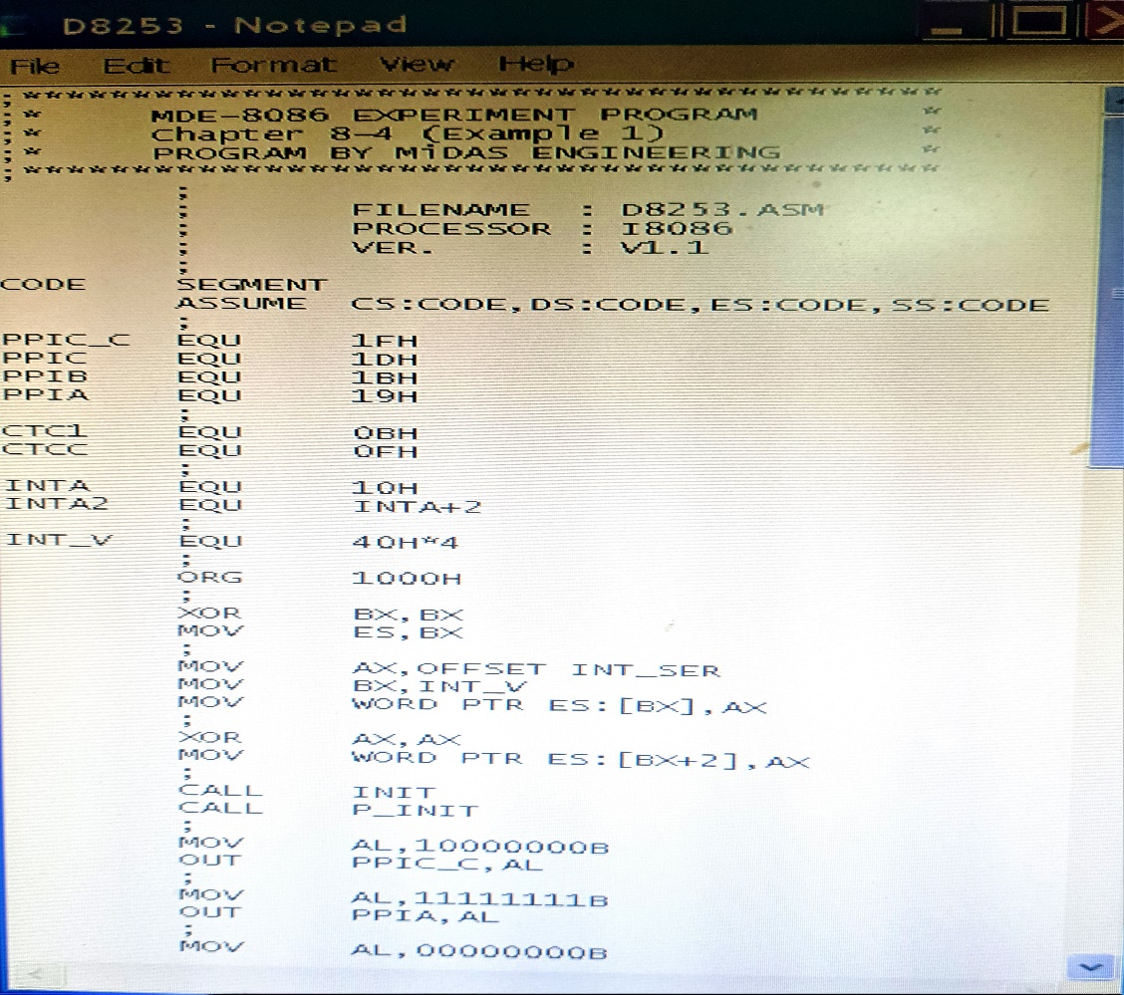

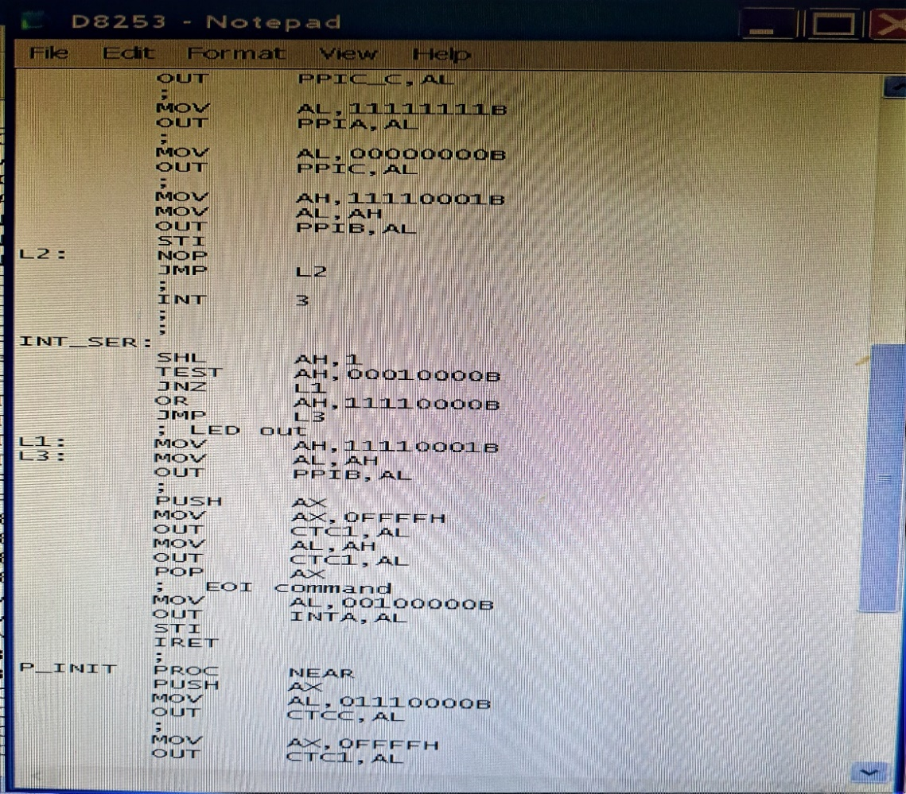

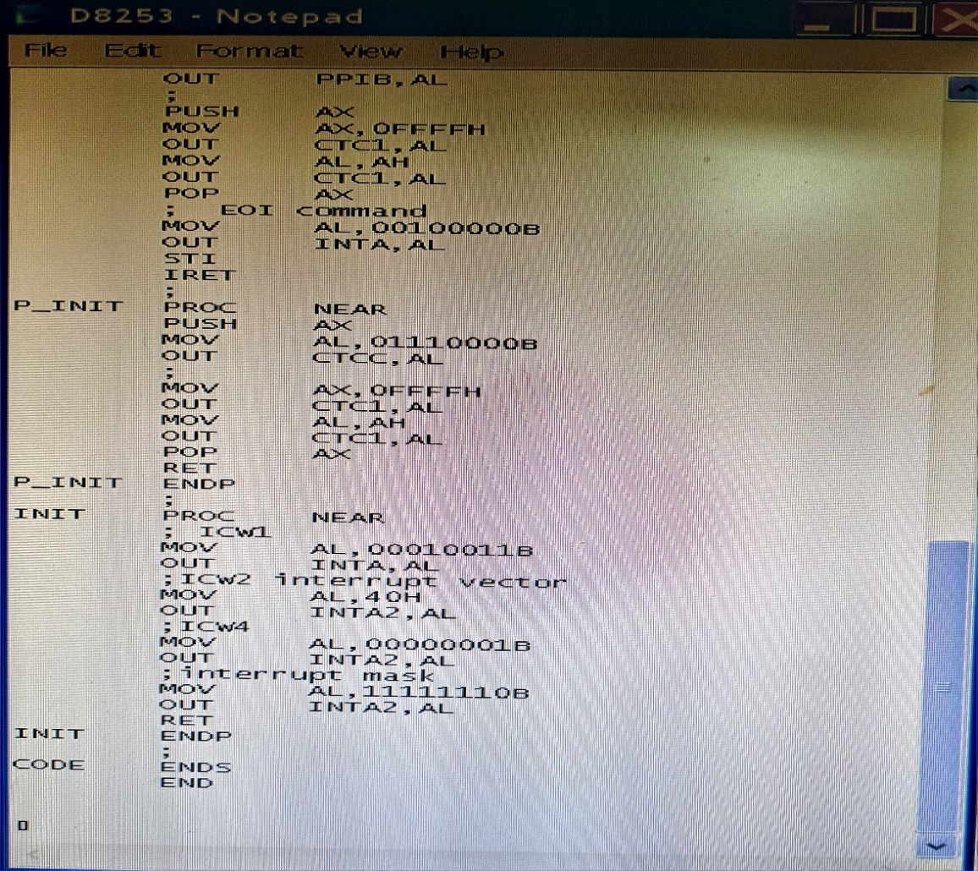

Fig. 9.1: Writing program on notepad

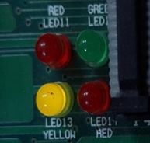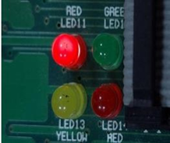 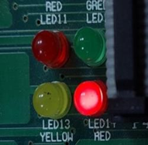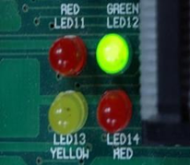

Fig. 9.2: Output

* 1. **Discussion & Conclusion**

In this experiment, we used code to perform the LED interfacing in 8255, 8253, and 8259. A program was developed in notepad and saved as **‘.asm’** file, which was then translated to **‘.obj’** and later into a **‘.abs‘** file. This was then executed and the output was observed using direct execution.

To turn ON and OFF each LED sequentially and concurrently with a predetermined interval, the 8253 PTI IC provided the necessary time delay and pushed the pin IR0 of the 8259 PIC IC with an interrupt. The 8255 PPI IC, which is coupled to the LEDs, was managed by the 8086, which received this interrupt. The 8086, which was in charge of the associated 8255 LEDs, lighted them up one at a time while maintaining the required time delay.

Thus, the experiment was a success.