**Experiment No. 08**

* 1. **Experiment Name**

8255 PPI interfacing: Dot matrix

* 1. **Objectives**
* To get acquainted with the "MDA 8086" Trainer Board and its operation
* To understand the operation of Dot matrix in 8255 PPI interfacing
* To learn how to implement program in “MDA 8086” Trainer Board and interconnect it with “Emu 8086”
  1. **Theory**

A dot Matrix consists of an array of LED's which are inter connected such that the positive terminal (anode) of each LED in the same column are connected together and the negative terminal (cathode) of each LED in the same row are connected together.

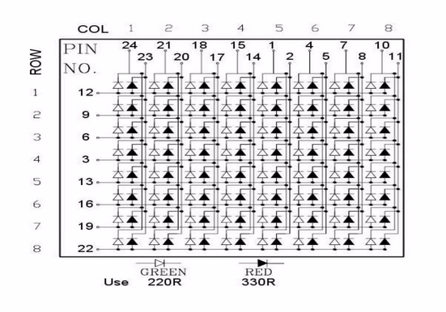

Here, the 8255 port address in accordance with the dot matrix are as follows,

|  |  |
| --- | --- |
| **Port name** | **Port address** |
| Port A | 18H |
| Port B | 1AH |
| Port C | 1CH |
| Control register | 1EH |

* 1. **Apparatus**
* MDA 8086 - Trainer Board
  1. **Code for column wise operation**

**CODE SEGMENT**

**ASSUME CS: CODE, DS: CODE, SS: CODE, ES: CODE**

**CNTRL EQU 1EH**

**PORTC EQU 1CH**

**PORTB EQU 1AH**

**PORTA EQU 18H**

**ORG 1000H**

**MOV AL, 100000000B**

**OUT CONTRL, AL**

**MOV AL, 100000000B**

**OUT PORTB, AL**

**MOV AL, 000000001B**

**L1;**

**OUT PORTC, AL**

**ROL AL, 1**

**CALL TIMER**

**JMP L1**

**INT**

**TIMER:**

**MOV CX, 0FFFFH**

**LOOP2:**

**NOP**

**NOP**

**NOP**

**NOP**

**LOOP LOOP2**

**RET**

**CODE ENDS**

**END**

* 1. **Output for column wise operation**

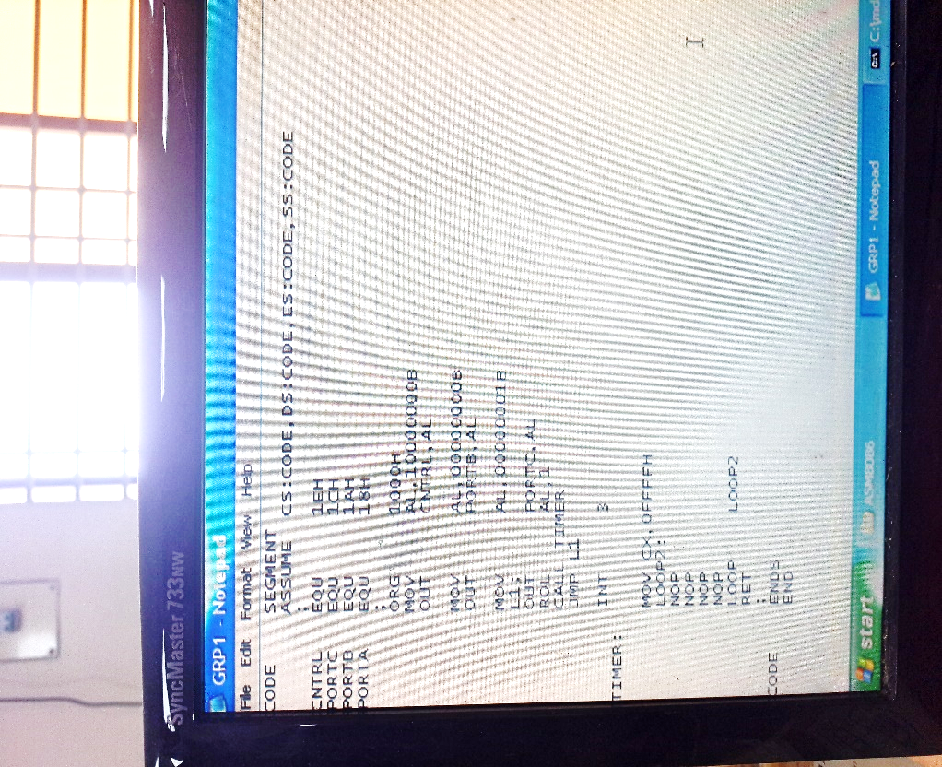

Fig. 8.1: Writing program on notepad

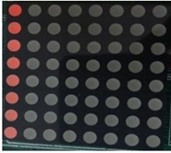 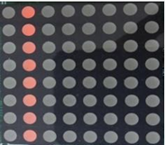 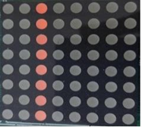 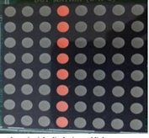

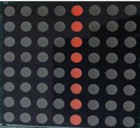 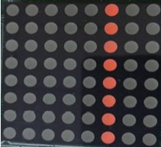 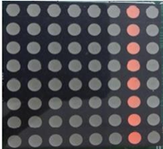 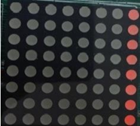

Fig. 8.2: Output

* 1. **Code for row wise operation**

**CODE SEGMENT**

**ASSUME CS: CODE, DS: CODE, SS: CODE, ES: CODE**

**CNTRL EQU 1EH**

**PORTC EQU 1CH**

**PORTB EQU 1AH**

**PORTA EQU 18H**

**ORG 1000H**

**MOV AL, 100000000B**

**OUT CONTRL, AL**

**MOV AL, 11111111B**

**OUT PORTC, AL**

**MOV CL, 8**

**MOV AL, 01111111B**

**L1;**

**OUT PORTB, AL**

**ROL AL, 1**

**CALL TIMER**

**JMP L1**

**INT**

**TIMER:**

**MOV CX, 0FFFFH**

**LOOP2:**

**NOP**

**NOP**

**NOP**

**NOP**

**LOOP LOOP2**

**RET**

**CODE ENDS**

**END**

* 1. **Output for row wise operation**

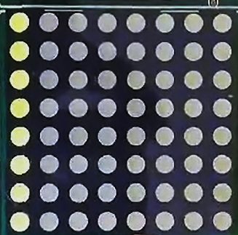 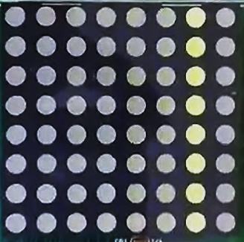 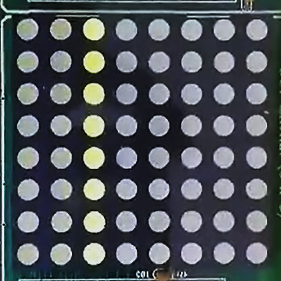 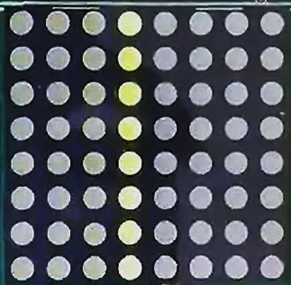 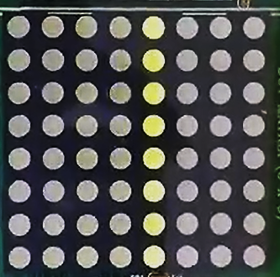   

Fig. 8.3: Output

* 1. **Discussion & Conclusion**

The procedure of working in serial monitor mode or PC mode with the 8086 MDA kit was introduced in this experiment. We used code to perform the dot matrix. A program was developed in notepad and saved as ‘.**asm**’ file, which was then translated to ‘.**obj**’ which was then translated into a ‘.**abs**‘ file. This was then executed by following the instructions, and the output was observed using both single-step execution and direct execution.

By using programming, the row-wise LEDs were turned on after the column-wise LEDs. Therefore, it may be concluded from all of the foregoing talks that the experiment was a success.