**Experiment No. 09**

* 1. **Experiment Name**

8255 PPI interfacing: LED

* 1. **Objectives**
* To get acquainted with the "MDA 8086" Trainer Board and its operation
* To understand working procedure of LED interfacing
* To learn how to implement program in “MDA 8086” Trainer Board and interconnect it with “Emu 8086”
  1. **Theory**

For this experiment, we applied 8255 interfacing in LED. Four LEDs are connected to Port B's bottom four pins. Typically, the ground is connected to LED cathodes. The 8255 microcontrollers have four general-purpose I/O ports that can be configured as input or output. By designating the port pins as output, the state of the port pins can be managed and modified to high or low. When the port is configured as an input, reading the pins will show the voltage state of the pins. The port pins must be configured as outputs in order for the LED to flash.

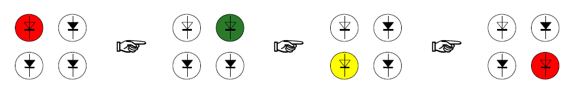

|  |  |
| --- | --- |
| **Port name** | **Port address** |
| Port A | 18H |
| Port B | 1AH |
| Port C | 1CH |
| Control register | 1EH |

* 1. **Apparatus**
* MDA 8086 - Trainer Board
  1. **Experimental problem no. 01**

**CODE SEGMENT**

**ASSUME CS: CODE, DS: CODE, ES: CODE, SS: CODE**

**ORG 1000H**

**PORTA EQU 1BH**

**CNTRL EQU 1FH**

**MOV AL,10000000B**

**OUT CNTRL, AL**

**MOV CL,5**

**L1:**

**MOV AL,00000001B**

**OUT PROTB, AL**

**CALL DELAY**

**MOV AL,00000010B**

**OUT PROTB, AL**

**CALL DELAY**

**MOV AL,000001000B**

**OUT PROTB, AL**

**CALL DELAY**

**MOV AL,000000100B**

**OUT PROTB, AL**

**CALL DELAY**

**LOOP L1**

**DELAY PROC**

**MOV CX,0FFFFH**

**LOOP1:**

**NOP**

**NOP**

**NOP**

**NOP**

**LOOP LOOP1**

**RET**

**DELAY ENDP**

**CODE ENDS**

**END**

* 1. **Output as clockwise direction in Z pattern**

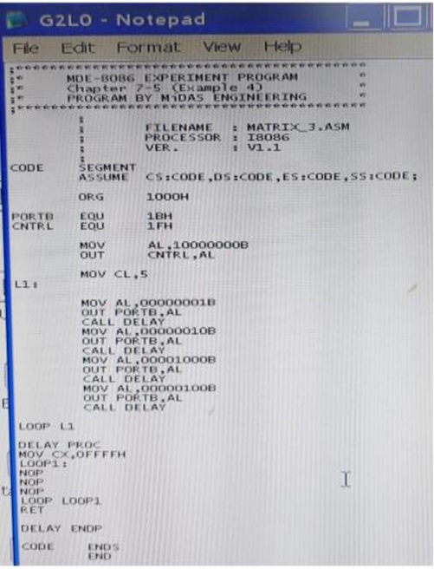

Fig. 9.1: Writing program on notepad

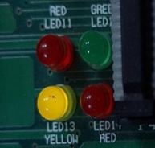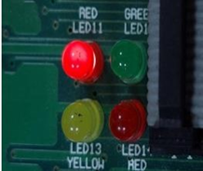 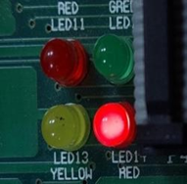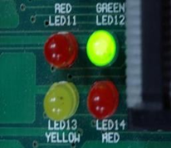

Fig. 9.2: Output

* 1. **Discussion & Conclusion**

In this experiment, we used code to perform the LED interfacing. A program was developed in notepad and saved as **‘.asm’** file, which was then translated to **‘.obj’** and later into a **‘.abs‘** file. This was then executed and the output was observed using direct execution.

Here, there were two more types of patterns available on the LED interface of the 8086 kits. Here, using programming, we activated the LEDs in two different directions: clockwise & z-pattern. Therefore, it may be concluded from all of the foregoing talks that the experiment was a success.