*Heaven’s light is our guide.*

*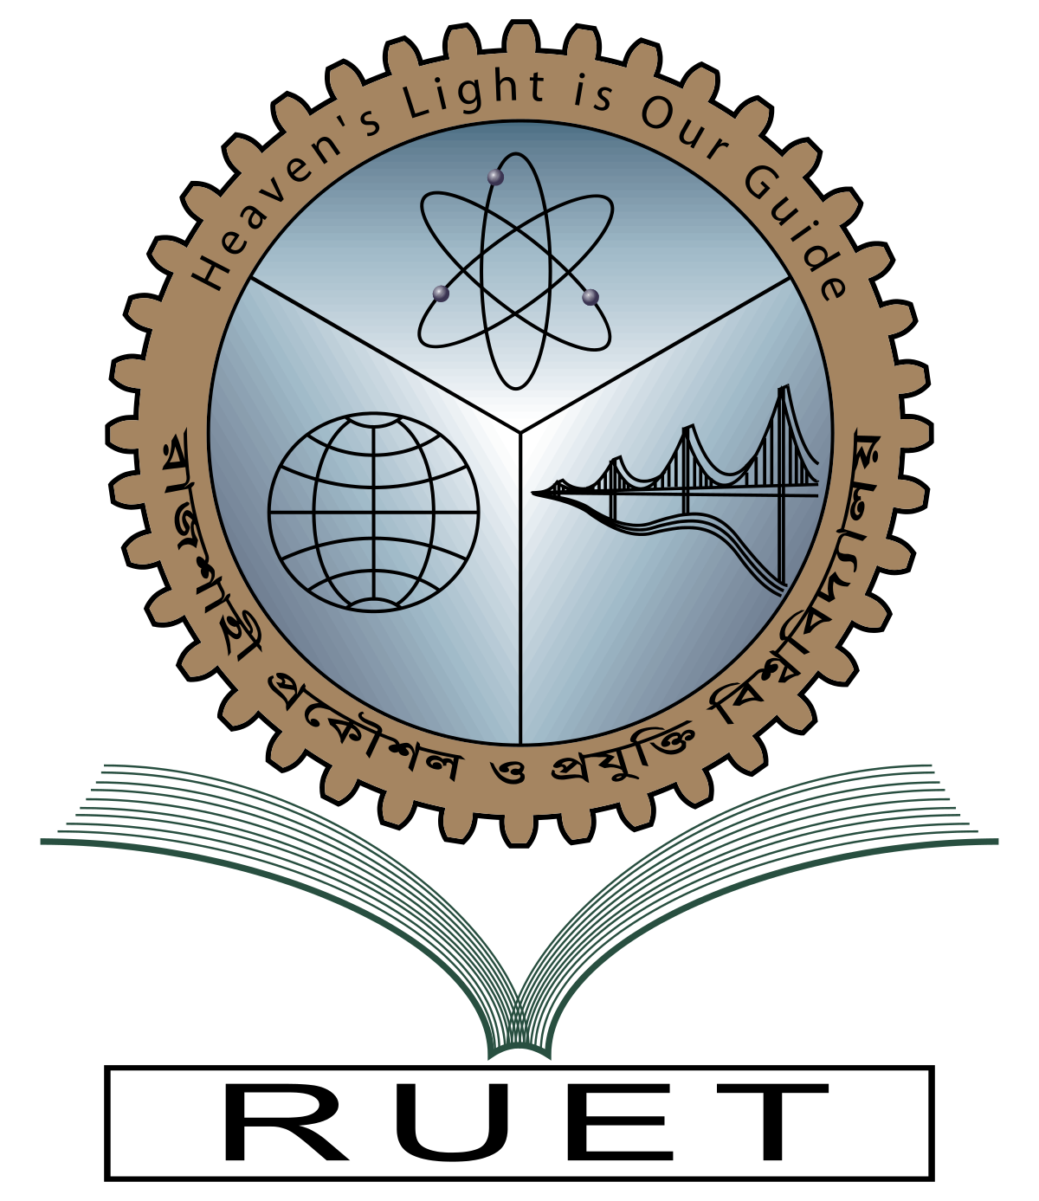***Rajshahi University of Engineering and Technology**

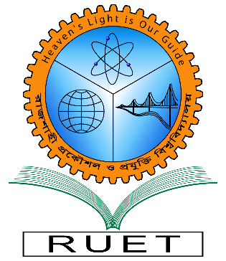

**Department of Electrical & Electronic Engineering**

**Course no.** EEE 3210

**Course title:** Microprocessor, Interfacing and System Design Sessional

**Experiment no.** 10

**Experiment name:** LED ON/OFF using 8253, 8255 & 8259

**Date of experiment:** January 8, 2022

**Date of submission:** January 15, 2022

|  |  |
| --- | --- |
| **Submitted by:** | **Submitted to:** |
| **Ashraf Al- Khalique**  **Roll:** 1801171  **Session:** 2018-2019  Dept. of Electrical & Electronic Engineering,  Rajshahi University of Engineering and Technology. | **Belal Hossain**  **Assistant Professor**  Dept. of Electrical & Electronic Engineering,  Rajshahi University of Engineering and Technology. |