**Experiment no. 02**

* 1. **Experiment Name**

Study of FM receiver and observation of signals at different stages of FM receiver kit

* 1. **Objectives**
* To get acquainted with the operation of the FM Receiver Kit
* To learn the procedure of how FM receiver works
* To understand about the operation of an antenna and how it radiates electromagnetic waves.
* To gain an understanding of the process of combining the message or modulating signal with the high frequency carrier signal.
  1. **Theory**

FM receiver is that receiver which takes input FM modulated electromagnetic wave and converts the information carried by them to a usable form. The received signal captured by the antenna is amplified by the RF amplifier. After that, the amplified signal is applied to the mixer stage. The local oscillator provides the mixer's second input.

The IF amplifier then amplifies this signal. The limiter circuit receives the output of the IF amplifier. The limiter reduces noise from the incoming signal and produces a signal with consistent loudness. When a phase discriminator is used to demodulate an FM signal, this circuit is necessary. The limiter output is now fed into the FM discriminator, which recovers the modulating signal.

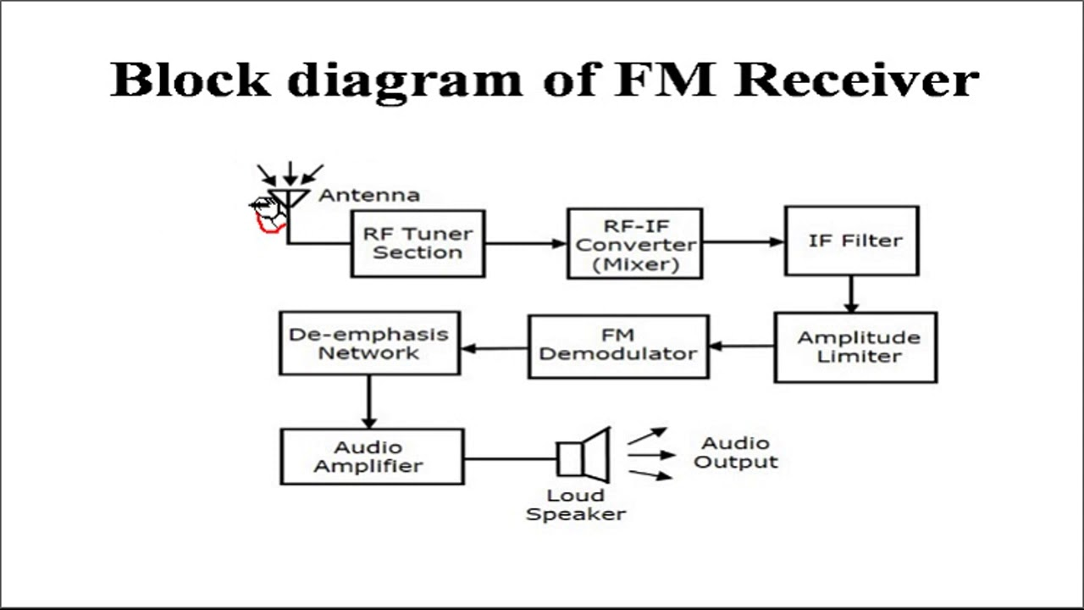

**Fig 2.1** Block Diagram of a Superheterodyne FM Receiver

This signal, however, is not the original modulating signal. It is deemphasized before being applied to the audio amplifier stages. De-emphasizing attenuates higher frequencies to restore them to their original amplitudes after they have been boosted or accentuated prior to transmission.

The audio signal is produced by the de-emphasized stage and is then applied to the audio stages and lastly to the speaker. It should be noted that the FM discriminators require a limiter circuit. If the demodulator stage employs a ratio detector rather than a discriminator, no limiter is necessary. This is because the loudness of the received signal is limited by the ratio detector.

**2.4** **Apparatus**

* FM Receiver (Model: KL-93064)
* Power supply
* Multi-meter
* Connecting wire
* Oscilloscope
  1. **Experimental Setup**

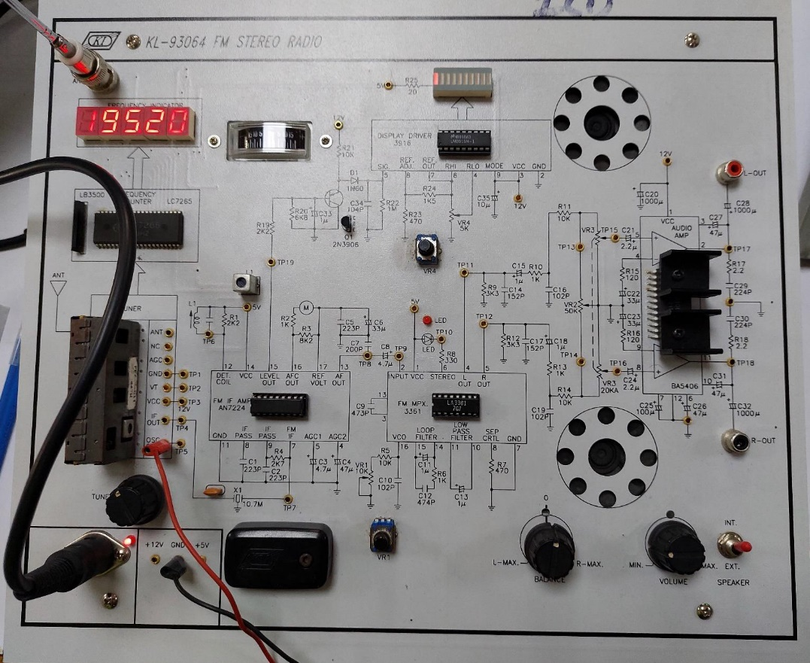

**Fig 1.2** Kl-93064 FM Receiver Radio kit

* 1. **Oscilloscope Output**

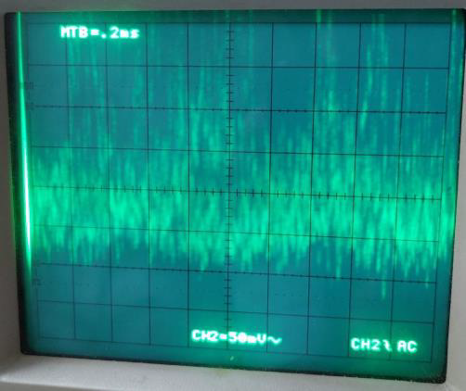 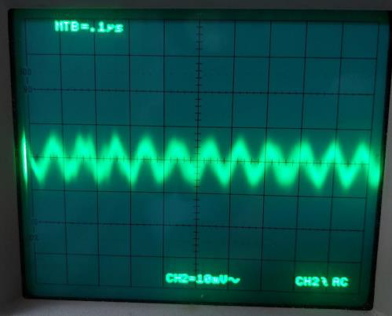

**Fig 2.3** Signal received at the AF stage **Fig 2.4** IF output ideal 10.7Mhz

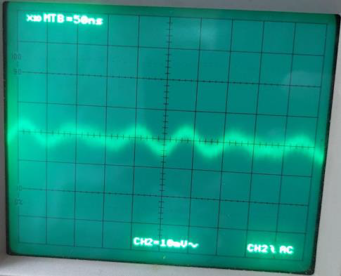 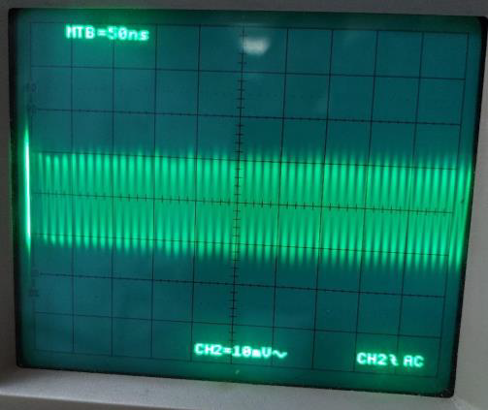

**Fig 2.5** IF output Experimental 11.11Mhz and ideal 10.7 Mhz **Fig 2.6** Oscillator output ideal 109.1MHz

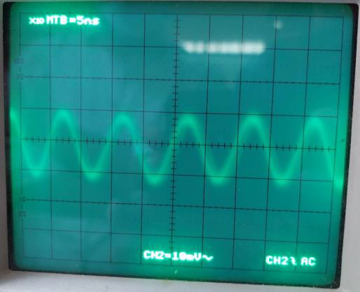 

**Fig 2.7** Oscillator output 100 MHz Experimental **Fig.2.8** Signal at audio output

* 1. **Discussion & Conclusion**

Signal reception was successful in this experiment. The experiment, according to our theoretical knowledge, was carried out in Kl-93064 FM Radio KIT. Step by step, various block and tuning procedures were noticed. The intended signal was then viewed on the oscilloscope.

In the experiment, we tuned 99.2 Radio Padma FM radio channel. Due to a training kit malfunction, the tuning signal can be hampered at times. This is mainly due to the damaged indicator. Thus, too many noises in the signal present. Apart from that, the experiment was deemed a success.

**2.8 Reference**

• Radio Engineering – GK. Mithal