**Experiment no. 03**

* 1. **Experiment Name**

Study of color TV trainer and observation of different signals

* 1. **Objectives**
* To get acquainted with the operation of the color TV trainer
* To learn about the signal generated from the color TV trainer
* To understand about the basics of the components of color TV receiver and how they work together to produce a color image on the screen
  1. **Theory**

A color TV trainer is an appliance that replicates the basic components of a color TV system. The trainer allows for practical experiments and demonstrations without the need for actual television sets, which can be more complex and difficult to deal with. An oscilloscope is required to view various signals. The waveform of signals such as the luminance (Y), in-phase (I), and quadrature (Q) components of the chrominance signal can be seen on an oscilloscope.

The frequency spectrum of signals such as the video carrier, sound carrier, and color subcarrier can be displayed via a spectrum analyzer. By examining these signals, one can learn how color information in a color TV system is encoded and decoded. The working method of this experiment may vary depending on the type and model of the color TV trainer, but the following is a general outline:

* Connecting an antenna, video signal generator, and power source, to the color TV trainer & turn them on.
* Pay attention to the colored image on the screen and make any required brightness, contrast, and color adjustments. Locating the color TV trainer's test points, sockets, and terminals that correspond to the various reception stages, such as the tuner, IF, video, sound, system, and so on.
* Using a multimeter, oscilloscope, and other tools to measure and monitor signals at various test locations and compare them to expected values.
* Using the fault simulator, establish various faults in the color TV receiver and watch how the signals and image on the screen change. Finally, using the test points and the fault simulator to diagnose and repair faults in the color TV receiver.

**2.4** **Apparatus**

* Color TV trainer
* Multi-meter
* Oscilloscope
  1. **Experimental Setup**

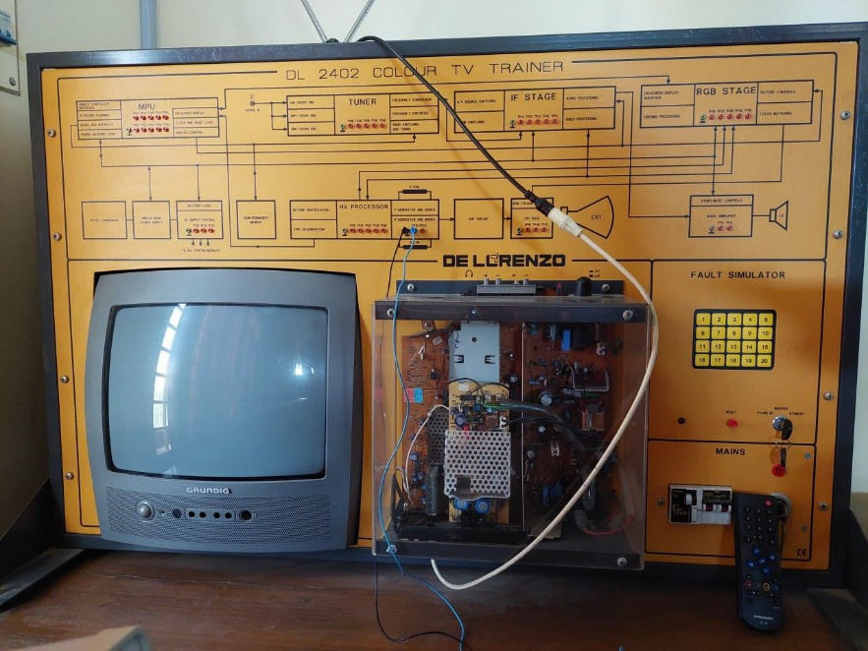

**Fig 3.1** Color TV trainer

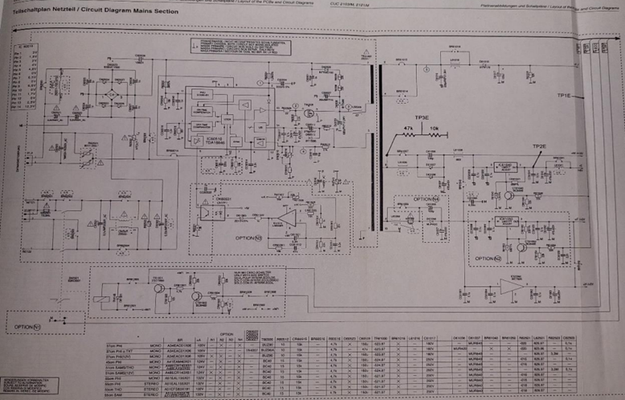

**Fig. 3.2:** Internal Circuit diagram of Mains Section

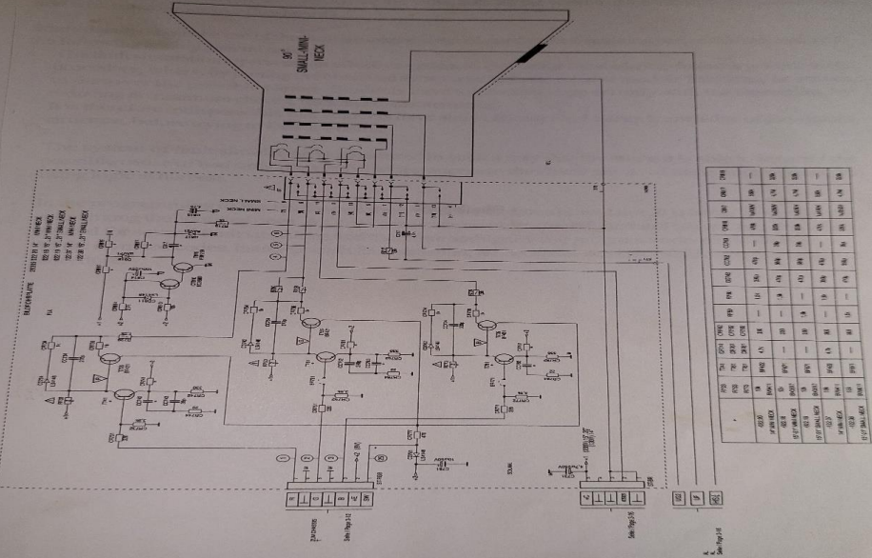

**Fig. 3.3** Internal Circuit diagram of CRT panel

* 1. **Oscilloscope Output**

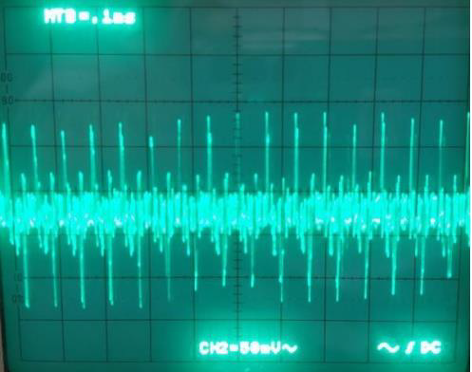 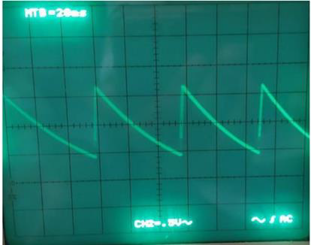

**Fig 3.4** Output waveshape from TP1F  **Fig 3.5** Output waveshape from TP2F

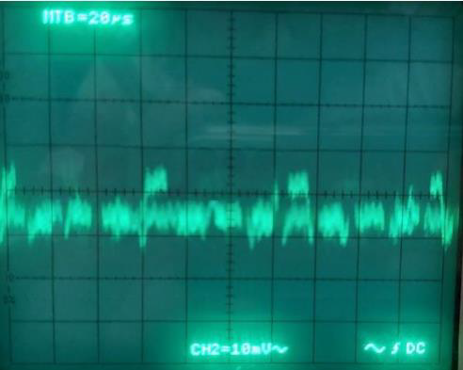 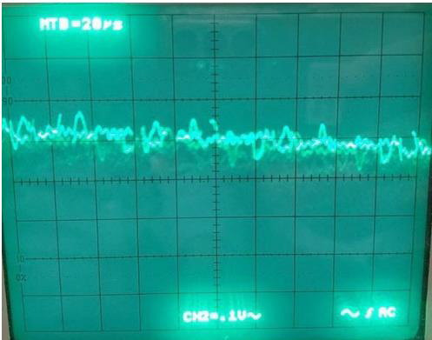

**Fig 3.6** Output waveshape from TP4F **Fig 3.7** Output waveshape from TP5F

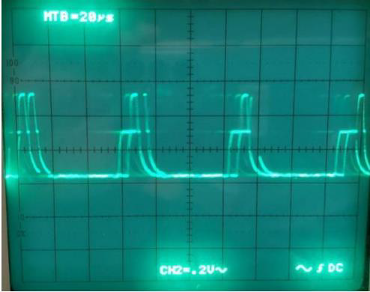 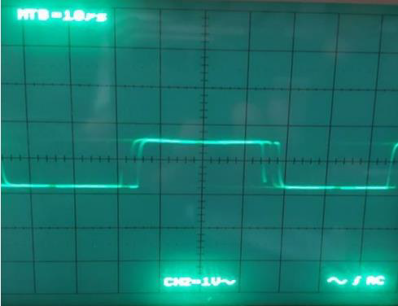

**Fig 3.8** Output waveshape from TP1G **Fig 3.9** Output waveshape from TP2G

* 1. **Discussion & Conclusion**

Signal reception was successful in this experiment. The experiment, according to our theoretical knowledge, was carried out in color TV trainer. Step by step, various block and tuning procedures were noticed. The intended signal was then viewed on the oscilloscope.

In the experiment, we understood how each color TV trainer level functioned. We looked at the output waveforms of other stages. In addition, we compared our oscilloscope waveforms to the normal waveforms in the lab manual. The color TV trainer's output waveforms differed from the standard waveforms in the lab guide due to its age and noise. After all of these discussions, it is safe to declare that the experiment was a success.