**Experiment no. 04**

* 1. **Experiment Name**

Fault simulation of color TV trainer

* 1. **Objectives**
* To get acquainted with the operation of the color TV trainer
* To learn about the fault simulated from the color TV trainer and their responses observed
* To understand about the basics of the components of color TV receiver and how they work together to produce a color image on the screen
  1. **Theory**

A color TV trainer is an appliance that replicates the basic components of a color TV system. The trainer allows for practical experiments and demonstrations without the need for actual television sets, which can be more complex and difficult to deal with. An oscilloscope is required to view various signals. The waveform of signals such as the luminance (Y), in-phase (I), and quadrature (Q) components of the chrominance signal can be seen on an oscilloscope.

Simulating flaws or issues that may develop in the circuitry or components of a color television includes creating and analyzing simulated issues. This technique assists engineers or technicians in recognizing potential problems with a color television, diagnosing them, and devising appropriate solutions. Follow these broad methods to imitate a color TV malfunction:

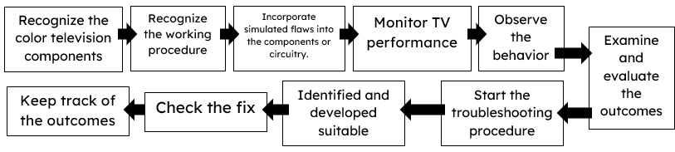

**2.4** **Apparatus**

* Color TV trainer
* Multi-meter
* Oscilloscope
  1. **Experimental Setup**

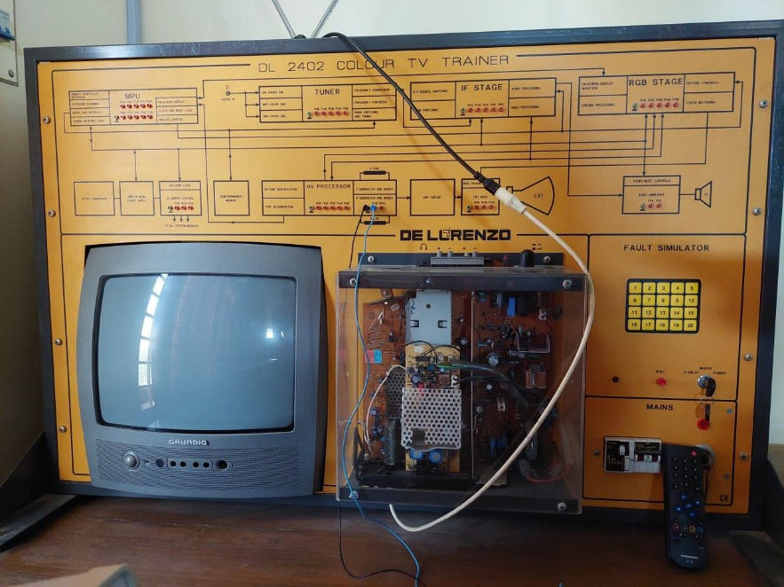

**Fig 4.1** Color TV trainer

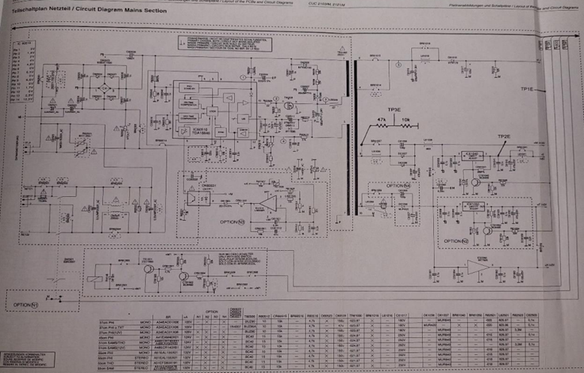

**Fig. 4.2:** Internal Circuit diagram of Mains Section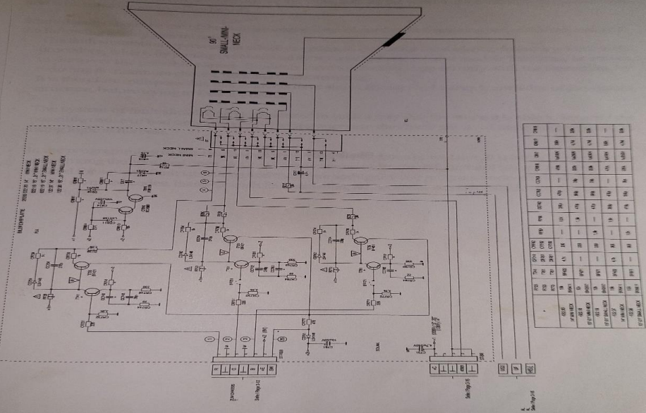

**Fig. 4.3** Internal Circuit diagram of CRT panel

* 1. **Faults in color TV trainer**

|  |  |  |  |  |  |  |
| --- | --- | --- | --- | --- | --- | --- |
| **FAULT NO.** | **FAULT LOCATION** | **SIMULATION QUALITY** |  | **FAULT NO.** | **FAULT LOCATION** | **SIMULATION QUALITY** |
| 1 | REMOTE CONTROL FAULT | PROPERLY SIMULATED |  | 11 | TUNER | NOT PROPERLY SIMULATED (BEHAVING LIKE 4TH FAULT) |
| 2 | KEY-BOARD OPERATION | NOT PROPERLY SIMULATED |  | 12 | TUNER | NOT PROPERLY SIMULATED |
| 3 | RESET OF MICROCONTROLLER | PROPERLY SIMULATED |  | 13 | TUNER | NOT PROPERLY SIMULATED |
| 4 | AUDIO | NOT PROPERLY SIMULATED |  | 14 | CPU | PROPERLY SIMULATED |
| 5 | ON-SCREEN-DISPLAY | PROPERLY SIMULATED |  | 15 | IF STAGE | PROPERLY SIMULATED |
| 6 | ON-SCREEN-DISPLAY | NOT PROPERLY SIMULATED |  | 16 | IF STAGE | NOT PROPERLY SIMULATED |
| 7 | ON-SCREEN-DISPLAY | NOT PROPERLY SIMULATED |  | 17 | IF STAGE | PROPERLY SIMULATED |
| 8 | RGB STAGE | PROPERLY SIMULATED |  | 18 | RGB STAGE | NOT PROPERLY SIMULATED |
| 9 | ON-SCREEN-DISPLAY | NOT PROPERLY SIMULATED |  | 19 | PICTURE CONTROL | PROPERLY SIMULATED |
| 10 | ON-SCREEN-DISPLAY | PROPERLY SIMULATED |  | 20 | AUDIO AMPLIFIER | NOT PROPERLY SIMULATED (BEHAVING LIKE 4TH FAULT) |

* 1. **Discussion & Conclusion**

The experiment, according to our theoretical knowledge, was carried out in color TV trainer. Step by step, various block and tuning procedures were noticed. The intended signal was then viewed on the oscilloscope.

We learned how to simulate flaws in a color TV trainer in this experiment. Using fault simulation, the significance of troubleshooting talents in locating and fixing problems in color television systems was demonstrated. We obtained practical experience by researching the inner workings of color televisions and fixing real-world problems by making particular errors and analyzing their impact.

We discovered that some errors were properly recreated while others were not because the color television trainer was old. The preceding discussion indicates that the experiment was a success.