**Experiment no. 06**

* 1. **Experiment Name**

Observation of waveshapes in FM transmitter

* 1. **Objectives**
* To get acquainted with the operation and the basics operation of the FM transmitter
* To learn about the waveshapes generated from the transmitter
  1. **Theory**

The FM transmitter is a low-power transmitter that transmits sound via FM waves. Based on the frequency difference, this transmitter sends audio signals via the carrier wave. The carrier wave frequency is equivalent to the amplitude of the audio signal, and the FM transmitter creates a VHF band ranging from 88 to 108 MHz

The microphone, audio pre-amplifier, modulator, oscillator, RF amplifier, and antenna are all needed components of an FM transmitter. The FM signal contains two frequencies: one for the carrier frequency and one for the audio frequency. The carrier frequency is modulated using the audio frequency. By allowing the AF, the FM signal is obtained by altering the carrier frequency. The FM transistor consists of the oscillator that produces the RF signal.

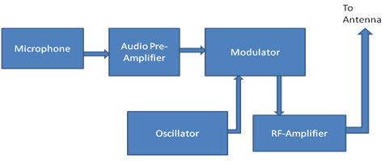

**Fig. 6.1.** Block diagram of FM transmitter

Advantages of the FM Transmitters is that the efficiency of the transmitter is very high and this transmitter will reject the noise signal from an amplitude variation. The FM transmitter and receiver will tend to be more complex. Due to some interference, there is poor quality in the received signals.

**6.4** **Apparatus**

* FM transmitter
* Multi-meter
* Oscilloscope
  1. **Experimental Setup**

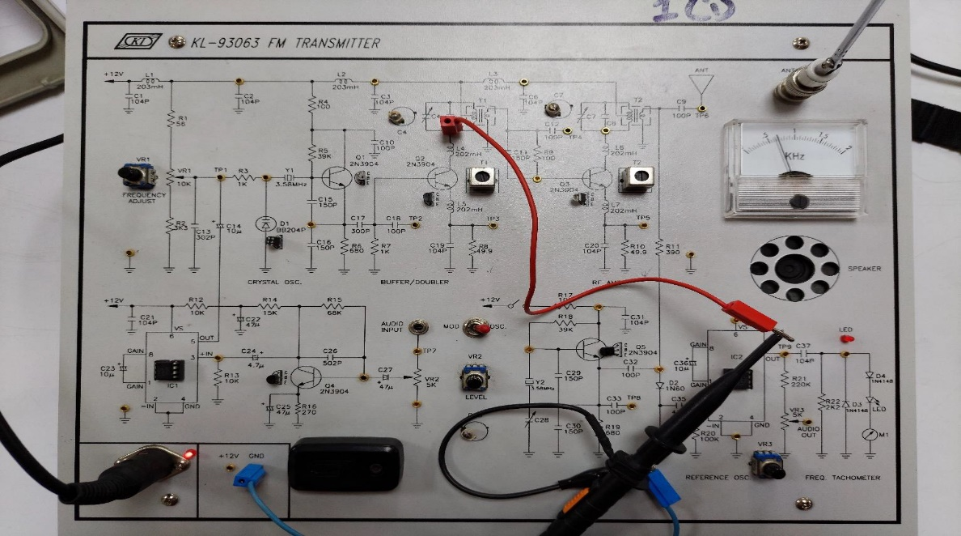

**Fig. 6.2:** Internal Circuit diagram of FM receiver

* 1. **Waveshapes**

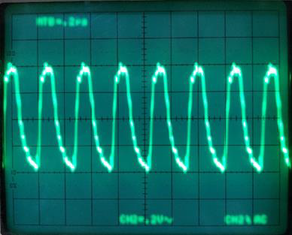 

**Fig. 6.3.** Carrier signal of 3.58MHz **Fig. 6.4.** C8 signal

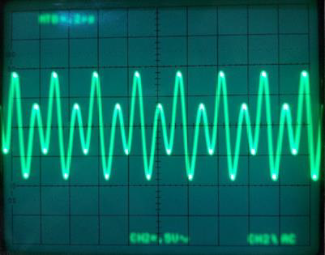 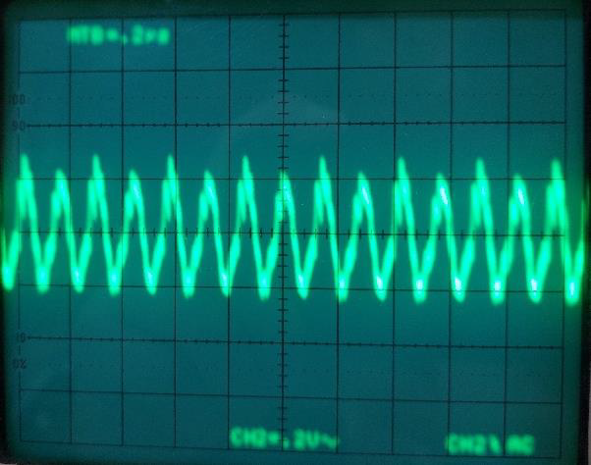

**Fig. 6.5.** Voltage signal due to Non-Linear harmonics current **Fig. 6.6.** Final output of amplified or boosted carrier

* 1. **Discussion & Conclusion**

The experiment, according to our theoretical knowledge, was carried out in AM/FM receiver trainer. Step by step, various block and tuning procedures were noticed. The intended signal was then viewed on the oscilloscope.

We concentrated on how the FM transmitter works in this experiment. To send the signal, the oscillator's carrier frequency was first changed. By adjusting the input voltage, the carrier signal was amplified or boosted and was then ready for transmission. Furthermore, as seen in fig.6.5, the amplitude of the carrier signal fluctuates due to non-linear harmonics current. Following all of these discussions, it is safe to declare that the experiment was a success.

We discovered that some errors were properly recreated while others were not because the color television trainer was old. The preceding discussion indicates that the experiment was a success.