*Heaven’s light is our guide.*

*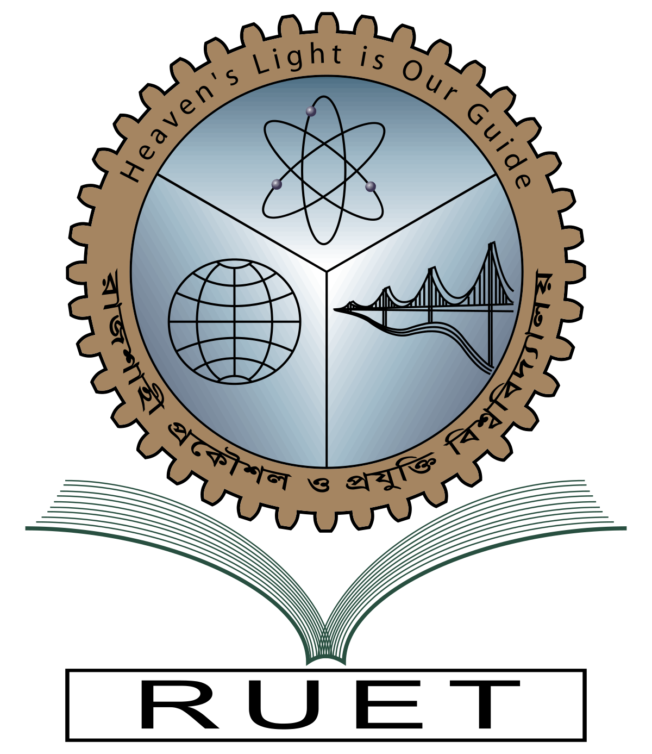***Rajshahi University of Engineering and Technology**

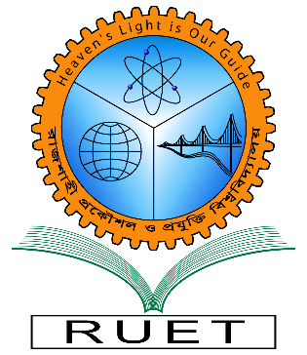

**Department of Electrical & Electronic Engineering**

**Course no.** EEE 4118

**Course title:** Radio & TV Engineering Sessional

**Experiment no.** 01

**Experiment name:** Study of AM receiver and observation of signals at different stages of AM receiver kit.

**Date of experiment:** May 3, 2023

**Date of submission:** May 17, 2023

|  |  |
| --- | --- |
| **Submitted to** | **Submitted by** |
| **Belal Hossain**  **Assistant Professor**  Dept. of Electrical & Electronic Engineering,  Rajshahi University of Engineering and Technology. | **Ashraf Al- Khalique**  **Roll:** 1801171  **Session:** 2018-2019  Dept. of Electrical & Electronic Engineering,  Rajshahi University of Engineering and Technology. |