Experiment no. 01
  - Experiment Name
Study of AM receiver and observation of signals at different stages of AM receiver kit
  - Objectives
- To get acquainted with the operation of the AM Receiver Kit
- To know the process of tuning of the local oscillator and the receiver for any particular station
  - Theory
AM receiver is that receiver which takes input AM modulated electromagnetic wave, demodulate it and output as a voice signal. This is an electronic equipment which pick-ups the desired signal, reject the unwanted signal and demodulate the carrier signal to get back the original modulating signal. This receiver is a super-heterodyne type receiver. This type of receiver uses an intermediate frequency by mixing the message signal and a high frequency signal. From the intermediate signal output is taken to speaker.
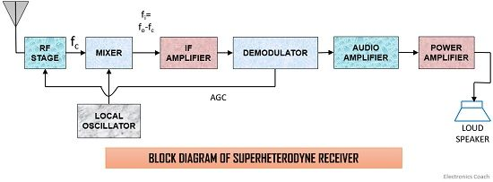
Fig 1.1 Block Diagram of a Superheterodyne AM Receiver
A Super-heterodyne receiver has different stages of operation, such as,
- Receiving Antenna: Receiving antenna convert the electromagnetic signal to electrical signal. It can sense all frequencies.
- RF amplifier: RF amplifier amplify the input signal voltage to a suitably high level before feeding it to the frequency mixer which contributes large noise. Thus, the signal/noise ratio is improved. It also provides discrimination or selectivity against image frequency signal and intermediate frequency signal.
- Mixer: Here,
  - Local oscillator maintain constant frequency difference is between the local oscillator and the RF circuits, normally through capacitance tuning. The local oscillator is a variable oscillator capable of generating a signal from 0.995 MHz to 2.105 MHz
  - Frequency mixer mixes RF carrier frequency signal with a predetermined local oscillator signal in the mixer. The signal from the mixer is then supplied to the IF (intermediate-frequency) amplifier and generally it is 455 kHz.
- IF amplifier: IF amplifier amplify the intermediate frequency signal. Because of its narrow bandwidth, the IF amplifier rejects all other frequencies but 455 kHz. This rejection process reduces the risk of interference from other stations. This selection process is the key to the superheterodyne’s exceptional performance, which is why it is widely accepted.
- Detector: Detector detects the IF signal by filtering the signal by eliminating one of the sidebands still present and separates the RF from the audio components of the other sideband
- Audio amplifier: Audio frequency output from detector is fed to the a.f. amplifier which provides additional amplification. If the signal strength is low to drive a speaker, power amplify is used to add power.
- Speaker: Speaker converts the electrical signal to audio signal.
1.4 Apparatus
- AM/DSB Receiver (Model: KL-93062)
- Power supply
- Multi-meter
- Connecting wire
- Oscilloscope

  - Experimental Setup
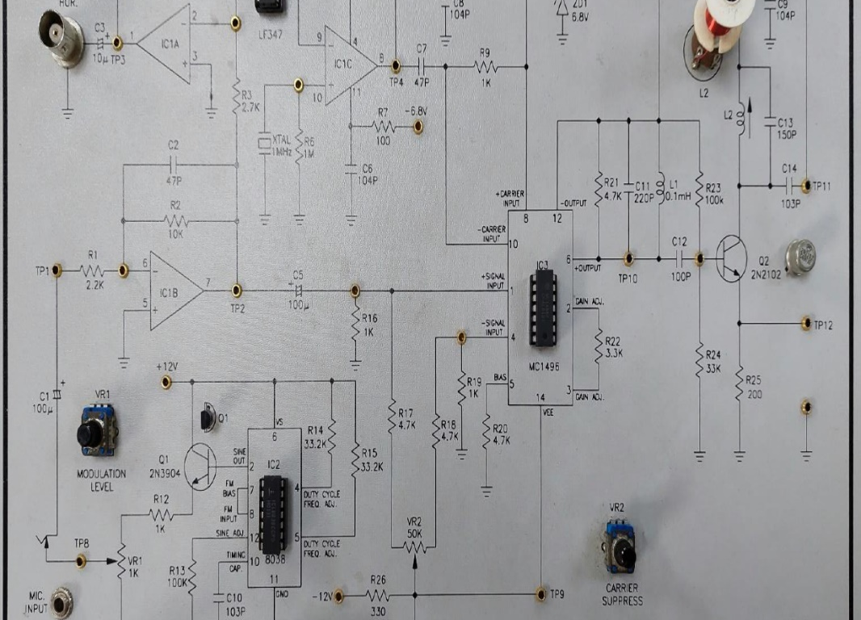
Fig 1.2 Kl-93061 AM/DSB Transmitter radio kit
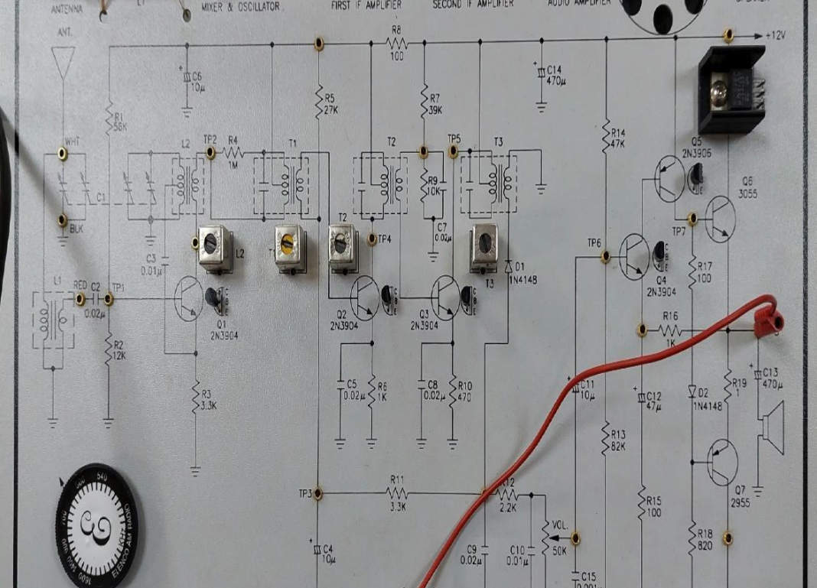
Fig 1.2 Kl-93061 AM/DSB Receiver radio kit
  - Oscilloscope Output
Fig 1.3 Signal received by antenna Fig 1.4 Signal of mixer output
Fig 1.5 Signal at1st IF amplifier output Fig 1.6 Signal at 2nd stage amplifier
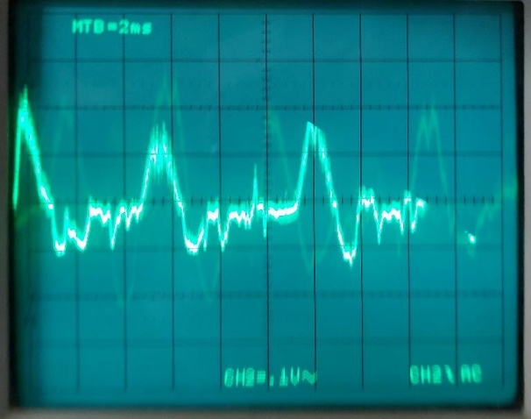
Fig 1.7 Signal at receiver’s output
  - Discussion & Conclusion
Signal reception was successful in this experiment. The experiment, according to our theoretical knowledge, was carried out in Kl-93062 AM Radio KIT. Step by step, various block and tuning procedures were noticed. The intended signal was then viewed on the oscilloscope. A signal at 1 MHz was received by the receiver's antenna.
The signal is then routed through the Mixer and Oscillator, the IF amplifier, and the RF amplifier before reaching the output end. Due to a training kit malfunction, the received signal can be seen distorted at times. However, that experiment was deemed a success.
  - Reference
• Radio Engineering – GK. Mithal

