**Experiment No. 01**

* 1. **Experiment Name**

Body composition analysis using four electrode bio impedance measurement technique

* 1. **Objectives**
* To gain knowledge about the composition of the human body in terms of its percentage of body fat, water, and muscle mass.
* To obtain practical knowledge and skills in utilizing the four-electrode bioimpedance measurement technique
* To learn to categorize health status based on the results of bioimpedance analysis and identify potential health risks associated with body composition imbalances
  1. **Theory**

The four-electrode method, a well-established technique dating back to the late 19th century, measures the resistivity of materials using separate pairs of electrodes for current injection and voltage measurement. In this application, one electrode pair was strategically placed at the finger joint, while the other pair was positioned on the wrist. To ensure proper measurements, the black and red leads must be consistently paired across both locations. This configuration allows for accurate and reliable determination of resistivity through the analysis of the induced voltage drop in response to the injected current.

Human body impedance measurements offer valuable insights into health and body composition. While cadavers exhibit an average impedance of 1,000 Ω, living bodies show significantly lower values at 500 Ω. Notably, electrode-skin contact impedance decreases significantly within the 10 Hz to 1 MHz frequency range. In terms of body composition for 18–30-year-olds, the average fat range is 12-18% for males and 20-26% for females. Additionally, water content, encompassing both extracellular and intracellular water, averages 55-65% for males and 50-60% for females at that age.

The "prediction marker," defined as the ratio of impedance at 200 kHz to 5 kHz, serves as a key indicator of health status. This analysis provides valuable information about a person's overall health and well-being.

Furthermore, the phase angle measures the functionality of cell membranes, essentially assessing the "battery life" of our cells. Leakage in the cell membrane impairs its ability to hold a voltage, leading to a decrease in the phase angle. Based on this measurement, individuals can be categorized into different health groups: poor (3.5-5.4), satisfactory (5.4-6.4), good (6.4-7.9), and outstanding (7.9+).

Finally, the impedance curve, a graph depicting the relationship between resistance and reactance for the human body, provides additional insights into health. The angle between the vector and reactance is known as the phase angle. While the experiment's sample size was limited to 2-3 individuals, the obtained data offer valuable preliminary findings for further research in this area.

* 1. **Apparatus**
* Carbon coated electrode (4 pieces)
* Body stat device (1 piece)
* Covering tape
* Weight machine
* Subject
  1. **Data Table**

**Table 1: Basic Information**

|  |  |  |  |  |  |
| --- | --- | --- | --- | --- | --- |
| ***Serial No.*** | ***Name*** | ***Gender*** | ***Age*** | ***Weight*** | ***Height*** |
| 117 | Modhusudan | Male | 25 | 57 | 1.65 |
| 118 | Efaz | Male | 25 | 75.5 | 1.7 |
| 119 | Noman | Male | 23 | 74.5 | 1.63 |
| 120 | Rakibul | Male | 24 | 68 | 1.68 |
| 121 | Pranto | Male | 24 | 72.5 | 1.65 |
| 123 | Maliha | Female | 24 | 52 | 1.55 |
| 124 | Mayesha | Female | 24 | 53 | 1.57 |
| 126 | Ifthekhar | Male | 25 | 65 | 1.75 |
| 127 | Saad | Male | 25 | 79 | 1.73 |
| 128 | Rokon | Male | 24 | 81 | 1.83 |

**Table 2: Analytical Data**

|  |  |  |  |  |  |  |  |  |
| --- | --- | --- | --- | --- | --- | --- | --- | --- |
| ***Serial. No.*** | ***Fat(%)*** | ***TBW(%)*** | ***Lean(%)*** | ***Z at 50Khz*** | ***PA*** | ***Status*** | ***BMI*** | ***Status*** |
| 117 | 13.5 | 61.6 | 86.5 | 557.4 | 5.62 | Satisfactory | 19.2 | Underwieght |
| 118 | 22.1 | 47.7 | 77.9 | 498.4 | 6.32 | Satisfactory | 28.5 | Overweight |
| 119 | 14.6 | 74.8 | 85.4 | 402.2 | 8.25 | Outstanding | 28 | Overweight |
| 120 | 21 | 46.1 | 79 | 562.9 | 5.58 | Satisfactory | 26 | Overweight |
| 121 | 22.5 | 61.1 | 77.5 | 500.4 | 7.3 | Good | 29 | Overweight |
| 123 | 19.4 | 47.6 | 80.6 | 546.4 | 7.05 | Good | 20.8 | Healthy |
| 124 | 30.5 | 42.9 | 69.5 | 653.2 | 4.36 | Poor | 23.8 | Healthy |
| 126 | 14.7 | 53.5 | 85.3 | 582.4 | 5.44 | Satisfactory | 21 | Healthy |
| 127 | 20.6 | 49.5 | 79.4 | 473.5 | 6.2 | Satisfactory | 28.3 | Overweight |
| 128 | 18.1 | 52.2 | 81.9 | 526.5 | 7.2 | Good | 25.1 | Overweight |

**Impedances Curves**

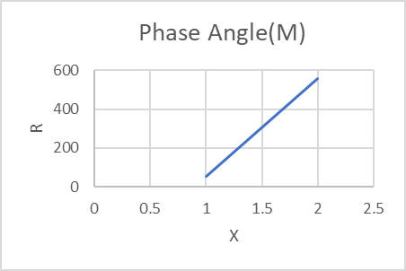 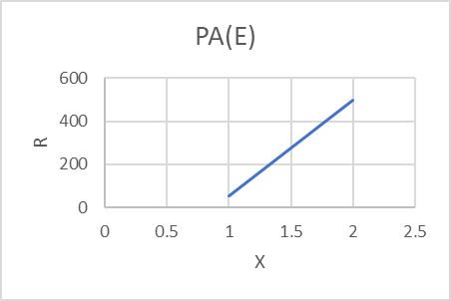

Fig(a) Phase Angle of SN 117 Fig(b) Phase Angle of SN 118

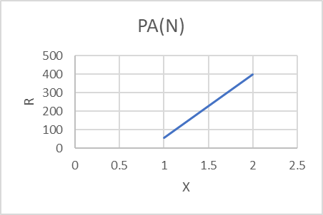 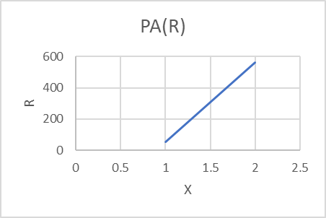

Fig(c) Phase Angle of SN 119 Fig(d) Phase Angle of SN 120

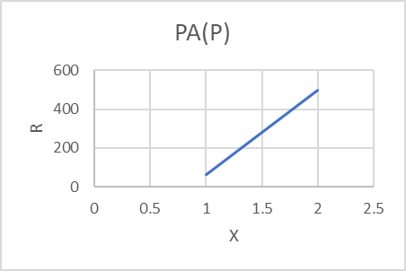 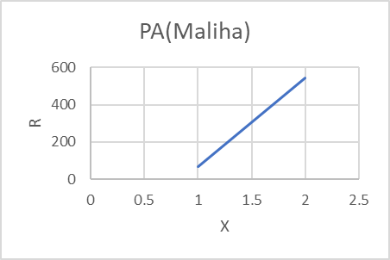

Fig(e) Phase Angle of SN 121 Fig(f) Phase Angle of SN 123

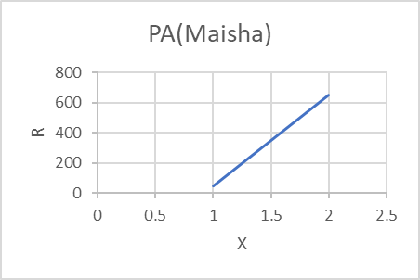 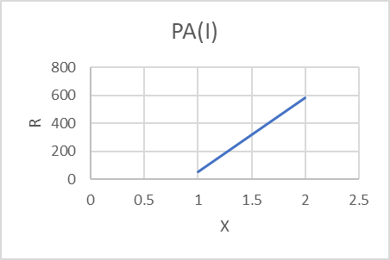

Fig(g) Phase Angle of SN 124 Fig(h) Phase Angle of SN 126

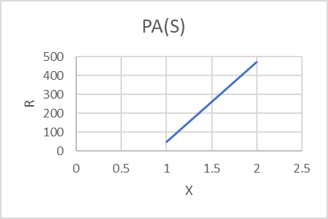 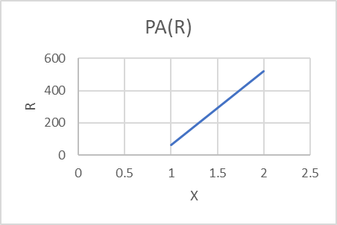

Fig(i) Phase Angle of SN 127 Fig(j) Phase Angle of SN 128

* 1. **Discussion & Conclusion**

This experiment successfully employed electrode bioimpedance analysis to assess body composition. Prior to the analysis, thorough background knowledge was acquired, and necessary precautions were implemented. Data was meticulously collected and analyzed using computer software. Standard charts facilitated the interpretation of the results and provided insights into the health status of the participant. An impedance diagram was also generated for further analysis. While limitations such as electrode-related errors and tape repetition time may have been present, all objectives were ultimately achieved, solidifying the experiment's successful execution.