**Experiment No. 02**

* 1. **Experiment Name**

Observation of cardiac states before (at rest state) and after physical activity

* 1. **Objectives**
* To observe and analyze variations in cardiac parameters, including heart rate and blood pressure, during a state of rest and after physical activity
* To understand the correlation between physical activity and cardiac responses
* To observe the R wave duration of lead-2
  1. **Theory**

Each heartbeat, a single cardiac cycle, is marked by a complex dance of electrical activity within the heart. It begins with the firing of the SA node, generating the P wave on an electrocardiogram as the atrial muscles depolarize. The signal then travels silently through the AV node before igniting the Purkinje fibers, initiating ventricular depolarization.

This rapid activity creates the downward and upward deflections of the QRS complex, followed by minimal deflection during basal ventricular depolarization. A straight line, the ST segment, signifies complete ventricular depolarization. After a brief pause, repolarization starts, marking the cycle's completion.

This intricate process, normally occurring 60-80 times per minute, can accelerate beyond 80 beats per minute after exercise, ensuring efficient blood flow throughout the body.

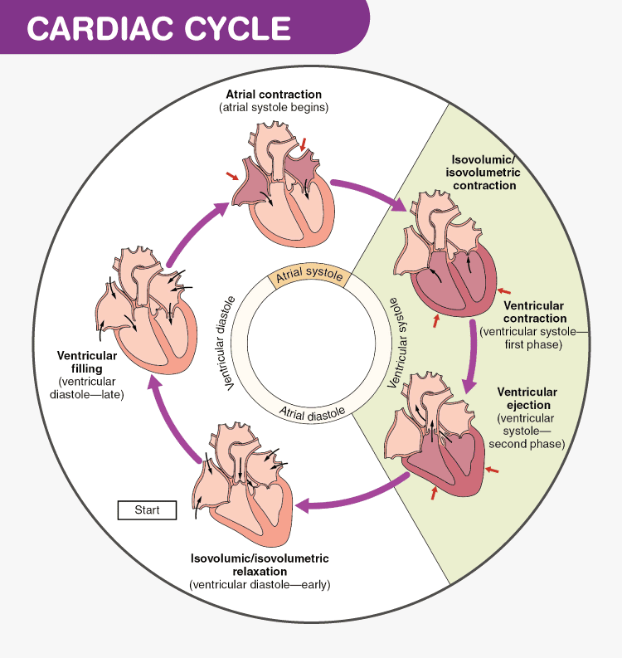

**Figure 2.1:** Different phases of the cardiac cycle

The atrial and ventricular rates are the same and are measured by the following equation:

|  |  |
| --- | --- |
| **Atrial rate = 1500 / t(P-P) bpm** | **Ventricular rate = 1500 / t(R-R) bpm** |

* 1. **Apparatus**
* Carbon coated electrode (4 Nos.)
* ECG machine
* Silver Fluoride gel
  1. **Data Table**

|  |  |  |
| --- | --- | --- |
| **Subject No.** | **Heart rate at rest (bpm)** | **Heart rate after exercise (bpm)** |
| 1. | 62.5 | 136.36 |
| 2. | 83.33 | 150 |
| 3. | 79 | 150 |
| 4. | 60 | 166.67 |
| 5. | 57.7 | 150 |

* 1. **ECG Signal**

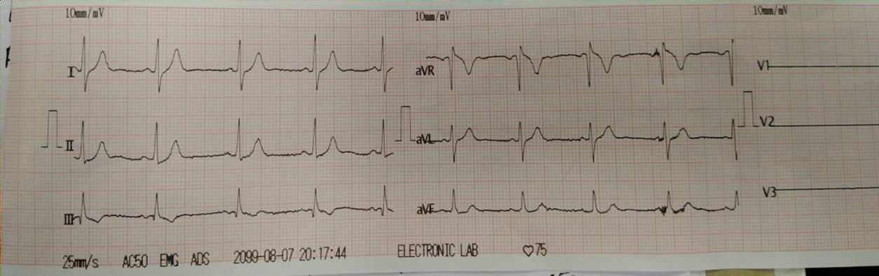

**Figure 2.2:** ECG signal from ECG machine

* 1. **Calculation**

**Ventricular rate of S5 = 1500 / t(R-R) bpm**

At rest, Ventricular rate of S5 = 1500 / 26 = 57.7 bpm

After physical activity, Ventricular rate of S5= 1500 / 10 = 150 bpm

* 1. **Discussion & Conclusion**

In this experiment, while examining lead 2 of the ECG, we observed that during rest, subject 5 (S5) exhibited longer intervals between consecutive R-peaks (R-R intervals) compared to their post-exercise measurements. This resulted in a higher frequency of R-peaks and, consequently, a lower heart rate at rest and an elevated heart rate during activity. Notably, all subjects displayed similar findings, further solidifying the link between R-R intervals and heart rate changes in response to exercise.