**Experiment No. 04**

* 1. **Experiment Name**

Development of a MATLAB based GUI app for processing ECG signal to determine Cardiac state

* 1. **Objectives**
* To develop a MATLAB-based GUI application that effectively processes ECG signals
* To contribute to the efficient determination of cardiac states, enabling timely diagnosis and intervention
  1. **Theory**

The electrocardiogram (ECG) stands as a pivotal diagnostic tool, capturing the heart's electrical activity over time. In the realm of ECG signal processing, essential steps include filtering, noise reduction, and feature extraction. Leveraging MATLAB's capabilities in data analysis, signal processing, and visualization proves ideal for developing tools tailored to process and analyze ECG signals. The Graphical User Interface (GUI) feature within MATLAB enhances user interaction, paving the way for user-friendly applications. The integration of automated analysis within the GUI application streamlines this complex process, offering a swift and accurate means of assessing cardiac health.

* 1. **Apparatus**
* MATLAB
  1. **MATALAB Code**

function varargout = ecg(varargin)

gui_Singleton = 1;

gui_State = struct('gui_Name', mfilename, ...

'gui_Singleton', gui_Singleton, ...

'gui_OpeningFcn', @ecg_OpeningFcn, ...

'gui_OutputFcn', @ecg_OutputFcn, ...

'gui_LayoutFcn', [] , ...

'gui_Callback', []);

if nargin && ischar(varargin{1})

gui_State.gui_Callback = str2func(varargin{1});

end

if nargout

[varargout{1:nargout}] = gui_mainfcn(gui_State, varargin{:});

else

gui_mainfcn(gui_State, varargin{:});

end

function ecg_OpeningFcn(hObject, eventdata, handles, varargin)

handles.output = hObject;

guidata(hObject, handles);

function varargout = ecg_OutputFcn(hObject, eventdata, handles)

varargout{1} = handles.output;

function ecgsig_Callback(hObject, eventdata, handles)

fullfile = dlmread('ECG_Signal.tsv'); %Load ECG signal during walking

Fs = 250; %The data are sampled at 250Hz

ecgsig = fullfile(:,2); %reading ecg signal

samples = 1:length(ecgsig); %No. of samples

tx = samples./Fs; %Getting time vector

f = 1./tx; % frequency of ecg

set(handles.listbox1,'String',ecgsig);

function listbox1_Callback(hObject, eventdata, handles)

function listbox1_CreateFcn(hObject, eventdata, handles)

if ispc && isequal(get(hObject,'BackgroundColor'), get(0,'defaultUicontrolBackgroundColor'))

set(hObject,'BackgroundColor','white');

end

function plot_ecg_Callback(hObject, eventdata, handles)

ecgsig = str2num(get(handles.listbox1,'String'));

Fs = 250; %The data are sampled at 250Hz

samples = 1:length(ecgsig); %No. of samples

tx = samples./Fs; %Getting time vector

f = 1./tx; % frequency of ecg

axes(handles.axes1);

plot(tx,ecgsig);

title('Original Lead II ECG Signal')

legend('Original ECG');

xlabel('Time (sec)')

ylabel('Voltage (volt)')

grid on

function baseline_drift_Callback(hObject, eventdata, handles)

ecgsig = str2num(get(handles.listbox1,'String'));

Fs = 250; %The data are sampled at 250Hz

samples = 1:length(ecgsig); %No. of samples

tx = samples./Fs; %Getting time vector

f = 1./tx; % frequency of ecg

for i = 1:1:length(ecgsig)

if i == 1

m(i) = ecgsig(i+1)-ecgsig(i);

end

if i>1

m(i) = ecgsig(i-1)-ecgsig(i);

end

end

denoised = m;

wp=20; ws=60; rp=0.5; rs=25; %Design a Butterworth filter of order 9 for smoothing noise

[N, Wn] = buttord(wp/(Fs/2), ws/(Fs/2), rp, rs);

[b, a]=butter(N, Wn);

yy=filter(b,a,denoised);

axes(handles.axes1);

plot(tx, yy);

title('Baseline noise removed ECG')

legend('Baseline noise removed ECG');

xlabel('Time (sec)')

ylabel('Voltage (volt)')

grid on

function r_peak_Callback(hObject, eventdata, handles)

ecgsig = str2num(get(handles.listbox1,'String'));

Fs = 250; %The data are sampled at 250Hz

samples = 1:length(ecgsig); %No. of samples

tx = samples./Fs; %Getting time vector

f = 1./tx; % frequency of ecg

for i = 1:1:length(ecgsig)

if i == 1

m(i) = ecgsig(i+1)-ecgsig(i);

end

if i>1

m(i) = ecgsig(i-1)-ecgsig(i);

end

end

base_remove_signal = m;

for i = 1:1:length(base_remove_signal)

if base_remove_signal(i)>=0.0005

n(i)=base_remove_signal(i);

end

end

r_peak=n;

plot(r_peak);

title('R Peak Detected Signal')

legend('R Peak Detected Signal');

xlabel('Time (sec)')

ylabel('Voltage (volt)')

grid on

end

end

* 1. **GUI Layout**

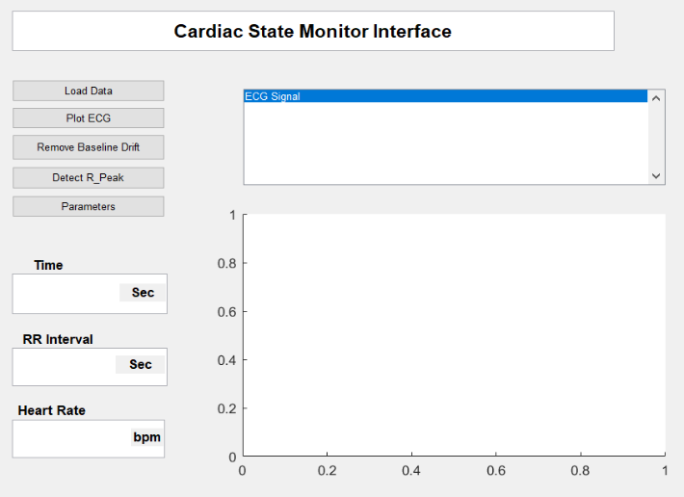 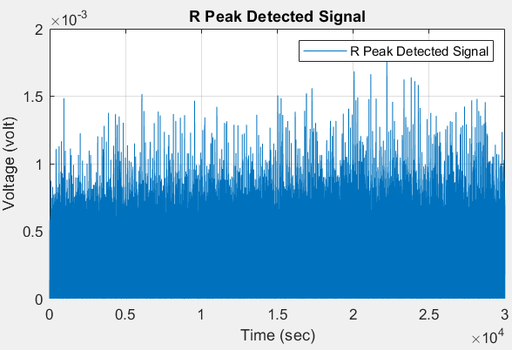 *Fig.4.1: GUI of Cardiac States Monitor Fig.4.2: R-peak Detected signal*

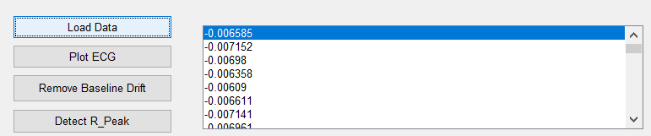

*Fig.4.3: Load Data*

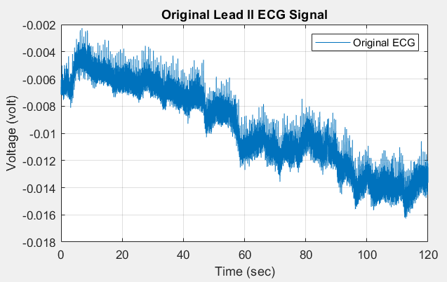 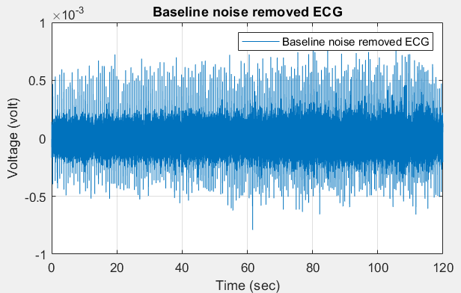

*Fig.4.4: Original Lead II ECG Signal Fig.4.5: Baseline noise removed ECG Signal*

* 1. **Discussion & Conclusion**

The experiment successfully developed a MATLAB-based GUI application for ECG signal processing, facilitating efficient cardiac state determination. MATLAB's robust capabilities in data analysis and signal processing, combined with a user-friendly GUI, presented a valuable tool for healthcare professionals. Processed ECG signals allowed for the assessment of normal rhythms, arrhythmias, and patterns indicative of cardiac disorders. The automated analysis within the GUI demonstrated efficiency, promising accelerated decision-making in clinical settings. Further validation and testing in diverse scenarios are essential for ensuring the reliability and applicability of this innovative tool.