*Heaven’s light is our guide.*

**Rajshahi University of Engineering and Technology**

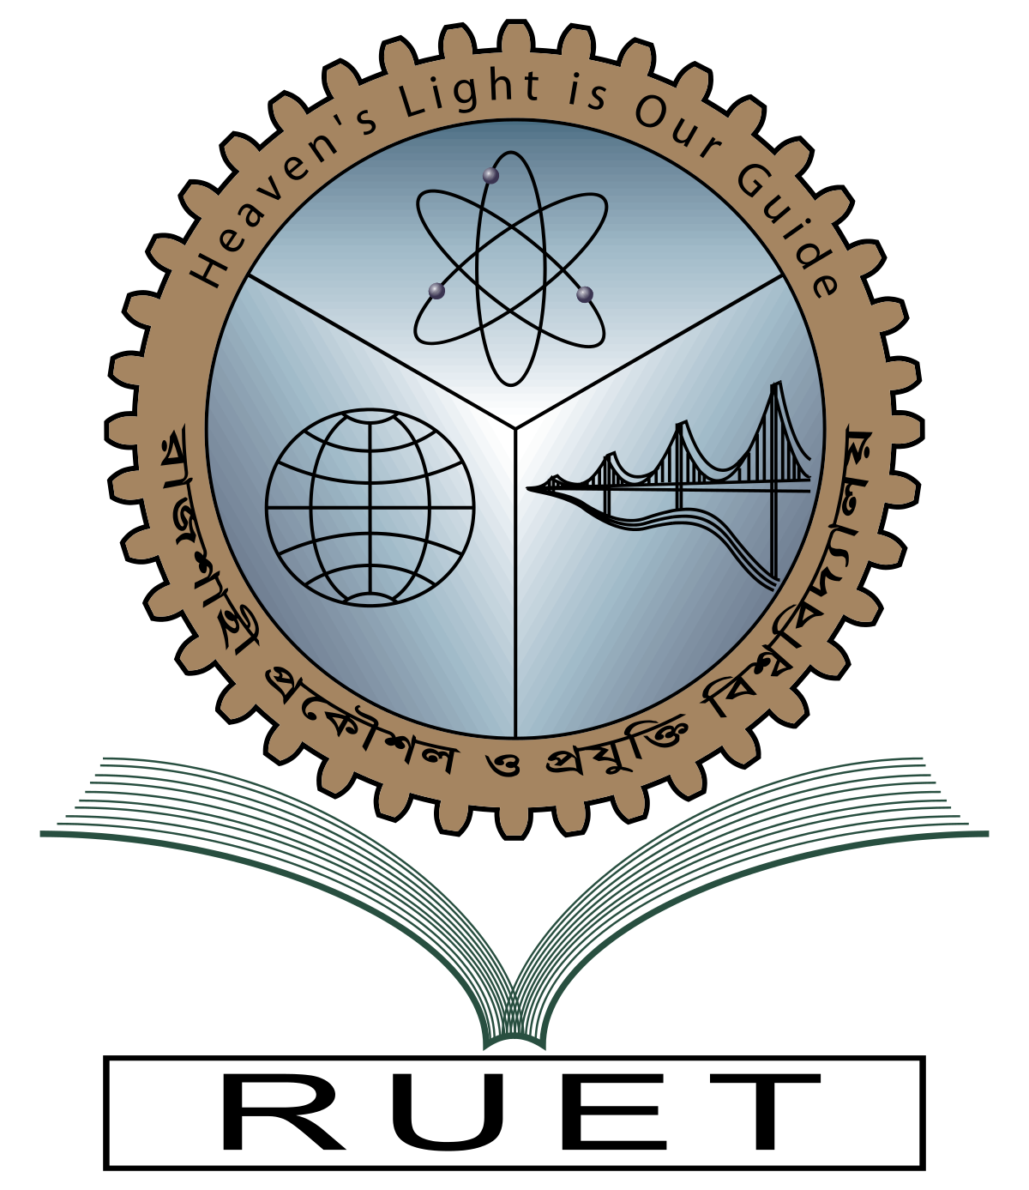

**Department of Electrical & Electronic Engineering**

**Course no.** EEE 4262

**Course title:** Biomedical Engineering Sessional

**Experiment no.** 4

**Experiment name:** Development of a MATLAB based GUI app for processing ECG signal to determine Cardiac state

**Date of experiment:** , 2023

**Date of submission:** , 2023

|  |  |
| --- | --- |
| **Submitted to:** | **Submitted by:** |
| **Kusum Tara**  **Assistant Professor**  Dept. of Electrical & Electronic Engineering,  Rajshahi University of Engineering and Technology. | **Ashraf Al- Khalique**  **Roll:** 1801171  **Session:** 2018-2019  Dept. of Electrical & Electronic Engineering,  Rajshahi University of Engineering and Technology. |