**Experiment No. 03**

* 1. **Experiment Name**

**3.1** s1 and s2 are two separate given signals. And s3=s1+s2, plot the Fast Fourier Transform (FFT) of s1, s2 and s3.

**3.2** s4=s3+ random noise, write a python code to remove the random noise from s4 using FFT analysis.

**3.3** denoise the signal s4 by designing a filter (Butter-worth filter) using python code

* 1. **Objectives**
* To get a better understanding of the Fast Fourier Transform (FFT) of the given signals
* To gain a deeper understanding of signal properties, relationships, and characteristics
  1. **Apparatus**
* Jupyter Notebook
  1. **Python code & graph**
     1. s1 and s2 are two separate given signals. And s3=s1+s2, plot the Fast Fourier Transform (FFT) of s1, s2 and s3.

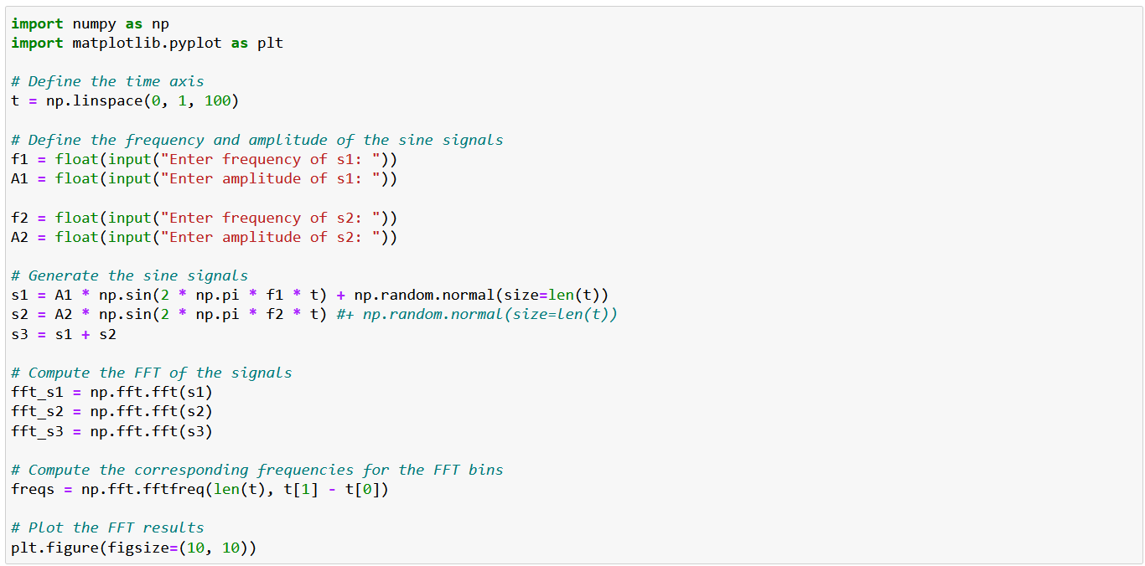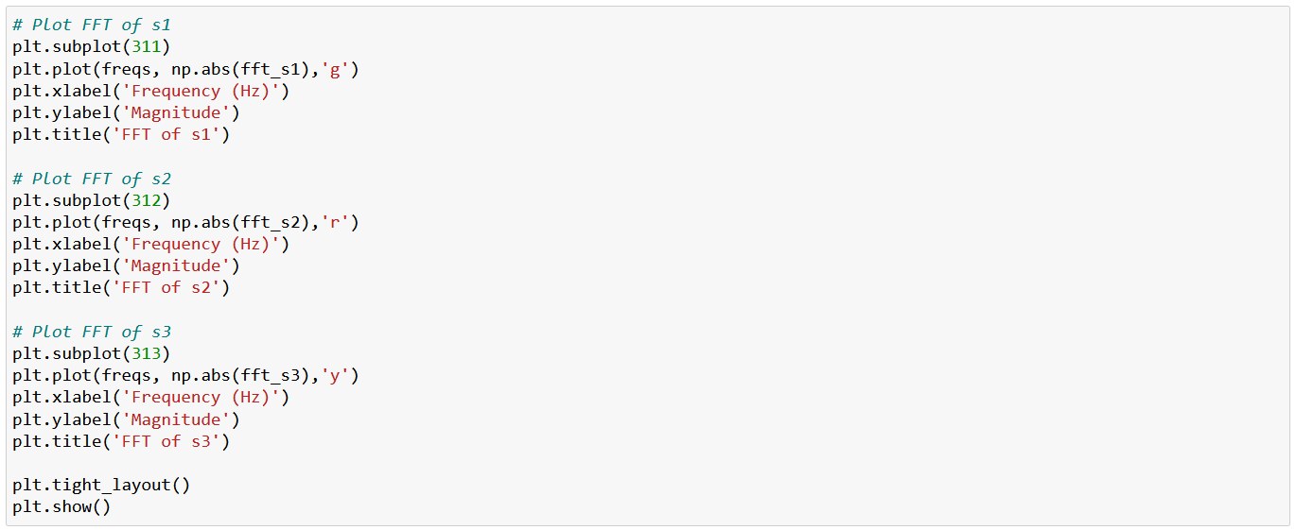



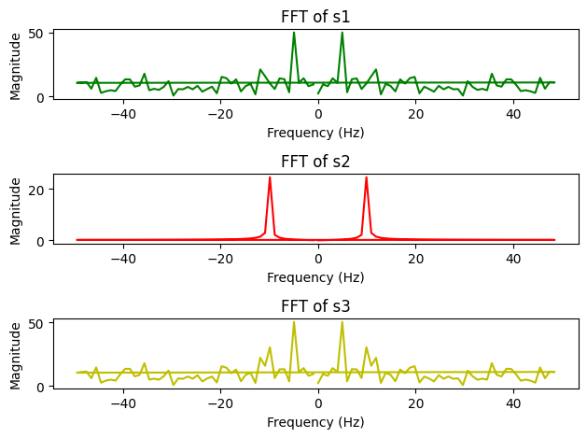

* + 1. s4=s3+ random noise, write a python code to remove the random noise from s4 using FFT analysis.

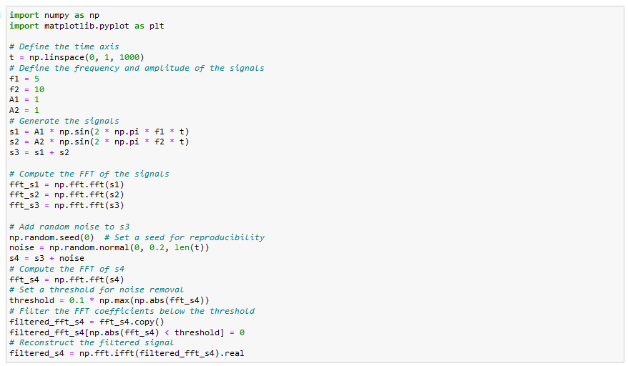

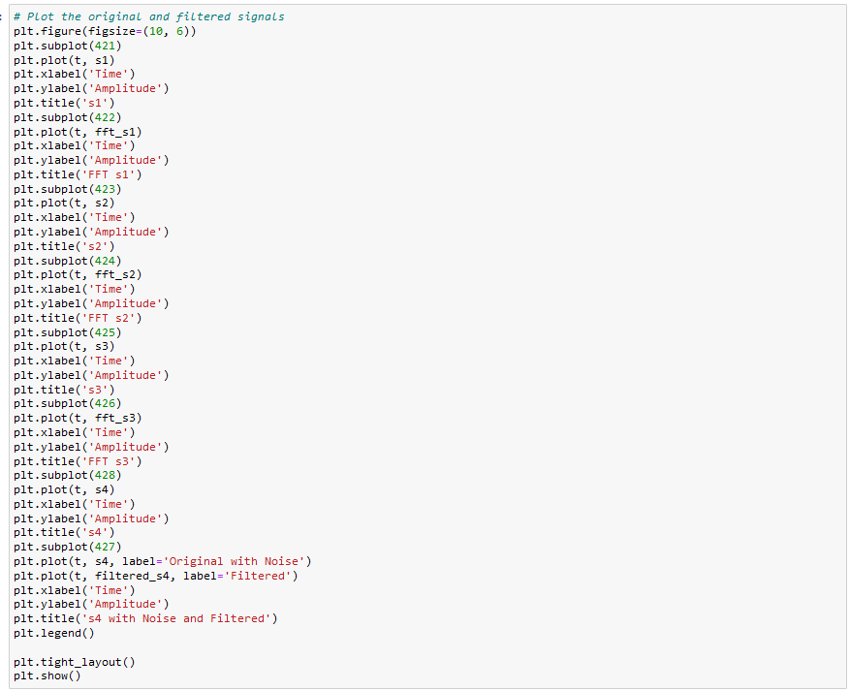

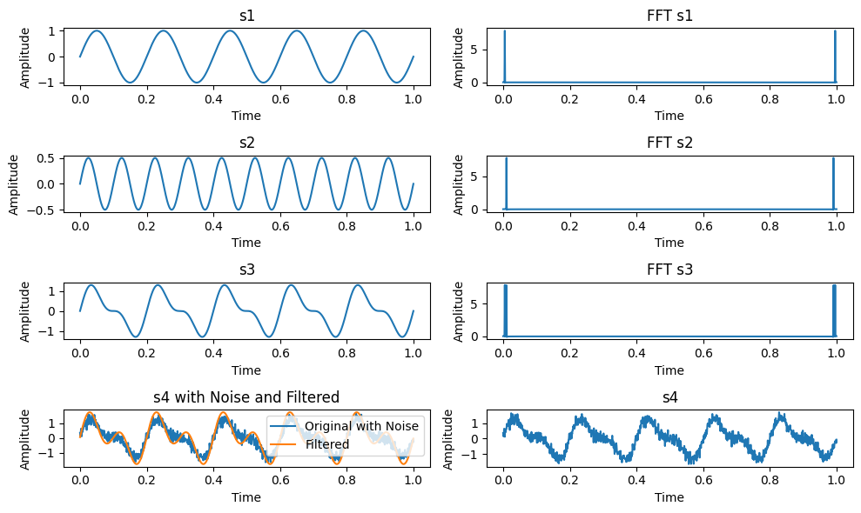

* + 1. denoise the signal s4 by designing a filter (Butter-worth filter) using python code
* **Butterworth filter**

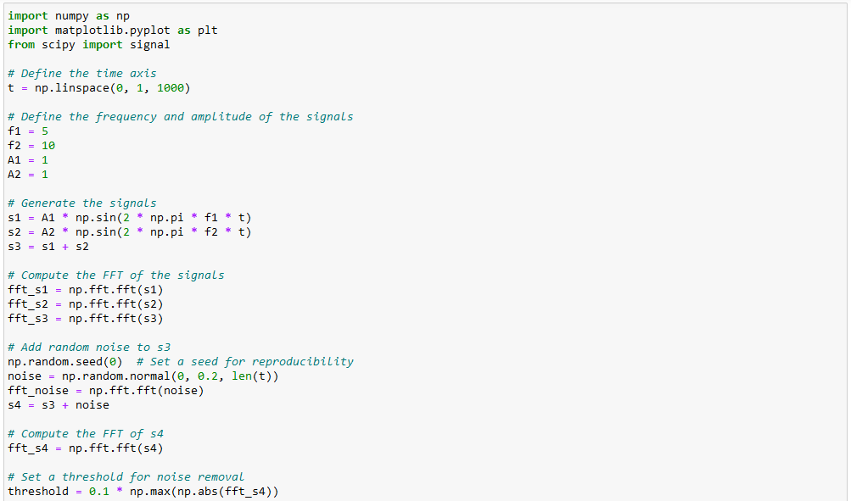

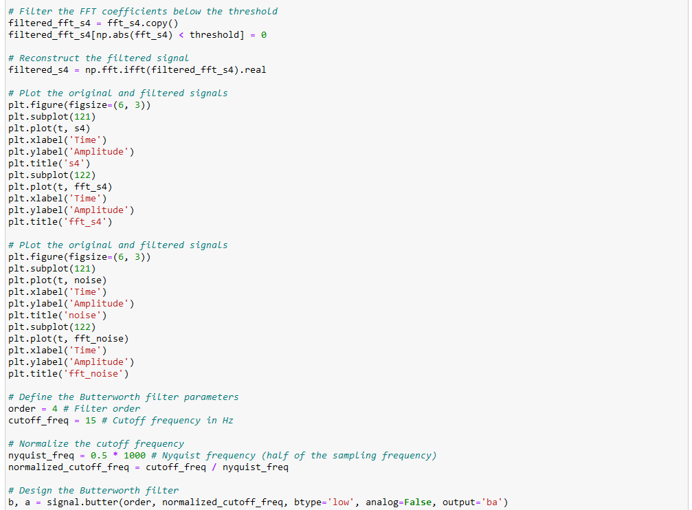

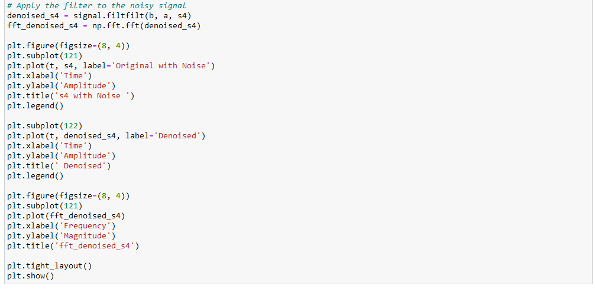

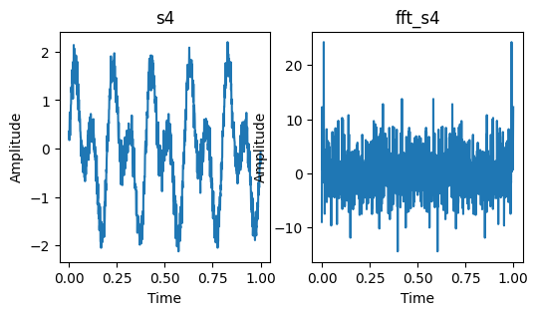 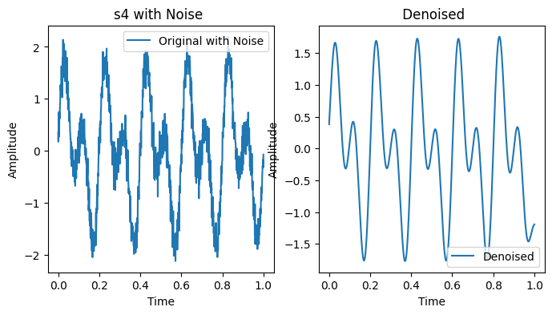 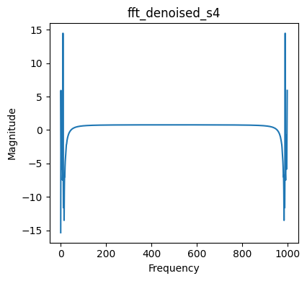

* **Chebyshev II filter**

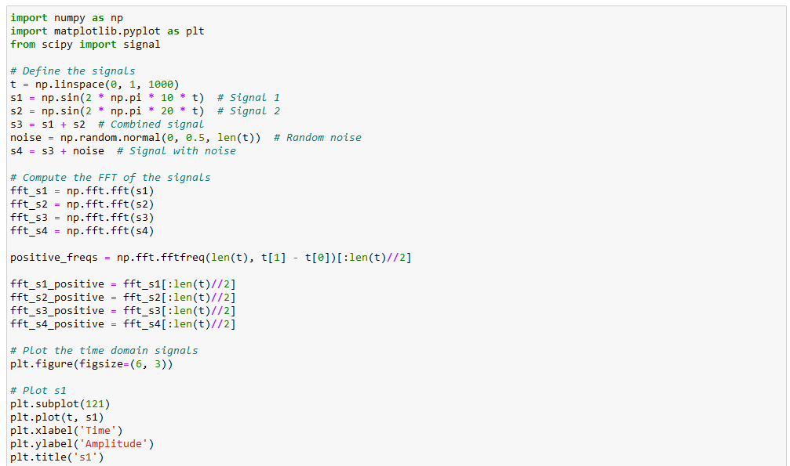

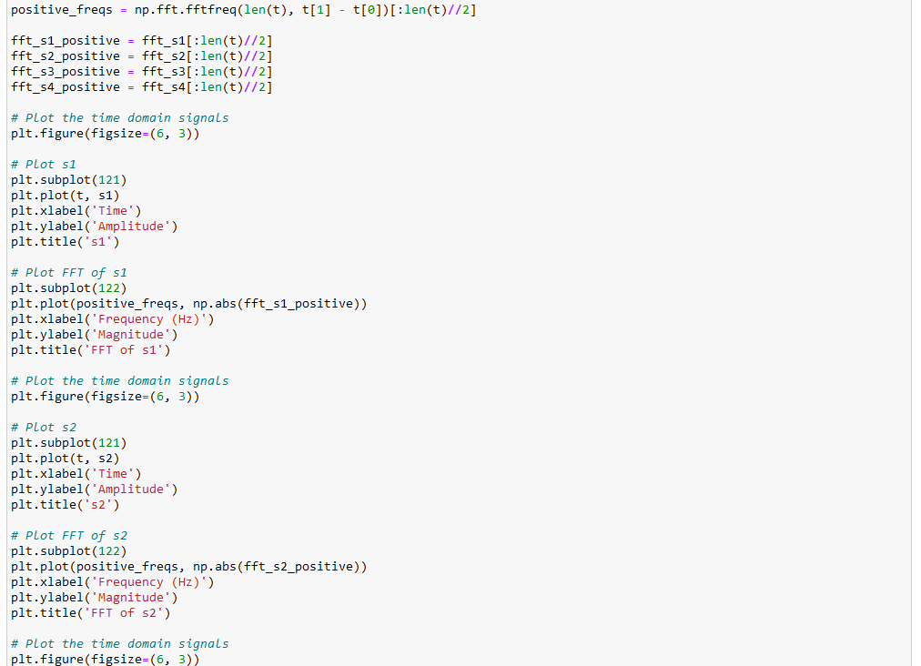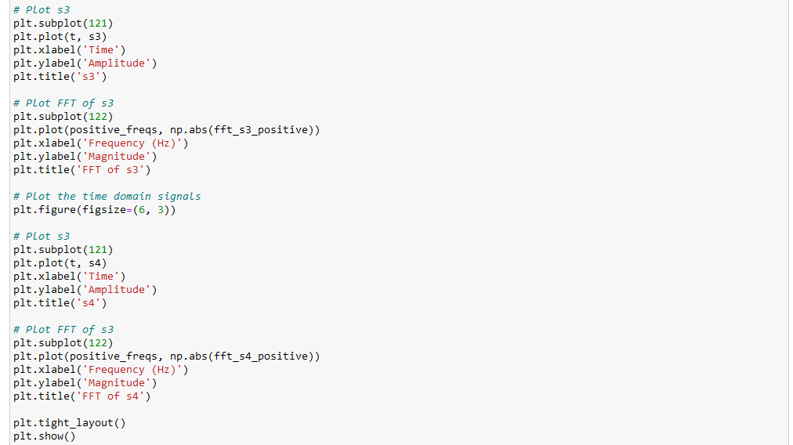

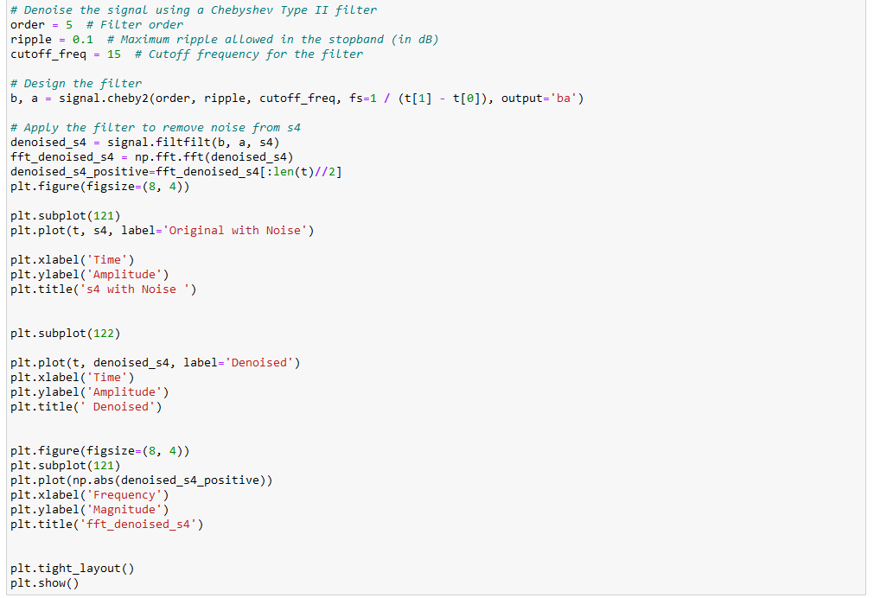

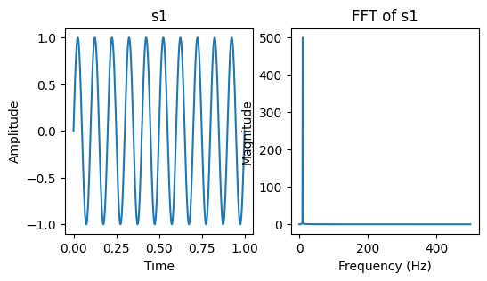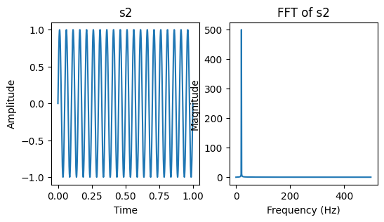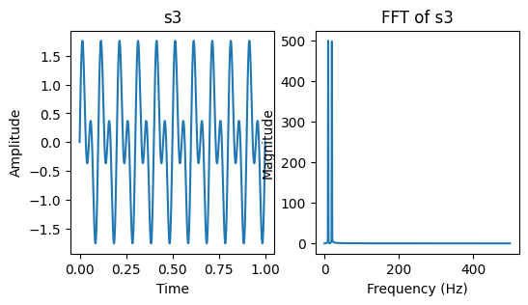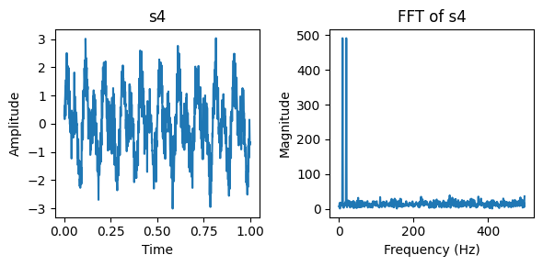

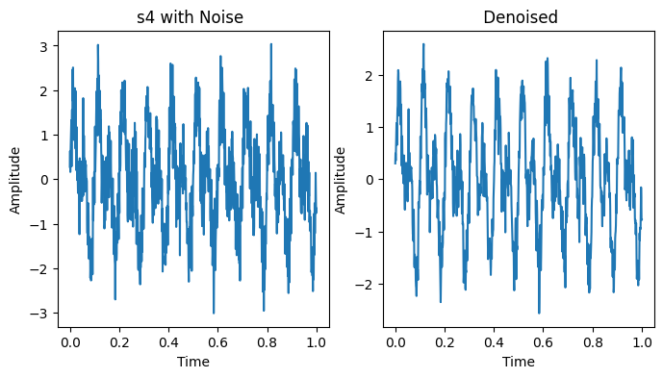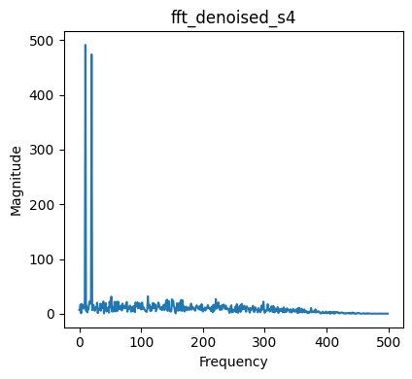

* 1. **Discussion & Conclusion**

In this experiment, we used the python to analyze the Fast Fourier Transform (FFT) of the given signals. We may better grasp the behavior and properties of signals and make wise decisions in signal processing applications by studying the FFT signal.