**Experiment No. 04**

* 1. **Experiment Name**

Study of convolution using Python Code

* 1. **Objectives**
* To get a better understanding of convolution of the given signals
  1. **Apparatus**
* Jupyter Notebook
  1. **Python code & graph**

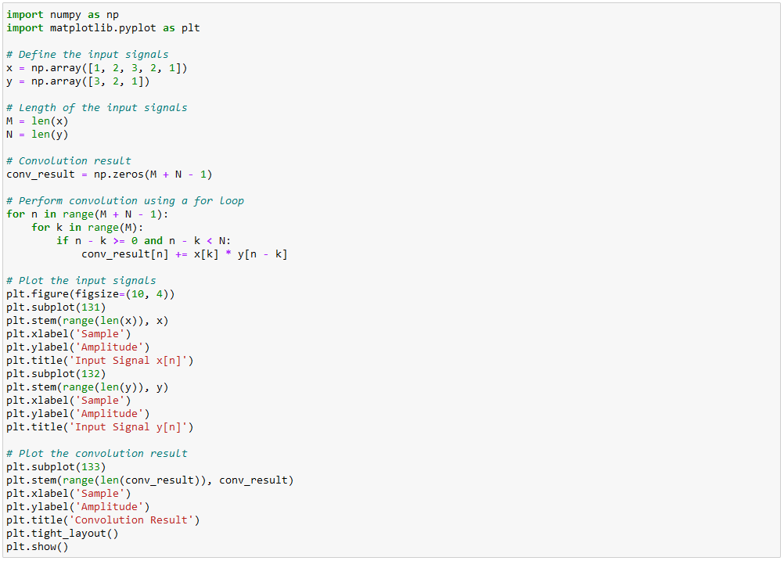

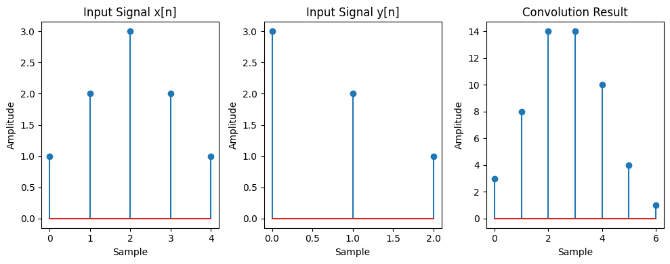

* 1. **Discussion & Conclusion**

In this experiment, we used the python to analyze convolution of the signals. Through this experiment, we got a better understanding of the convolution process and its’ practical use and understood the scope of improvements in the regarding field.